#### UY INTEGRATED Image result for vegetable oil milling company images"SOLUTION

#### SHARADA SMALL SCALE, KANO,KAONO STATE

Table of Contents

1.0 EXECUTIVE SUMMARY 3

1.1 OBJECTIVES 5

1.2 MISSION 6

**1.3** **VISION** 6

1.4 KEYS TO SUCCESS 6

2.0 PRODUCTS AND SERVICES 7

2.2 OIL MILLING PRODUCTION PROCESS 8

2.2.1Cleaning and grinding 9

2.2.2 Pressing 10

2.2.3 Extracting additional oil with solvents 11

2.2.4 Removing solvent traces 11

2.2.5 Refining the oil 11

2.2.6 Packaging the oil 13

2.2.7 OIL MILLING PRODUCTION FLOW CHART 14

3.0 MARKET ANALYSIS SUMMARY 14

3.1 MARKET SEGMENTATION 15

3.2 TARGET MARKET SEGMENT STRATEGY 16

4.0 STRATEGY AND IMPLEMENTATION SUMMARY 18

5.0 SWOT ANALYSIS 19

5.1 COMPETITIVE EDGE 24

5.2 MARKETING STRATEGY 25

5.3 SALES STRATEGY 26

5.4.1 SALES FORECAST 28

5.4.2 Payment Options 28

6.0 MANAGEMENT SUMMARY 29

6.1 Roles and Responsibilities of individual management 30

7.0 ORGANIZATIONAL STRUCTURES 34

## 1.0 EXECUTIVE SUMMARY

This plan is prepared by UY INTEGRATED SOLUTION, based on many year of cognate milling experience, both practical and intellectual in the oil extracting business. Our firm is highly focused and promised to follow a path of prosperity in oil milling for its owner, staff and outsider consumers. UY INTEGRATED SOLUTION engages in the crushing and processing of groundnuts and soy beans in order to extract vegetable and soy oil. Our intention of starting our own oil producing company is so as to be able to sell highly refined and quality vegetable and soy oil that is cholesterol and dirt free to our various customers not only here in northern Nigeria but also beyond well. Our intention is not only to establish our business for profit making but to also compete favorably with our competitors both nationally and internationally.

Groundnuts and soy beans are major raw material in the production of vegetable oil and palm-kernel oil. The proposed installation capacity of the factory is about 35 metric tons of vegetable and soy oil being produced per day. This is generated from the analysis below:

Maximum factory daily capacity = 50 metric tons

Number of working days = 6days

Number of working weeks = 52 weeks

Expected production capacity = 70%

Therefore daily production is:

50 metric tons × 6 days = 300 metric tons/ week

300 metric tons × 52 weeks = 15,600 metric tons/ year

70% of 15,600 metric tons = 10,920 metric ton/year (yearly production capacity)

10,920 ÷ 312 working days = 35 metric ton/ day.

Subsequently, the projections contained herein are authentic and will be used as the budget for the business.

Because of the best practices standard we have set for ourselves, we have ensured that we procured the best pressing and refining machineries that will allow us to be able to produce quality and refined vegetable groundnut and soy oil. Our packaging methods are also up to standard as we carry out all our activities with hygiene in mind so that we are able to set a standard for our customers.

Getting the best distribution networks are very important for this kind of business and so we have secured the best channels that will see our vegetable groundnut and soy oils get to the end users. We will continue to seek for the best means at ensuring that our products get to our consumers at the right time.

We intend to incorporate good work ethics as our corporate goal and also be renowned for our transparency standards. In order to ensure that we adhere to our corporate culture, we will recruit the best professionals possible that not only understand the industry we are in but also understand our company’s policies and are dedicated to ensuring that we are able to achieve our goals and objectives.

We will ensure that we get our employees to undergo continuous training that will not only enhance their skills but make them increase productivity for our organization. We will also ensure that our employees are well paid and undergo performance appraisals that will make them put in their best.

Finally, our production team is topmost refiners with many year experiences in this industry and also in a managerial role. They know how best to help towards the achievement our intended goals and objectives.

## 1.1 OBJECTIVES

UY INTEGRATED SOLUTION will produce vegetable groundnut and soy oil for the state (Kano state), region of its domicile, Northern Region and the nation in general. The first three years will be used to consolidate its hold on the raw materials bases while continuing its production process in the state.

## 1.2 MISSION

With the use of the latest production processes and state-of-the-art equipment UY INTEGRATED SOLUTION shall produces consumption oil and related products to match consumer’s specific product requirement. We do so, following good manufacturing practices and employing quality management processes to ensure that we provide pure and uncompromising products.

In our processes, we endeavor to always be mindful of the impact we have on our environment. We use only the best selected materials acquired through fair trade practice to ensure that remain sustainable along with our (raw material) farmers who are valued stakeholders in our enterprise.

* 1. **VISION**

Our vision is to ensure that we produce highly refined and quality groundnut oil that is cholesterol free for our various customers and also be amongst the top three groundnut oil producers globally.

## 1.4 KEYS TO SUCCESS

* To produces vegetable oil and palm kernel of high quality matching industry standards and chemistry expectations.
* To deliver to buyers with punctuality and at competitive and guaranteed prices.
* To give incentives and good purchasing prices to suppliers who deliver to us good quality groundnut and palm kernel nuts with low moisture content, low shell content and low imparities content and regular basis.

## 2.0 PRODUCTS AND SERVICES

Groundnut seed ( Arachis hypogea) and Soybean seed (Glycin max), also known as peanut and earthnut, are the most common oil nuts grown as an annual crop on about 19 million hectares of land in tropical, sub-tropical and warm temperature regions of the world. They are grown principally for its edible oil and protein rich seeds. The oil content of the seeds is between 45% and 55% depending on the variety. To remove the oil content from the seeds, the process known as oil milling or extraction, expelling or expressing is carried out. Traditionally, these seeds oil extraction involves shelling pods, roasting the shelled seeds, de-skinning/winnowing the seeds, milling the cleaned seeds and kneading the paste produced. Among the different method of oil extraction (traditional, mechanical, chemical and mechano chemical methods, Study revealed that 75% of the rural women engaged in groundnut processing used the traditional technologies which are labour intensive and time consuming. Also, it was found that amongst 436 processors of groundnut oil in three Northern States (Niger, Kaduna and Kano), 74% claimed that they were processing for income generation. Thus, groundnut and soybean seeds processing represents an important economic activity for the women. In recognition of the importance of the activity, as outlined above, many studies were carried out with a viewed to improving the process. Our research team conducted a study to evaluate the traditional groundnut oil extraction process. Results revealed that apart from the drudgery involved, a lot of time is wasted in the activity.



A woman milling oil using traditional method.

UY INTEGRATED SOLUTION intends to produce and supply highly refined vegetable and palm kernel oil to its various customers in the region it operate and beyond as well as all over the world.

Our aim as a business entity is to ensure that we not only generate revenue but maximize profit as well and to this end, we intend to create multiple sources of income so as to be able to have a solid bottom line. The ways we will source for extra means of revenue will be according to our ambition and in compliance with the laws.

Therefore the products and services we intend to offer at UY INTEGRATED SOLUTION are;

* Sale of processed vegetable oil for domestic and commercial purposes

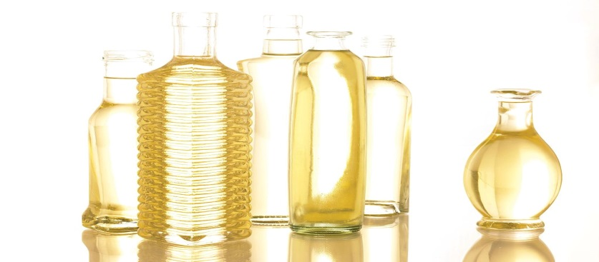

* Sale of processed soybean oil for domestic and commercial purposes

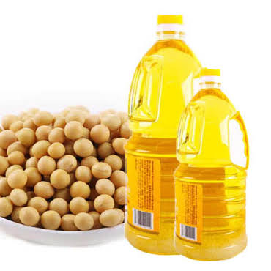

* Sale of byproduct – groundnut cake

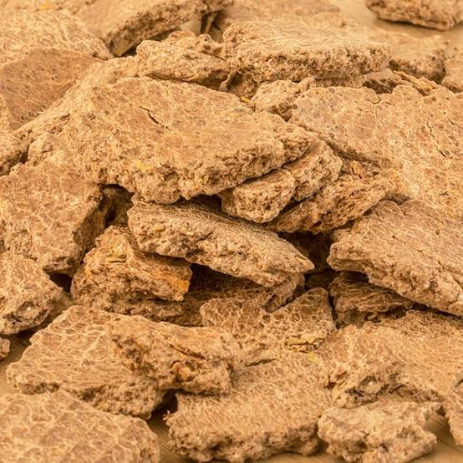

* Consultancy and Advisory Services

## 2.2 OIL MILLING PRODUCTION PROCESS

The production process of vegetable groundnut oil and soybean oil involves the removal of oil from plant components, typically seeds. UY INTEGRATED adopted mechanical extraction model/method using an oil mill chemical extraction solvent. The extracted oil is then purified and refined and not chemically altered.

Through these mechanical processes, Oils is removed via mechanical extraction, termed "crushing" or "pressing." This method is typically used to produce the more traditional oils (e.g., olive, coconut etc.), and it is preferred by most "[health-food](https://en.wikipedia.org/wiki/Health-food)" customers in the United States and in Europe. There are several different types of mechanical extraction. But we at UY INTEGRATED SOLUTION preferred to use the oil seed presses.

Oilseed presses are commonly used in developing countries, among people for whom other extraction methods would be prohibitively expensive. The amount of oil extracted using this method varies widely.

## 2.2.1Cleaning and grinding

* Groundnut and soybean seeds are passed over magnets to remove any trace metal before being dehulled, deskinned, or otherwise stripped of all extraneous material.
* The stripped seeds or nuts are then ground into coarse meal to provide more surface area to be pressed. Mechanized grooved rollers or hammer mills crush the material to the proper consistency. The meal is then heated to facilitate the extraction of the oil. While the procedure allows more oil to be pressed out, more impurities are also pressed out with the oil, and these must be removed before the oil can be deemed edible.

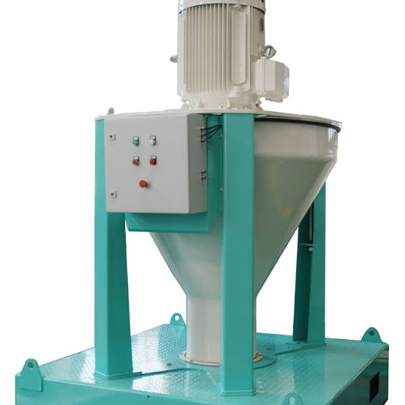Oil cleaning and grinding machine.

## 2.2.2 Pressing

* The heated meal is then fed continuously into a screw press, which increases the pressure progressively as the meal passes through a slotted barrel. Pressure generally increases from 68,950 to 206,850 kilopascals as the oil is squeezed out from the slots in the barrel, where it can be recovered.

. 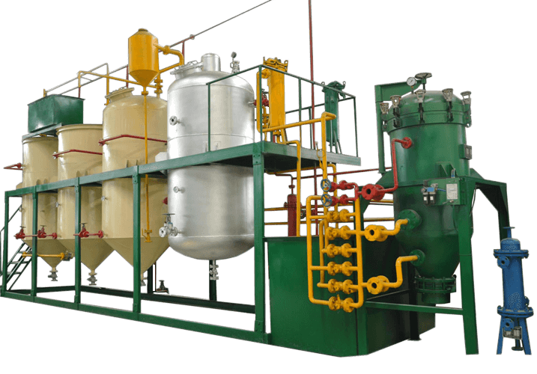

Modern Oil seeds pressing machine.

## 2.2.3 Extracting additional oil with solvents

Soybeans are usually not pressed at all before solvent extraction, because they have relatively little oil, but groundnut seeds with more oil are pressed and solvent-treated. After the initial oil has been recovered from the screw press, the *oil cake*remaining in the press is processed by solvent extraction to attain the maximum yield. A volatile hydrocarbon (most commonly hexane) dissolves the oil out of the oil cake, which is then recovered by [distilling](http://www.madehow.com/knowledge/Distillation.html) the light solvent out. The Blaw-Knox Rotocell is used to meet the demands oil industry. In using this machine, flakes of meal are sent through wedge-shaped cells of a cylindrical vessel. The solvent then passes through the matter to be collected at the bottom. The solvent percolates through the matter which is periodically dumped and replaced.

## 2.2.4 Removing solvent traces

Ninety percent of the solvent remaining in the extracted oil simply evaporates, and, as it does, it is collected for reuse. The rest is retrieved with the use of a stripping column. The oil is boiled by steam, and the lighter hexane floats upward. As it condenses, it, too, is collected.

## 2.2.5 Refining the oil

* The oil is next refined to remove color, odor, and bitterness. Refining consists of heating the oil to between 107 and 188 degrees Fahrenheit (40 and 85 degrees Celsius) and mixing an alkaline substance such as sodium hydroxide or sodium carbonate with it. Soap forms from the undesired fatty acids and the alkaline additive, and it is usually removed by centrifuge. The oil is further washed to remove traces of soap and then dried.
* Oils are also degummed at this time by treating them with water heated to between 188 and 206 degrees Fahrenheit (85 and 95 degrees Celsius), steam, or water with acid. The gums, most of which are phosphatides, precipitate out, and the dregs are removed by centrifuge.
* Oil that will be heated (for use in cooking) is then bleached by filtering it through fuller's earth, activated carbon, or activated clays that absorb certain pigmented material from the oil. By contrast, oil that will undergo [refrigeration](http://www.madehow.com/knowledge/Refrigeration.html) (because it is intended for salad dressing, for example) is winterized—rapidly chilled and filtered to remove waxes. This procedure ensures that the oil will not partially solidify in the refrigerator.
* Finally, the oil is deodorized. In this process, steam is passed over hot oil in a vacuum at between 440 and 485 degrees Fahrenheit (225 and 250 degrees Celsius), thus allowing the volatile taste and odor components to distill from the oil. Typically, citric acid at. 01 percent is also added to oil after deodorization to inactivate trace metals that might promote oxidation within the oil and hence shorten its shelf-life.

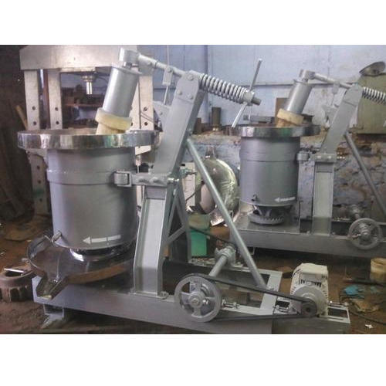

Cooking oil refining machine.

## 2.2.6 Packaging the oil

* The completely processed oil is then measured and poured into clean containers, usually plastic bottles for domestic oils to be sold in supermarkets, glass bottles for imports or domestic oils to be sold in specialty stores, or cans for exports.

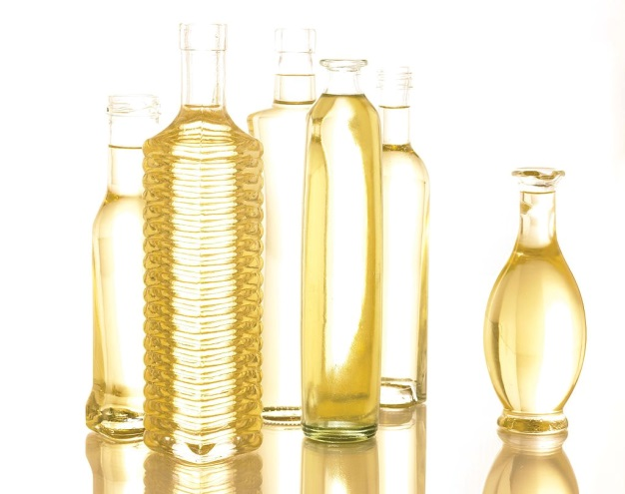

Vegetable groundnut oil Soybean oil

## 2.2.7 OIL MILLING PRODUCTION FLOW CHART

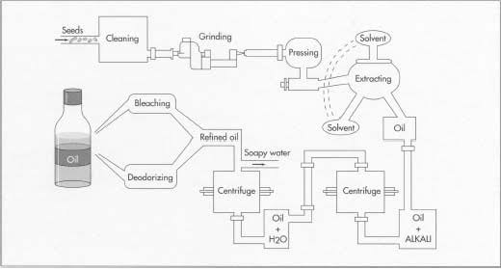

## 3.0 MARKET ANALYSIS SUMMARY

Nigeria with an estimated population of over 180 million people, a national population growth rate of 5.7% per annum and an average economic growth rate 3.5% per annum in the past five years it has a very large market for vegetable oil and groundnut cake. This is because about 80% of all the edible vegetable oil consumed in Nigeria is made from refined groundnuts, what we call “groundnut oil “in the ordinary market place.

So with these, the demand for oil in the local market is very huge, as a result that, the refineries that uses it as their raw materials do book for the products and pay in advance in order to secure the products.

Going by a recently concluded detailed research, presents a detailed analysis which shows that demand and supply gap is currently estimated to be between 500,000 metric tons to 600,000 metric tons per annual. An estimate also shows that Nigeria requires about 1,000,000 tons of vegetable oils to meet up to the national requirements for food and non-food uses.

From a detailed analysis of the sector, total vegetable groundnut and soy oil product per annum is currently about 74,000 tons even though the ban on importation into the country was lifted in the year 2008, yet it has not bridged the gap and currently the present administration has imposed a ban on importation. So we can see that with this demand and supply gap, it opens up more business opportunities for investors and business owners in the sector.

## 3.1 MARKET SEGMENTATION

The segmentation of the vegetable groundnut and soy oil market includes its application, type, and extraction method. The application segment of the market is divided into food and industrial. The food segment is further sub-segmented into salads and cooking oils, baking and frying processes, fatty ingredients, processed and frozen foods, margarine, and other spreads. The industrial segment is sub-segmented into lubricants, pharmaceuticals, paints, cosmetics, and others. Based on type segment, the market is segregated into palm kernel oil, sunflower oil, soybean oil, minor vegetable oil, rapeseed (canola) oil, and palm oil. The palm oil is the dominating segment in the south among others while here in the north; the dominating segment is the groundnut and soybean oil. The extraction method segment is fragmented into sparing, solvent extraction, mechanical extraction, and hydrogenation.

## 3.2 TARGET MARKET SEGMENT STRATEGY

The market for vegetable oil and palm kernel oil is national. With a population of over 180million people and an estimated national population growth rate of 5.7% per annum ,an average economic growth rate of 3.5% per annum in the past five {5} years, Nigeria has a large market for edible oil. The demand is high but local supply low hence the need for importation in the past. Industry data suggest that Nigerian consumers use more than one million and eight hundred {1,800,000} tones of vegetable and palm kernel oil annually. In 2005, in order to stimulate local production and attain self-sufficiency in vegetable oil production, the government introduced the presidential initiative on the development of edible oil over a period not exceeding three {3} years.

Under this initiative, attention was focused on the promotion of eleven scheduled oil seed crops which are oil palm seed, groundnut seed, Soya beans seed, cotton seed etc. and production target was set for each of the crops under the programme as follow;

* Oil Palm: 1 million hectares capacity of producing 15 million fresh fruit bunches
* Groundnut: 15 million tons annually
* Soya beans: 670,000 1 million tons per annum
* 1 million tons over the plan period

After about seven {7} years of the initiative, the domestic edible oil demand far exceeds the national production. The short fall in supply is estimated at about 800,000 tons per year.

From the above figures, it is clear that there is a large and sustainable market for vegetable and palm kernel oil in Nigeria. One of the first activities when planning our oil processing business is to decide who will be our target customers. Our targeted audience is therefore listed as follow:

1. Retail Consumers
2. Food service
3. Wholesale
4. Institutional
5. Food businesses
6. Soap Manufacturers
7. Confectionaries
8. Cosmetic industries
9. Food industries
10. Grocery Stores and Supermarkets

Naturally, the target market is the end consumer who uses oil in cooking. Every household consumes vegetable and soy oil. Also a large chunk of manufacturing companies depends on this vegetable oil as their raw materials. In essence we planned to see our processed output to as many people as possible. We will ensure that we position our product to attract household consumers and other manufacturing firms within and outside Nigeria.

## 4.0 STRATEGY AND IMPLEMENTATION SUMMARY

We are quite aware that the reason why processing company hardly make good profits is their inability to sell off their processed output as at when produced. In view of that, we decided to set up a standard supply chain to help us maximize profits. Over and above, we have perfected our sale and marketing strategies first by networking with distributing merchants and companies that rely on oil as their major raw material. In all, UY INTEGRATED SOLUTION has developed the following strategies in marketing our processed oil:

* The segment of the markets planned to reach.
* Distribution channels planned to be used to reach market segments: television, radio, sales associates, and mail order.
* Share of the market expected to capture over a fixed period of time.

All of this has been analyzed through an analysis of our Strength Weakness Opportunity and Threat.

## 5.0 SWOT ANALYSIS

SWOT analysis is a strategic planning tool that is used to do a situational analysis of a company operation. It is an important technique present to you to understand the Strengths (S), Weakness (W), Opportunities (O) & Threats (T) UY INTEGRATED SOLUTION is facing in its current business environment. The SWOT Analysis framework helps an organization to identify the **internal strategic factors** such as -strengths and weaknesses, & **external strategic factors** such as - opportunities and threats. It leads to a 2X2 matrix – also known as **SWOT Matrix**

### STRENGTHS

Our strength lies in the fact that we offer our customers’ high quality processed vegetable groundnut and soy oil which is cholesterol free. This means that customers who use other substitutes because they feel those are better for their diet will stick to our own brand of oil instead. We are in a location that is not only strategic but also convenient for our customers and employees to access. Other includes;

* STRONG DEALER COMMUNITY: UY INTEGRATED SOLUTION has built a culture among distributor & dealers where the dealers not only promote company’s products but also invest in training the sales team to explain to the customer the maximum nutritional benefits out of the products.
* SUPERB PERFORMANCE: UY INTEGRATED SOLUTION has built expertise at entering new markets and making success of them. The expansion has helped our organization to build new revenue stream and diversify the economic cycle risk in the markets we operates in.
* RELIABLE SUPPLIERS: UY INTEGRATED SOLUTION has a strong base of reliable supplier of raw material thus enabling the company to overcome any supply chain bottlenecks.
* GOOD RETURNS ON CAPITAL EXPENDITURE: UY INTEGRATED SOLUTION is relatively successful at execution of new projects and generated good returns on capital expenditure by building new revenue streams. As seen in the production of groundnut cake.

**WEAKNESSES**

The nut oil processing industry is a saturated one and so would require us to adapt strategies that would allow us to stand out against our competitors. Also, because we are just starting up, we do not yet have the necessary finances and staff strengths as our already established competitors.

These weaknesses are the areas where UY INTEGRATED SOLUTION can improve upon. Strategy is about making choices and weaknesses are the areas where an organization can improve using SWOT analysis and build on its competitive advantage and strategic positioning.

* Need more investment in new technologies. Given the scale of expansion and different geographies the company is planning to expand into, UY INTEGRATED SOLUTION needs to put more money in technology to integrate the processes across the board. Right now the investment in technologies is not at par with the vision of the company.
* The marketing of the products left a lot to be desired. Even though the product is a success in terms of sale but its positioning and unique selling proposition is not clearly defined which can lead to the attacks in this segment from the competitors.
* The company has not being able to tackle the challenges present by the new entrants in the segment and has lost small market share in the niche categories. UY INTEGRATED SOLUTION has to build internal feedback mechanism directly from sales team on ground to counter these challenges.
* Days inventory is high compare to the competitors – making the company raise more capital to invest in the channel. This can impact the long term growth of UY INTEGRATED SOLUTION.

### OPPORTUNITIES

There are several opportunities that abound for us in this industry as cooking oil is widely consumed by a whole lot of people. We are however seeking innovative ways to attract the health conscious customers who have shifted to alternative sources because they feel that vegetable groundnut and soy oil isn’t hygienic enough in helping to achieve their fitness goals. Our advisory and consultancy services will serve to open up more opportunities for us in this industry.

* Economic uptick and increase in customer spending, after years of recession and slow growth rate in the industry, is an opportunity for UY INTEGRATED SOLUTION to capture new customers and increase its market share.

### Government green drive also opens an opportunity for procurement of UY INTEGRATED SOLUTION products by the state as well as federal government contractors.

* Stable free cash flow provides opportunities to invest in adjacent product segments. With more cash in bank the company can invest in new technologies as well as in new products segments. This should open a window of opportunity for UY INTEGRATED SOLUTION in other product categories.
* The planned market development will lead to dilution of competitor’s advantage and enable UY INTEGRATED SOLUTION to increase its competitiveness compare to the other competitors.

### THREATS

Threats in a business environment are normal expectations if the business is a serious one. The threats that we are likely to face as an processing company will arise from unfavorable government policies, stiff competition from competitors, as well as customers’ shift to close substitutes on personal preference grounds. We have laid down strategies in place that will enable us handle whatever threats we are likely to face. Other may include;

* Imitation of the counterfeit and low quality product is also a threat to UY INTEGRATED SOLUTION product especially in the emerging markets and low income markets.
* Rising pay level especially the introduction of the new minimum wage for workers can lead to serious pressure on profitability of UY INTEGRATED SOLUTION.
* Liability laws in different countries are different and UY INTEGRATED SOLUTION may be exposed to various liability claims given change in policies in those markets.
* The company can face lawsuits in various markets given - different laws and continuous fluctuations regarding product standards in those markets.
* Rising raw material can pose a threat to the UY INTEGRATED SOLUTION profitability.
* As the company is operating in numerous countries it is exposed to currency fluctuations especially given the volatile political climate in number of markets across the world.

## 5.1 COMPETITIVE EDGE

Competitors for UY INTEGRATED SOLUTION are Golden Oil company-Onitsha, PRESCO Plc., etc. UY INTEGRATED SOLUTION competitive edge includes the use of modern milling equipment which turns out high quality products, excellent customer service, the expertise of its founders, etc.

Our intentions to start oil UY INTEGRATED SOLUTION is to give our various customers not only here in the Nigeria but all over the world, quality cooking groundnut oil that is cholesterol free and soy oil that is dirt free. To be able to achieve this, we have drafted strategies that will allow us have a competitive advantage over that of our competitors.

Our first competitive advantage is in the quality of vegetable and soy oil we are giving our customers all over the world. Because this is oil that is to be consumed, we have taken great care in ensuring that from the raw materials down to the processing all go through a high standard of quality checks. We take great pride in ensuring that our customers can trust our cooking groundnut oil.

We have engaged the services of the best professionals who not only know this industry thoroughly but also understand how best to make a business become the world standard we have intended for it.  Our employees also understand our corporate philosophies and goals and are willing and dedicated to ensuring that we achieve it.

We have put in place processes and plans that will ensure that our employees receive trainings as at when due. These trainings will allow them to have enhanced skills that will also improve their productivity for the company. We will also ensure that our employees are well paid and have better welfare packages than that of their counterparts in similar startups such as ours.

Finally, we will ensure that we put our customers first by not only meeting but exceeding their expectations. We will ensure that we take good care of our loyal customers and offer them incentives. We will ensure that we keep an updated customer database so as to keep in touch with our customers and allow them be aware of our products and other services that we might be offering.

## 5.2 MARKETING STRATEGY

Marketingstrategy is a long-term, forward-looking approach to planning with the fundamental goal of achieving a sustainable [competitive advantage](https://en.wikipedia.org/wiki/Competitive_advantage). UY INTEGRATED SOLUTION has devised the following measure to penetrate in to the market.

While our competitors think of slashing their prices to stand out, there’s value in going the other direction. “You don’t buy a Rolex to tell time.” Charging more is what’s referred to as “prestige pricing.” It’s used not just to boost margins but to increase a brand’s image and social capital by appealing to buyers who don’t take cheaper products seriously. The only caution here is that our products need to be able to justify the higher pricing we want to command.

Also, “Nutritional benefit” is a nebulous term in food and beverages industry these days, but its function as a competitive edge is simple to understand: The more people who know the nutritional benefits of our company product, the more customers we’ll acquire.

Furthermore, we adopt to stand out in our space is the use new technology that company else is using. This makes our product refined and one which is not affected by cold weather.

## 5.3 SALES STRATEGY

This is one important element that is not usually overlooked is the sales aspect. Not only are strategies created to better market a product or service, a budget is also created so that strategies can be effectively implemented. Sales also serve a dual purpose as it not only generates revenue for the company but also creates awareness for the business as well.

Publicity is very important for every business, as it is what allows the target market that consists of both existing and potential customers. This is why even though a business has been established for a long period of time, it still engages in publicity so as to be able to not only retain its customers but also attract new customers to patronize it. The publicity we tend to create for our business is one that will project the image of our business positively.

In a bid to ensure that we create effective publicity strategies, we intend to engage the services of a brand consultant who understands the business and the industry we are in. the brand consultant has been empowered to use conventional and unconventional means to ensure that we get the awareness we need for our business not only here in the northern Nigeria but also all over the country.

Below are the platforms we intend to use in creating awareness as well as advertising UY INTEGRATED SOLUTION oil product all over;

* Create an official website and use this to create awareness about our groundnut oil producing company
* Place adverts in local and national newspapers and on radio and television stations here in Florida and nationally as well
* Participate in and sponsor relevant community programs here in Fort Lauderdale
* Use our social media platforms such as Facebook, Twitter, LinkedIn and Google Plus to promote our groundnut oil producing company
* Place attractive and distinctive bill boards in strategic locations all around Florida and outside its environs
* Write articles and post on different relevant blogs and websites

## 5.4.1 SALES FORECAST

Both vegetable groundnut and soy oil are cooking oil that is being consumed daily by most people and used for domestic and commercial purposes and therefore will always be in demand.

Our location here at Kano, Nigeria is one that is very strategic and has us very optimistic of being able to not only generate the needed revenue within one year but also one that will allow us maximize our profit, as the forecast has shown that this is highly achievable.

We carried out several researches whilst conducting our sales forecast and used several assumptions and information from similar start-ups such as ours not only here in Kano but also all over the Nigeria so as to be able to get accurate data to arrive at the below stated projections.

The stated projections for UY INTEGRATED SOLUTION products will be based on accurate assumptions and data are as follows;

## 5.4.2 Payment Options

Any smart business knows that it is very important for customers to have convenient means by which they pay for products and services. Therefore knowing this, we intend to offer various payment platforms so as to be able to cater to our various clients and their different preferences.

The different payments options that we therefore intend to make available are;

* Payment via cash
* Payment via checks
* Payment via bank draft
* Payment via online payment portal

It should be noted that the above payment options were carefully chosen by us to make payments not only easier for our clients but also to ensure that we are able to run our business without hitches.

## 6.0 MANAGEMENT SUMMARY

Building a Management Structure that will right for oil business is very important to us, which is why we are making sure that we put in all efforts to recruit and the right hands that will help us achieve our goals and objectives.

It is important that our management team understand and identify with our core vision and objectives and as such is able to effectively communicate these policies and goals to the lower end staff and ensure that it is effectively implemented.

Due to the fact that we intend to offer additional services to our core service, our management structure include more employees than the conventional oil producing company. This is so that the different tasks will be effectively handled without pushing too many responsibilities in the hands of a few employees.

* Chief Executive Officer
* Plant Manager
* Purchasing Manager
* Human Resources and Admin Manager
* Accountants
* Marketing Executives
* Truck Drivers
* Customer Care Executives
* Maintenance Team
* Security Guard

## 6.1 Roles and Responsibilities of individual management

**Chief Executive Officer**

* Creates strategies and policies for the overall direction of the organization
* Responsible for negotiating with high level clients on behalf of the organization
* Ensures that policies created are effectively implemented

**Plant Manager**

* Monitors production processes and ensures that it aligns with both company and industry standard
* Develops and implements budgets for production
* Seeks ways to reduce costs without reducing quality

**Purchasing Manager**

* Sources for reliable vendors and suppliers of raw materials
* Drafts purchasing contracts and ensures that it is to the benefit of the organization
* Drafts and implements purchasing strategies on behalf of the organization

**Human Resources and Admin Manager**

* Responsible for recruiting, giving orientation as well as ensuring that customers get attuned to the company’s policies
* Responsible for employee welfare and incentive packages as well as carrying out performance appraisals on behalf of the company
* Ensures that the administrative functions of the organization are carried on smoothly

**Accountants**

* Responsible for creating ensuring the implementation of financial statements, records and budget on behalf of the organization
* Prepares tax records and ensures that they are submitted to the right authorities
* Responsible for cash inflow and outflow and petty cash

**Marketing Executives**

* Drafts effective marketing strategies and modifies them continuously in order to generate revenue for the organization
* Engages in direct marketing with customers on behalf of the organization
* Manages existing customer relationship in order to help increase customer loyalty and retention on behalf of the organization

**Truck Drivers**

* Responsible for delivering products to customers at accurate destinations
* Carry out maintenance on the vehicle when necessary and report major faults to the management
* Keep traffic laws and regulations and also a logbook

**Customer Care Executives**

* Responsible for taking orders, answering enquiries and providing accurate information to clients.
* Ensures that customers’ complaints are readily resolved on behalf of the company
* Keeps an updated customer database on behalf of the company

**Maintenance Team**

* In charge of maintaining all the equipment and machineries used by the organization
* Arranges for new parts and replacements for the machineries
* Reports major machinery and equipment faults to the management

**Security Guard**

* Patrols the facility and its perimeter during work and after work hours to ensure that there is no trespasser
* Monitors incoming and outgoing people and visitor and responsible for surveillance equipment
* Remains updated on security tips and ensures that company staff is aware of security tips as well

## 7.0 ORGANIZATIONAL STRUCTURES

UY INTEGRATED SOLUTION has a strong, capable and experienced Board of Directors and Senior Management; a multinational team to provide leadership, strength and depth of knowledge to manage and grow the business, to maintain status as a leader in oil milling product and oil milling consultancy services within Nigeria.

**Key personnel as follow:**

[**Chairman and CEO.**](mailto:tony@remmoil.com?subject=from%20website)

The chairman of UY INTEGRATED is Businessman having many years’ experience in running businesses in Kano, Nigeria.

[**Operational Manager**](mailto:Bob@remmoil.com?subject=From%20Website)

He has worked in the oil milling industry for several years. He is a time proven toolmaker/machinist, having served in many oil milling industry in the North many years.

[**Machine Shop/Fabrication Manager.**](mailto:nass@remmoil.com?subject=from%20website)

Naas is a qualified turning machinist, CNC milling and turning programmer. He has a lot of experience in the oil milling industry. He has been working in the Oil mill for 25 years now. Considering his versed experienced in oil milling, he was appointed as the machine shop manager by UY UNTEGRATED SOLUTION board management.

[**Asst. Machine Shop Manager.**](mailto:assistantmsm@remmoil.com?subject=website%20contact)

A Mechanical Engineering graduates and trained and was the QA/QC Inspector and CNC Operator with over 14 years’ experience.

[**QA/QC Manager,**](mailto:qcqa@remmoil.com?subject=website%20contact)

Personnel here are engineering graduates, has 7 years extensive working experience in QA/QC and Quality Management, within the Oil milling industry, particularly groundnut oil milling.

[**HSES Officer**](mailto:hses@remmoil.com?subject=website%20contact)

Personal here has over six years’ industrial working experiences in the engineering construction and oil mill industry. Have undergone several safety courses, good knowledge in safety procedures, with effective strategies to reduce risk and improve safety in work environment. They are young men that have introduced innovation in HSES matters in the company.

**SUMMARISED BACKGROUND OF OIL MILLING IN NIGERIA**

Groundnut is one of the crops that are grown abundantly in Nigeria. Groundnut oil is also one of the edible oils that is in very high demand. Extraction of oil from groundnut is also one of the projects that can contribute to the economic development of Nigeria. Groundnut is grown heavily in the Middle Belt and Northern part of Nigeria. This means that raw materials for the processing of groundnut oil are readily available. Establishment of groundnut oil processing factory will contribute to the rural sector development, as farmers will be encouraged to produce more because their product can get ready market.

The market for vegetable oil in Nigeria cannot be overemphasised. With the Nigerian population of over 120 million people and vegetable oil being a daily need item, market for groundnut oil in Nigeria is highly un-imaginable right now, the supply cannot meet the demand of the people. Establishment of groundnut oil processing factory will create employment opportunities thereby reducing social vices. Vegetable oil is one of the chief sources of vitamins and minerals that are meant for the growth and development of human beings.  In this case, establishment of this project will contribute to the physical and mental development of Nigerians.

Northern part of Nigeria has been known for the groundnut pyramids in those days.  Groundnut production has contributed tremendously to the development of Northern part of Nigeria because it is both food and cash crop.  Encouraging groundnut oil production will return this old glory and feat. Technology for the production of groundnut oil is very simple to install and maintain. In this regard, various government agencies (state and federal) can adopt it and install in all rural areas of Nigeria as part of poverty alleviation program.