**(The Analysis and Management of Stakeholders in a complex Project: A case Study of the Relocation of FAWAZ Plastic Enterprises from Jos, Plateau state to Ilorin, Kwara state Nigeria)**

**Client Company : FAWAZ PLASTIC ENTERPRISES**

**Final Word Count :**

**Turnitin Score % :**

**1.0 PROJECT INTRODUCTION & BACKGROUND**

"The Analysis and Management of Stakeholders in a complex Project: A case Study of the Relocation of FAWAZ Plastic Enterprises from Jos, Plateau state to Ilorin, Kwara state Nigeria" focuses on the critical aspect of stakeholder management in a complex project scenario. The relocation of a manufacturing company like FAWAZ Plastic Enterprises involves multiple stakeholders with varying interests, expectations, and concerns. Effectively managing these stakeholders is crucial for the success of the project.

**1.1 Problem Statement**

The relocation of FAWAZ Plastic Enterprises presents several challenges related to stakeholder management. The diverse range of stakeholders, including employees, customers, suppliers, regulatory authorities, and local communities, may have conflicting interests and expectations regarding the relocation. Failure to address these stakeholder needs and concerns could lead to resistance, delays, and potential project failure. Therefore, there is a need to analyze and manage stakeholders effectively to ensure a smooth and successful relocation process.

**1.2 Relevance to FAWAZ Plastic Enterprises**

As a leading plastic manufacturing company in Nigeria, FAWAZ Plastic Enterprises has a strong presence in the market and a reputation to uphold. The decision to relocate the company's operations from Jos to Ilorin is a strategic move aimed at enhancing operational efficiency, market reach, and cost savings. However, the success of the relocation project heavily depends on how well the company manages its stakeholders throughout the process.

In addition, FAWAZ Plastic Enterprises must ensure that all stakeholders are engaged, informed, and involved in the relocation process to mitigate risks, build trust, and minimize resistance. By understanding the needs, expectations, and concerns of various stakeholders, the company can proactively address issues, resolve conflicts, and create a positive impact on all parties involved. Effective stakeholder management will not only contribute to the success of the relocation project but also strengthen the company's relationships and reputation in the long run.

The analysis and management of stakeholders in the relocation of FAWAZ Plastic Enterprises is a critical aspect of the project that requires careful planning, communication, and engagement. By addressing the diverse needs and concerns of stakeholders, the company can navigate the complexities of the relocation process and achieve a successful outcome.

**2.0 CLIENT INTRODUCTION**

FAWAZ Plastic Enterprises is a renowned plastic manufacturing company that has been a key player in the industry for several years. Based in Jos, Plateau state, Nigeria, the company has built a solid reputation for producing high-quality plastic products and serving a wide range of customers in the region.

The decision to relocate the company's operations from Jos to Ilorin, Kwara state, stems from a combination of factors, including market expansion opportunities, the need for operational efficiency, and cost considerations. However, one of the primary reasons for the relocation is the prevailing insecurity in the northern part of Nigeria, particularly in Jos. The region has unfortunately experienced sporadic incidents of violence and unrest, which have posed significant challenges to businesses operating in the area.

In light of these security concerns and the desire to ensure the safety of its employees, assets, and operations, FAWAZ Plastic Enterprises made the strategic decision to relocate to Ilorin, Kwara state. Ilorin is situated very close to southwestern part of Nigeria and is known for its relatively stable security environment and conducive business climate. By moving its operations to Ilorin, the company aims to mitigate the risks associated with insecurity in Jos and create a more secure and sustainable operational base for its business.

Furthermore, Ilorin offers strategic advantages such as proximity to major transportation routes, access to a skilled workforce, and potential for business growth and expansion. The city's strategic location and favorable business environment make it an attractive destination for companies seeking to establish a strong presence in Nigeria's competitive market.

This relocation represents a strategic move to ensure the company's continued growth, sustainability, and success in the dynamic Nigerian market (Ogunro, 2014).

**3.0 PROJECT SCOPE AND EXCLUSIONS**

The project scope involves the planning, coordination, and execution of the relocation of FAWAZ Plastic Enterprises from Jos to Ilorin. This includes:

|  |  |  |
| --- | --- | --- |
| **Objective** | **Description of Objective** | **SMART Criteria** |
| Relocate machinery, equipment, inventory, and personnel | Physically move all necessary assets and personnel from the current location in Jos to the new location in Ilorin. | **Specific**: Clearly define what needs to be relocated.  **Measurable**: Quantify the assets and personnel to be moved.  **Achievable**: Ensure feasibility of relocating all assets.  **Relevant**: Directly related to the project scope.  **Time-bound**: Complete relocation within a specified timeframe. |
| Establish new facilities in Ilorin | Set up the required infrastructure, including buildings, utilities, and amenities, at the new site to support operational needs. | **Specific**: Clearly state the task of establishing new facilities.  **Measurable**: Define the components needed for new facilities.  **Achievable**: Ensure resources are available for establishment.  **Relevant**: Aligns with project goal of relocating to Ilorin.  **Time-bound**: Complete facility setup by a specific deadline. |
| Conduct risk assessment and mitigation plan | Identify potential risks associated with the relocation process and develop strategies to mitigate them effectively. | **Specific**: Clearly state the task of risk assessment and mitigation.  **Measurable**: Identify and quantify potential risks.  **Achievable**: Develop feasible mitigation strategies.  **Relevant**: Crucial for ensuring a successful relocation.  **Time-bound**: Complete risk assessment and mitigation plan before relocation begins. |
| Develop communication strategy | Create a comprehensive plan to communicate with all stakeholders, including employees, management, clients, and vendors, regarding the relocation process and its implications. | **Specific**: Clearly define the need for a communication strategy.  **Measurable**: Outline communication channels and frequency.  **Achievable**: Ensure resources for effective communication.  **Relevant**: Essential for keeping stakeholders informed.  **Time-bound**: Have communication strategy in place before relocation begins. |
| Implement post-relocation evaluation | Assess the success of the relocation process by evaluating operational performance, identifying any issues, and implementing corrective actions as necessary. | **Specific**: Clearly define the need for post-relocation evaluation.  **Measurable**: Establish criteria for evaluating success.  **Achievable**: Allocate resources for evaluation and corrective actions.  **Relevant**: Essential for ensuring a smooth transition.  **Time-bound**: Complete evaluation within a specified period after relocation. |

Exclusions from the project scope consist of any alterations to the core business processes of FAWAZ Plastic Enterprises, any significant restructuring of the organization, and any legal or regulatory compliance issues that are not directly related to the relocation.

**4.0 PROJECT RESOURCE AND REQUIREMENT**

The project will require a dedicated project team consisting of project managers, logistics experts, IT specialists, and other relevant stakeholders. The project team will be responsible for coordinating all aspects of the relocation, including transportation, setup of new facilities, communication with stakeholders, and risk management.

|  |  |  |  |
| --- | --- | --- | --- |
| **S/n** | **Resource** | **Resources Breakdown** | **Need** |
| 1 | Human Resources |  |  |
| 1.1 |  | Project Manager | Responsible for overall coordination and management of the relocation project |
| 1.2 |  | Logistics Experts | Responsible for planning and executing transportation of machinery, equipment, inventory |
| 1.3 |  | IT Specialists | Responsible for IT infrastructure setup and technology-related aspects of relocation |
| 1.4 |  | Stakeholders | Involvement and communication with various stakeholders throughout the relocation process |
| 2 | Financial Resources |  |  |
| 2.1 |  | Funding for transportation | Budget allocation for hiring transportation services for moving machinery, equipment, and inventory |
| 2.2 |  | Setup of new facilities | Budget allocation for setting up new facilities, offices, and infrastructure in Ilorin |
| 2.3 |  | Employee training | Budget allocation for training employees on new processes, equipment, and safety protocols |
| 2.4 |  | Other related expenses | Budget allocation for unforeseen costs, permits, licenses, and any other expenses during relocation |
| 3 | Information and Data Resources |  |  |
| 3.1 |  | Inventory lists | Detailed lists of machinery, equipment, and inventory to be relocated |
| 3.2 |  | Equipment specifications | Detailed specifications of machinery and equipment for proper handling and setup at new location |
| 3.3 |  | Employee records | Access to employee information, skills, and training records for resource allocation |
| 3.4 |  | Regulatory requirements | Access to information on permits, licenses, and regulatory compliance for operating in Ilorin |

In terms of resources, the project will require funding for transportation, setup of new facilities, employee training, and other related expenses. The project will also require access to relevant information and data, such as inventory lists, equipment specifications, and employee records.

**5.0 KEY ASSUMPTIONS, CONSTRAINTS AND DEPENDENCIES**

The successful relocation of FAWAZ Plastic Enterprises from Jos, Plateau state to Ilorin, Kwara state is a complex project that requires careful planning, coordination, and management of various stakeholders. As with any project of this scale, there are key assumptions, constraints, and dependencies that must be considered to ensure a smooth and successful transition.

**Assumptions**

1. The necessary resources, such as funding, manpower, and equipment, will be available for the relocation project.
2. All stakeholders, including employees, suppliers, and regulatory authorities, will cooperate and support the relocation process.
3. The project timeline will be adhered to without significant delays or disruptions.
4. The new facilities in Ilorin will be suitable for the operations of FAWAZ Plastic Enterprises without major modifications or adjustments.

**Constraints**

1. Budget limitations may restrict the allocation of funds for unforeseen expenses during the relocation process.
2. Time constraints may impact the ability to complete the relocation within the desired timeframe, leading to potential delays.
3. Potential logistical challenges, such as transportation issues or supply chain disruptions, could hinder the smooth execution of the relocation.
4. Regulatory compliance requirements may pose constraints on the relocation process, requiring additional time and resources to address legal obligations.

**Dependencies**

1. The timely completion of construction work at the new site in Ilorin is essential for the setup of new facilities and the transfer of operations.
2. Availability of transportation services, such as trucks for moving equipment and inventory, is crucial for the physical relocation process.
3. Coordination with regulatory authorities for permits and licenses is necessary to ensure compliance with legal requirements and avoid delays in the relocation.
4. Cooperation from external stakeholders, such as local communities and government agencies, is dependent on the successful engagement and communication throughout the relocation project.

**6.0 STAKEHOLDER ANALYSIS & COMMUNICATION PLAN**

Stakeholder Analysis & Communication Plan

Stakeholder analysis is the process of identifying and assessing the interests, influence, and needs of various stakeholders involved in a project or organization (Riahi, 2017). This analysis helps in understanding the key stakeholders, their expectations, and how they may impact the project or organization.

A communication plan, on the other hand, is a strategic document that outlines how information will be shared with stakeholders to keep them informed and engaged throughout (Butt, et al., 2016) the project or organization's lifecycle. This plan typically includes the communication objectives, key messages, communication channels, and frequency of communication.

When combined, stakeholder analysis and communication plan help in effectively managing relationships with stakeholders by understanding their needs and expectations and communicating with them in a timely and relevant manner (Zwikael, et al., 2022). This, in turn, helps in building trust, gaining support, and achieving project or organizational goals.

**Stakeholder Analysis**

|  |  |  |  |  |  |  |  |
| --- | --- | --- | --- | --- | --- | --- | --- |
| **S/n** | **Stakeholder** | **Relevancy** | **Position** | **Interest** | **Power** | **Probability of Behavior** | **Action to Manage Stakeholder** |
| 1 | Management | High | Support | High | High | Medium | Regular updates |
| 2 | Employees | High | Support | High | High | Medium | Regular updates, training, and support during transition |
| 3 | Customers | High | Support | High | Medium | Low | Communication on changes, potential disruptions, and benefits |
| 4 | Suppliers | Medium | Support | Medium | Low | Low | Updates on new logistics, timelines, and requirements |
| 5 | Regulatory Authorities | High | Support | High | High | Medium | Compliance updates, permit applications, and approvals |
| 6 | Local Communities | High | Oppose | High | Low | Low | Community engagement, addressing concerns, and benefits |
| 7 | Other Relevant Parties | Medium | Support | Medium | Medium | Low | Communication on project progress, impacts, and collaboration |

**Stakeholders Matrix**

|  |  |  |  |  |  |  |
| --- | --- | --- | --- | --- | --- | --- |
| C:\Users\USER\AppData\Local\Temp\ksohtml21748\wps9.png | **Stakeholders Matrix** | | | | | |
| High | **Satisfy their needs.** | |  | **Essential participant** | |  |
|  |  |  |
|  |  |  |  |  |  |  |
|  | **Least significant** | |  | **Give consideration** | |  |
| Low |  |  |
|  |  |  |  |  |  |  |
|  | C:\Users\USER\AppData\Local\Temp\ksohtml21748\wps10.png |  |  |  |  |  |
|  |  | Low |  |  | High |  |

**Communication Plan**

|  |  |  |  |  |  |
| --- | --- | --- | --- | --- | --- |
| **S/n** | **Stakeholder** | **Actions to Manage Stakeholder** | **Frequency of Communication** | **Means of Communication** | **Responsibility** |
| 1 | Management | Regular updates | Weekly/bi-weekly |  | Project Manager |
| 2 | Employees | Regular updates, training, and support during transition | Weekly/bi-weekly | Meetings, emails, newsletters | Project Manager |
| 3 | Customers | Communication on changes, potential disruptions, and benefits | Monthly | Emails, social media updates | Project Manager |
| 4 | Suppliers | Updates on new logistics, timelines, and requirements | As needed | Phone calls, emails | Project Manager |
| 5 | Regulatory Authorities | Compliance updates, permit applications, and approvals | As needed | Official letters, meeting | Project Manager |
| 6 | Local Communities | Community engagement, addressing concerns, and benefits | Quarterly | Community meetings, flyers | Project Manager |
| 7 | Other Relevant Parties | Communication on project progress, impacts, and collaboration | Monthly | Updates via emails, meetings | Project Manager |

By conducting a thorough stakeholder analysis and implementing a comprehensive communication plan, the project team can effectively manage and engage with all stakeholders involved (Butt, et al., 2016) in the relocation of FAWAZ Plastic Enterprises. This will help ensure a smooth transition, address concerns, and build positive relationships throughout the project.

**7.0 PROJECT PLAN**

The project plan for the relocation of FAWAZ Plastic Enterprises from Jos to Ilorin will include a detailed timeline, milestones, deliverables, and responsibilities for each phase of the relocation process.

Project Plan Timeline:

|  |  |  |  |  |
| --- | --- | --- | --- | --- |
| **S/N** | **Task** | **Start Date** | **End Date** | **Who is Responsible** |
| 1 | Identify Stakeholders and Communication Plan | 25/03/2024 | 29/03/2024 | Project Manager |
| 2 | Conduct Stakeholder Analysis | 02/04/2024 | 03/04/2024 | Project Team |
| 3 | Develop Communication Plan | 08/04/2024 | 09/04/2024 | Communications Specialist |
| 4 | Assess Resource Requirements | 15/04/2024 | 19/04/2024 | Project Manager |
| 5 | Develop Project Budget | 22/04/2024 | 03/05/2024 | Finance Team |
| 6 | Secure Necessary Permits and Licenses | 08/05/2024 | 4/6/2024 | Legal Team |
| 7 | Plan Physical Relocation Logistics | 5/5/2024 | 11/5/2024 | Logistics Team |
| 8 | Coordinate Employee Training and Transition | 12/6/2024 | 21/06/2024 | HR Team |
| 9 | Conduct Trial Run at New Location | 01/07/2024 | 09/07/2024 | Operations Team |
| 10 | Official Relocation and Transition | 10/07/2024 | 29/07/2024 | Project Manager |
| 11 | Monitor and Evaluate Post-Relocation Performance | 29/07/2024 | 05/08/2024 | Project Team |
| 12 | Submit Final Report and Recommendations | 7/08/2024 | 07/08/2024 | Project Manager |

This project plan provides a structured timeline for the various phases of the relocation process, assigning responsibilities to relevant team members and ensuring that key milestones are met. Risk management strategies and contingency plans will be integrated into each phase to address any potential challenges that may arise during the relocation of FAWAZ Plastic Enterprises.

GANTT CHART

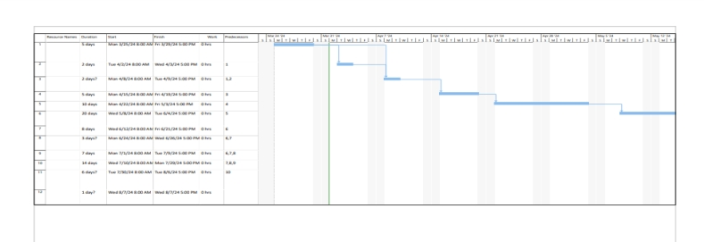

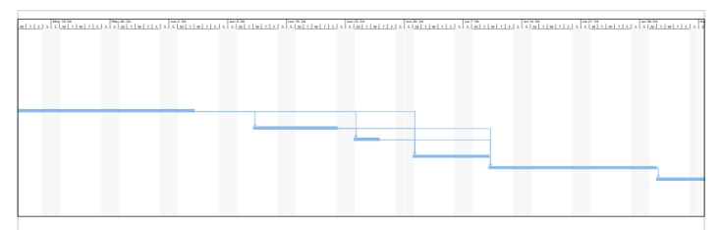

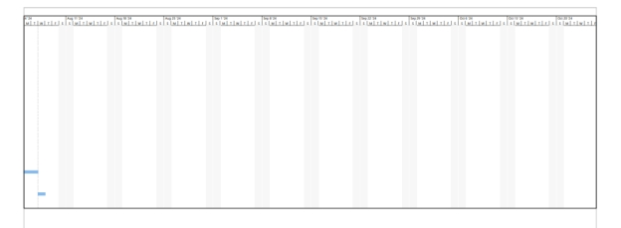

**NETWORK DIAGRAM**

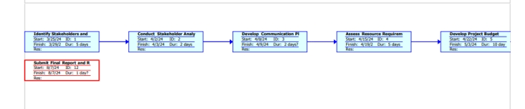

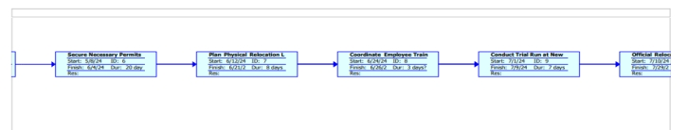

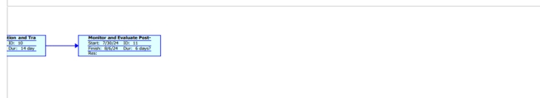

**REVIEW OF RELEVANT LITERATURES AND CASE STUDY**

**Stakeholder Management in Project Management:** This topic is relevant to the research as it provides insights into the importance of effectively managing stakeholders in a project, especially in a complex project (Nguyen, et al., 2018) scenario like the relocation of FAWAZ Plastic Enterprises. Understanding stakeholder needs, expectations, and concerns is crucial for the success of the project.

**Risk Management in Project Management:** This topic is important as it explores the potential challenges and risks associated with the relocation process. By identifying and mitigating risks proactively, the project team can ensure a smooth transition and minimize any negative impacts on the project (Ahmed, 2017).

**Change Management in Organizational Relocation:** Change management is essential in the context of organizational relocation, as it involves transitioning employees, processes, and operations to a new location. Understanding how to effectively manage change and ensure a smooth transition is key to the success (Kumarasinghe & Dilan, 2021) of the relocation project.

**Communication Strategies in Project Management:** Effective communication is vital in stakeholder management and ensuring all parties are informed and engaged (Zwikael, et al,. 2022) throughout the relocation process. By implementing clear communication strategies, the project team can build trust, address concerns, and foster positive relationships with stakeholders.

**Cultural Considerations in Organizational Relocation:** Understanding the cultural differences between the current location in Jos and the new location in Ilorin is crucial for the success of the relocation project. This literature can provide insights into how to navigate cultural challenges, ensure cultural integration, and promote a harmonious transition for employees and stakeholders.

**8.0 RESEARCH QUESTIONS**

1. What are the expectations and concerns of different stakeholders regarding the relocation?
2. What are the best practices for managing stakeholders in a complex relocation project?

This Project Initiation Document provides an overview of the analysis and management of stakeholders in the relocation of FAWAZ Plastic Enterprises from Jos to Ilorin. The document outlines the project background, scope, resources, assumptions, constraints, dependencies, stakeholder analysis, communication plan, project plan, and research questions.

**REFERENCES**

Ahmed, R. (2017). Risk Mitigation Strategies in Innovative Projects. 10.5772/intechopen.69004.

Butt, A., Naaranoja, M. & Savolainen, J. (2016). Project change stakeholder communication. International Journal of Project Management. 34. 1579-1595. 10.1016/j.ijproman.2016.08.010.

Kumarasinghe, H.P. N. & Dilan, H. (2021). Organizational Change and Change Management.

Nguyen, T. S., Mohamed, S. & Panuwatwanich, K. (2018). Stakeholder Management in Complex Project: Review of Contemporary Literature. Journal of Engineering, Project, and Production Management. 8. 10.32738/JEPPM.201807.0003.

Ogunro, V. (2014). Nigeria’s Business Environment: Issues Challenges and Prospects. International Journal of Academic Research in Business and Social Sciences. 4. 10.6007/IJARBSS/v4-i4/770.

Riahi, Y. (2017). Project stakeholders:Analysis and Management Processes. International Journal of Economics and Management Studies. 4. 39-45. 10.14445/23939125/IJEMS-V4I3P108.

Zwikael, O., Salmona, M., Meredith, J. & Zarghami, A. (2022). Enhancing Project Stakeholder Communication under Insufficient Knowledge of Project Management Concepts. Engineering Construction & Architectural Management. 10.1108/ECAM-02-2022-0154.