**PROJECT INITIATION DOCUMENT**

**(Stakeholders Analysis and Management Procedures for Project; Expansion of Olak Beverages LTD)**

**Client Company : OLAK BEVERAGES LTD**

**Final Word Count :**

**Turnitin Score % :**

Table of Contents

List of Tables and Figures

1.0 **PROJECT INTRODUCTION & BACKGROUND**

Expanding the operations of Olak Beverages Limited will involve various stakeholders who have a vested interest in the success of the project. According to (Dwivedi, 2021), stakeholders are individuals or groups who can affect or be affected by the project, and their involvement and support are crucial for the successful implementation of the expansion project.

Stakeholder analysis is a process of identifying and assessing the interests, influence, and potential impact of stakeholders on the project. It helps in understanding the needs and expectations of stakeholders, as well as developing strategies to engage and manage their involvement throughout the project lifecycle (Olander & Landin, 2005).

Managing stakeholders effectively involves identifying, concerns, and expectations, as well as developing communication and engagement strategies (Pandi-Perumal, et al., 2015) to address their needs. This may include regular updates, stakeholder meetings, feedback sessions, and involvement in decision-making processes.

By conducting a thorough stakeholder analysis and developing a robust stakeholder management plan, Olak Beverages Limited can build strong relationships with key stakeholders, align their interests with the project objectives, and ensure their support throughout the expansion project. This proactive approach to stakeholder engagement can help mitigate risks, resolve conflicts, and enhance project outcomes, ultimately leading to the successful expansion of Olak Beverages' operations.

1.1 **Problem Statement**

Olak Beverages Limited is currently facing challenges in meeting the growing demand for its products due to limited production capacity and inefficient distribution channels. The company's existing production facilities are operating at full capacity, leading to bottlenecks in the production process and delays in fulfilling orders. Additionally, the distribution channels currently in place are not optimized to reach new markets effectively, limiting the company's ability to capitalize on emerging opportunities.

The reason for expansion for Olak Beverages Limited can be attributed to two main factors: the existing market is small and saturated, and there is a need to tap into new markets to sustain growth and maintain a competitive edge in the beverage industry.

**Existing Market is Small and Saturated**

The current market where Olak Beverages Limited operates is relatively small and saturated, with limited room for further growth. The company has already captured a significant market share in its existing market segment, but further expansion within this market may be limited by factors such as market saturation, intense competition, and changing consumer preferences. In order to continue growing and increasing revenue, Olak Beverages Limited needs to explore new market opportunities outside its current market boundaries.

**Need to Tap into New Markets**

Expanding into new markets presents an opportunity for Olak Beverages Limited to diversify its product offerings, reach a broader customer base, and increase its market share. By entering new markets, the company can leverage its brand reputation, product quality, and existing distribution network to introduce its products to new consumers (Seppi, 2021) and establish a presence in untapped regions. This strategic expansion will not only drive revenue growth but also position the company for long-term success (Farida, & Setiawan, 2022) by reducing dependency on a single market and mitigating risks associated with market fluctuations.

Therefore, the need for expansion at Olak Beverages Limited is driven by the challenges of limited production capacity and inefficient distribution channels in the existing market, as well as the opportunities presented by tapping into new markets to sustain growth and maintain a competitive edge in the beverage industry. Expanding into new markets will enable the company to capitalize on emerging opportunities, diversify its revenue streams, and strengthen its position in the market.

**CLIENT INTRODUCTION**

Olak Beverages Limited, the client for the expansion project, is a well-established beverage company with a strong presence in the Nigerian market. The company is known for its high-quality drinks and has built a loyal customer base over the years. Headquartered in Oyo, with a branch in Ilorin, Olak Beverages Limited operates in multiple locations across Nigeria, serving a diverse customer base.

The company's management team, led by Manager Olawale Ridwan Ololade, is dedicated to driving growth and innovation in the business. With a focus on quality, customer satisfaction, and market expansion, the management team has identified the expansion project as a key strategic initiative to capitalize on market opportunities and maintain the company's competitive edge.

The decision to expand the company's operations reflects Olak Beverages Limited's commitment to meeting the growing demand for its products, improving operational efficiency, and exploring new market opportunities. By investing in the expansion project, the company aims to strengthen its market presence, increase production capacity, and enhance its distribution channels to reach a wider audience.

**PROJECT SCOPE AND EXCLUSIONS**

**Scope**

|  |  |  |  |  |  |
| --- | --- | --- | --- | --- | --- |
|  | **SMART OBJECTIVES** | | | | |
| **SCOPE** | **Specific** | **Measurable** | **Achievable** | **Relevant** | **Time-bound** |
| Increasing production capacity by upgrading existing facilities and investing in new equipment | Upgrade bottling line to increase production capacity by 30% | Measure the increase in production output through daily production reports and compare it to the previous capacity | Invest in new equipment and conduct facility upgrades within the allocated budget and timeframe | Increasing production capacity aligns with the company's goal of meeting growing demand and expanding market presence | In 6 weeks, Period of Project |
| Improving distribution channels to reach new markets and increase market share | Expand distribution network to penetrate three new regional markets | Track the increase in sales volume in the newly entered markets compared to baseline sales data | Develop partnerships with distributors in target regions and establish efficient logistics systems | Expanding distribution channels supports the company's objective of increasing market share and reaching untapped markets | In 5 weeks, Period of Project |
| Conducting market research to identify opportunities for product diversification and expansion | Conduct comprehensive market research to identify at least three potential product diversification opportunities | Evaluate the feasibility and market demand for each identified opportunity through consumer surveys and competitor analysis | Allocate resources for market research activities and engage with external agencies if necessary | Identifying new product opportunities aligns with the company's strategy for growth and innovation | In 2 Weeks, Period of Project |
| Developing a stakeholder engagement and management plan | Create a stakeholder engagement plan outlining key stakeholder, communication strategies, and engagement activities | Monitor stakeholder feedback and participation in engagement activities through surveys and feedback forms | Allocate dedicated resources for stakeholder engagement and establish communication channels | Effective stakeholder management is crucial for project success and maintaining positive relationships with all stakeholders | In 2 Weeks, Period of Project |
| Implementing new marketing strategies to promote expanded product offerings | Launch integrated marketing campaigns to promote new product offerings across multiple channels | Track sales performance and customer feedback following the launch of marketing campaigns | Develop creative marketing materials and allocate budget for advertising and promotions | Effective marketing strategies are essential for creating awareness and driving sales of new products | In 6 weeks, Period of Project |
| Enhancing supply chain management to ensure efficient production and distribution processes | Optimize supply chain processes to reduce lead times by 20% within six months | Monitor and analyze key performance indicators such as inventory turnover and order fulfillment time | Implement software solutions for supply chain optimization and streamline procurement processes | Improving supply chain efficiency directly impacts production and distribution processes, leading to cost savings and enhanced customer satisfaction | In 12 weeks, Period of project |
| Training and development programs for employees to support the expansion and growth of the company | Implement a training program covering technical skills and customer service for all production and sales staff within four months | Assess employee performance and skill development through regular evaluations and feedback sessions | Develop training modules and allocate resources for conducting training sessions | Investing in employee development ensures a skilled workforce capable of supporting company growth and maintaining quality standards | In one week |

**Exclusions**

1. Detailed market research and analysis (this will be covered in a separate market research plan)
2. Environmental impact assessment (this will be conducted by an external environmental consultant)
3. Human resources planning and recruitment (this will be managed by the HR department)
4. Technology infrastructure upgrades (this will be overseen by the IT department)
5. Supply chain optimization and logistics planning (this will be handled by the logistics team)
6. Detailed financial analysis and budgeting (this will be covered in a separate financial plan)
7. Legal and regulatory compliance issues (this will be handled by the company's legal team)

4.0 **PROJECT RESOURCES AND REQUIREMENTS**

To ensure the successful completion of the Olak Beverages LTD expansion project, essential project requirements encompass people, processes, technical resources, and data.

|  |  |  |  |  |
| --- | --- | --- | --- | --- |
| **Category** | **Requirements** | **Resources Required** | **Data Needed** | **Processes to Follow** |
| **People** | Project Manager | Experienced in project management | NIL | Leadership and coordination |
|  | Cross-functional Project Team | Members from different departments | NIL | Collaboration and diverse expertise |
|  | Technical Resources | Skilled labor for facility upgrades | NIL | Execution of technical aspects |
| **Process** | Stakeholder Analysis and Management | Stakeholder engagement tools and software | Stakeholder data | Identification, communication, and engagement |
|  | Budget Management | Budget for equipment purchase and upgrades | Financial data | Allocation, monitoring, and control |
|  | Project Management Methodology | NIL | NIL | Structured project management framework |
| **Technical Resources** | Budget for Equipment Purchase and Facility Upgrades | Funding for equipment and upgrades | Market research data | Procurement and facility enhancement |
|  | Market Research Resources | Access to market research data and tools | Market research data | Informed decision-making and strategic planning |
|  | Stakeholder Engagement Tools and Software | Software for stakeholder communication | Stakeholder data | Communication and relationship management |
| **Data** | Market Research Data | NIL | Market research data | Market trends, consumer preferences |
|  | Financial Data | NIL | Financial data | Budgeting, forecasting, and financial analysis |
|  | Project Progress Data | NIL | Project progress data | Monitoring and performance evaluation |

Adhering to these project requirements ensures a structured approach towards accomplishing the expansion goals of Olak Beverages LTD while effectively managing resources and stakeholders throughout the project lifecycle.

**KEY ASSUMPTIONS, CONSTRAINTS, AND DEPENDENCIES**

Assumptions:

1. Stakeholders are supportive of the expansion project
2. Sufficient budget and resources are allocated for the project
3. Market conditions remain favorable for the beverage industry

Constraints:

1. Time constraints for project completion
2. Limited availability of skilled labor for facility upgrades

Dependencies:

1. Market research findings will inform product diversification and market entry strategies
2. Stakeholder engagement will influence project success

**STAKEHOLDER ANALYSIS & COMMUNICATION PLAN**

Stakeholder Analysis

|  |  |  |  |  |  |  |  |
| --- | --- | --- | --- | --- | --- | --- | --- |
| S/n | Stakeholder | Relevancy | Position | Interest | Power | Probability of Behavior | Action to Manage Stakeholder |
| 1 | Company Management | High | Decision-makers | High | High | Low | Regular updates, clear communication on project progress |
| 2 | Employees | Medium | Operational staff | Medium | Low | Medium | Engagement sessions, training on new processes |
| 3 | Suppliers | Medium | External vendors | Medium | Medium | Low | Contract negotiation, performance monitoring |
| 4 | Distributors | Medium | External partners | Medium | Medium | Low | Training on new products, incentives for sales |
| 5 | Customers | High | End-users | High | Low | Medium | Market research, feedback collection, product launch events |
| 6 | Regulatory Authorities | High | Government bodies | High | High | Low | Compliance with regulations, regular reporting |
| 7 | Local Communities | Medium | Community members | Medium | Low | Low | Community engagement, corporate social responsibility initiatives |
| 8 | Project Manager | High | Project Management and Coordination | High | High | Medium | Regular updates, clear communication on project progress |

This stakeholder analysis identifies key stakeholders for the expansion project at Olak Beverages Limited, assessing their relevancy, position, interest, power, and probability of behavior. Effective management of these stakeholders through communication, engagement, and tailored strategies will be crucial for the success of the project.

**Stakeholders Matrix**

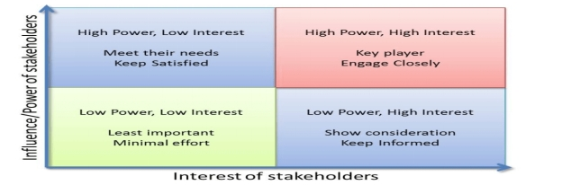

**Communication Plan**

|  |  |  |  |  |  |  |
| --- | --- | --- | --- | --- | --- | --- |
| **Stakeholders** | **Interest** | **Influence** | **What to communicate** | **Medium of Communication** | **Timeliness** | **Who is accountable?** |
| Company Management | High | High | Project progress, budget updates, key decisions | Meetings, Reports | Weekly Report | Project Manager |
| . Employees | High | Medium | Impact on roles and responsibilities, training opportunities | Meetings, Emails | Bi-weekly | HR Manager/Project Manager |
| Suppliers | Medium | | Low | Changes in demand, new requirements | Emails, Phone calls | As needed | Procurement Manager |
| Distributors | High | Medium | Changes in distribution channels, new products | Meetings, Newsletters | As needed | Sales Manager |
| Customers | High | High | Product availability, new offerings, promotions | Social media, Website, Email campaigns | As needed | Marketing Manager |
| Regulatory Authorities | High | High | Compliance updates, regulatory changes | Official letters, Meetings | As needed | Legal Counsel |
| Local Communities | Medium | Low | Environmental impact, community engagement initiatives | Community meetings, Newsletters | Monthly | Corporate Social Responsibility Manager |

This communication plan outlines the key stakeholders, their interests, influence, what needs to be communicated (Stephens, et al., 2005), the medium of communication, timeliness, and the accountable person for each stakeholder group. Regular and effective communication with stakeholders will be essential for the success of the expansion project at Olak Beverages Limited.

**PROJECT PLAN**

|  |  |  |  |  |  |
| --- | --- | --- | --- | --- | --- |
| **S/N** | **Task** | **Defining Task** | **Start Date** | **End Date** | **Who is Responsible** |
| 1 | Project Initiation | Document project scope, objectives, and key stakeholders | 3/11/2024 | 3/14/2024 | Project Manager |
| 2 | Market Research | Conduct market research to identify opportunities for product diversification and expansion | 3/18/2024 | 3/28/2024 | Market Research Team |
| 3 | Stakeholder Analysis | Identify key stakeholders, their interests, and communication preferences | 4/1/2024 | 4/5/2024 | Project Manager |
| 4 | Facility Upgrades | Upgrade existing production facilities and invest in new equipment | 4/9/2024 | 5/10/2024 | Engineering Team |
| 5 | Distribution Channel Improvement | Improve distribution channels to reach new markets and increase market share | 4/15/2024 | 4/29/2024 | Sales and Marketing Team |
| 6 | Product Diversification | Develop new product lines based on market research findings | 4/23/2024 | 5/6/2024 | Product Development Team |
| 7 | Stakeholder Engagement | Engage with stakeholders through regular updates, feedback sessions, and communication | 3/11/2024 | 6/3/2024 | Project Manager |
| 8 | Project Evaluation | Assess project outcomes, stakeholder satisfaction, and lessons learned | 5/15/2024 | 6/4/2024 | Project Team |

Gannt Chart

Visual representation of project tasks, timelines, and dependencies

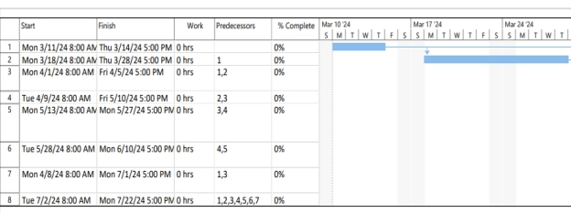

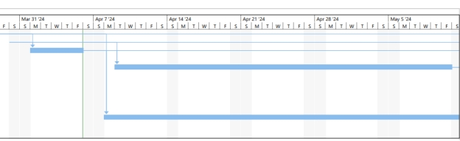

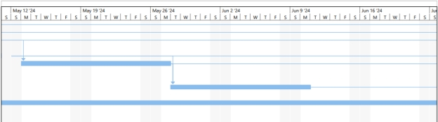

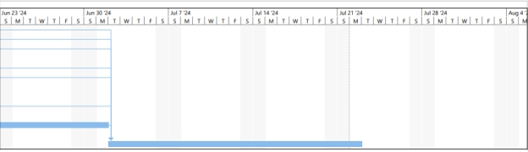

**Network Diagram**

Detailed project schedule with critical path analysis

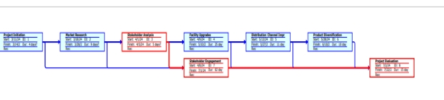

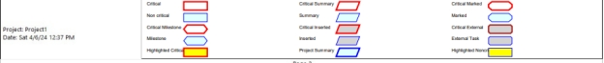

**LITERATURE REVIEW AND CASE STUDIES**

In the realm of project management, stakeholders' analysis and effective management procedures are crucial for the success of any project (Riahi, 2017), particularly in the context of initiating phases. This literature review aims to explore relevant research, both theoretical and practical, pertinent to Olak Beverages LTD's expansion project.

Understanding the current research landscape concerning stakeholder analysis and management within the beverage industry is imperative. Studies such as those by Derakhshanalavijeh, et al., (2019) offer theoretical frameworks for stakeholder identification, analysis, and engagement. Additionally, practical case studies like the expansion projects of Coca-Cola or PepsiCo would provide valuable insights into real-world applications and challenges faced in similar contexts.

Also, this research will critically evaluate existing project management theories, such as the Project Management Body of Knowledge (PMBOK) framework, and their applicability to Olak Beverages LTD's project initiation phase. Moreover, it will examine practical case studies to identify best practices and potential pitfalls in stakeholder analysis and management.

**Research Question**

The research question guiding this review is twofold:

1. What stakeholder management procedures are essential for the successful initiation of Olak Beverages LTD's expansion project?
2. How can project management theory be effectively applied to address the unique challenges and opportunities within the beverage industry?

**CONCLUSION**

This Project Initiation Document provides an overview of the expansion project for Olak Beverages Limited, outlining the scope, key assumptions, constraints, and dependencies, as well as the stakeholder analysis and communication plan. The document serves as a foundation for project planning and execution, guiding the project team towards successful project delivery.

**REFERENCES**

Dwivedi, R. (2021). Role of Stakeholders in Project Success: Theoretical Background and Approach. International Journal of Finance, Insurance and Risk Management. 11. 10.35808/ijfirm/248.

Farida, I. & Setiawan, D. (2022). Business Strategies and Competitive Advantage: The Role of Performance and Innovation. Journal of Open Innovation: Technology, Market, and Complexity. 2022; 8(3):163. <https://doi.org/10.3390/joitmc8030163>

Olander, S. & Landin, A. (2005). Evaluation of stakeholder influence in the implementation of construction projects. International Journal of Project Management. 23. 321-328. 10.1016/j.ijproman.2005.02.002.

Pandi-Perumal, S. R., Akhter, S., Zizi, F., Jean-Louis, G., Ramasubramanian, C., Edward, F. R. & Narasimhan, M. (2015). Project Stakeholder Management in the Clinical Research Environment: How to Do it Right. Front Psychiatry. 2015 May 18;6:71. doi: 10.3389/fpsyt.2015.00071. PMID: 26042053; PMCID: PMC4434843.

Seppi, J. (2021). Small Business International Expansion: Geographic Diversification Strategy. 10.13140/RG.2.2.25077.50406.

Stephens, K., Malone, P. & Bailey, C. (2005). Communicating with Stakeholders During a Crisis. Journal of Business Communication - J Bus Comm. 42. 390-419. 10.1177/0021943605279057.