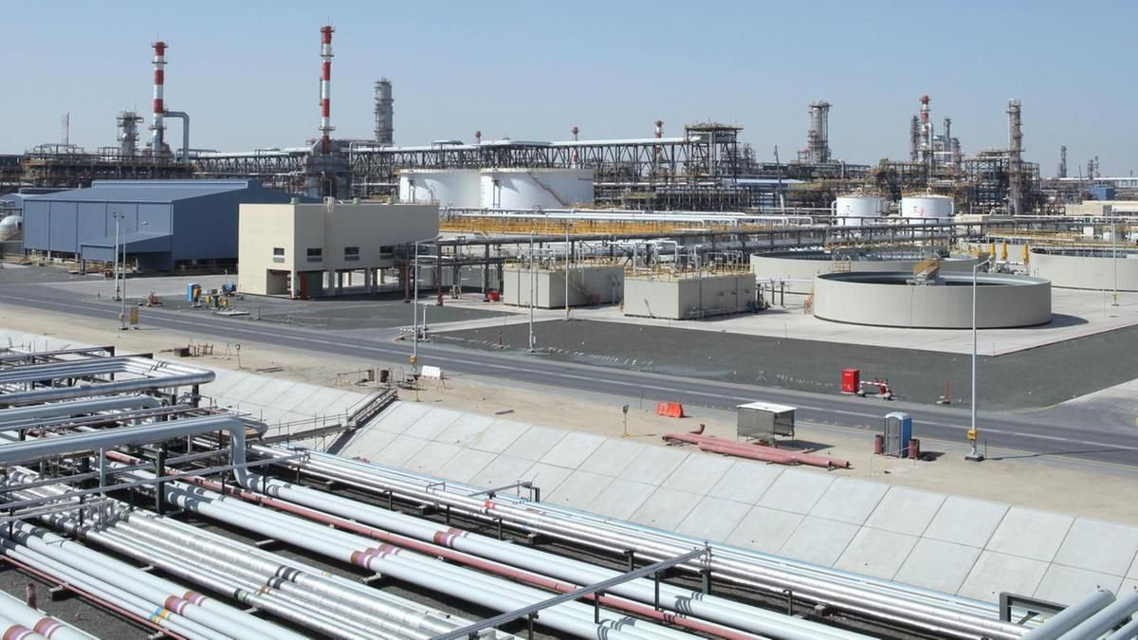

PURETECH SCIENTIFIC NIGERIA LIMITED business plan

**PURETECH SCIENTIFIC NIGERIA LIMITED**

**NO2, industrial avenue, Kano, Kano state Nigeria**

**+234801234567**

**+12345678**

**12/1/2019**

PURETECH SCIENTIFIC NIGERIA LIMITED

…………………………….providing high tech chemical product



**PURETECH SCIENTIFIC NIGERIA LIMITED (CHEMICAL PRODUCTION)**

**BUSINESS PLAN**

1. **EXECUTIVE SUMMARY**

Pure Tech Scientific Nigeria Limited is a registered chemical manufacturing company that will be located in Kano – Kano state Nigeria; in an ideal location highly suitable for the kind of manufacturing business we want to establish.

Pure Tech Scientific Nigeria Limited will be involved and specialize in the production of bio-chemicals from renewable resources and other organic and non – organic chemicals. We are set to service a wide range of client in and around Kano- Kano state and throughout Nigeria.

We are aware that there are several chemical manufacturing companies all around Nigeria, which is why we spent time and resources to conduct a thorough feasibility studies and market survey so as to be well positioned to favourably compete with our competitors.

Pure Tech Scientific Nigeria Limited, at all-time demonstrates her commitment to sustainability, both individually and as a firm, by actively participating in our communities and integrating sustainable business practices wherever possible. We will ensure that we hold ourselves accountable to the highest standards by meeting our customers’ needs precisely and completely whenever they patronize our products.

Pure Tech Scientific Nigeria Limited will ensure that all our customers are given first class treatment whenever they visit our factory. We have a Customer Relation Management (CRM) software that will enable us manage a one on one relationship with our customers (wholesale distributors) no matter how large they are. We will ensure that we get our customers involved when making some business decisions that will directly or indirectly affect them.

Pure Tech Scientific Nigeria Limited is a profit oriented business to be managed by team with many year experiences in chemical production and also they know how best to help towards the achievement our intended goals and objectives.

**1.2 OUR MISSION**

Our **mission** is to provide high-chemical products and top-notch services to our customers that add value to their businesses.

**1.3 OUR VISION**

Our vision is to establish a world – class chemical manufacturing company whose products will not only be retailed in Nigeria, but also be exported to other countries of the world.

**1.4 KEY TO SUCCESS**

The keys to success identified by our research team for our type of business include

* Good production location and safe disposal of waste product.
* The availability and safe facility of skilled labour.
* Abundant access to raw materials
* Competitive pricing and closeness to customers for our product

1. **OUR PRODUCT AND SERVICES**

PURETECH SCIENTIFIC NIGERIA LIMITED will deal with mass production of chemicals, this chemicals can be categorised in the following categories;

* Basic chemical: These include organic and inorganic chemicals, plastic resins, die and pigment. Plastic resins in particular have experienced significant growth as a replacement for tradition material in the automotive, construction and packaging end-use market.

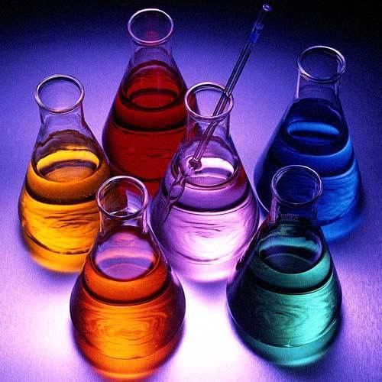 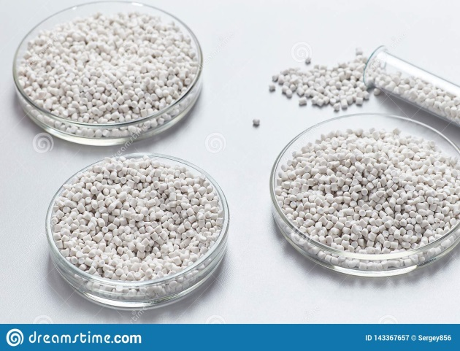

**BASIC CHEMICALS PLASTIC RESINS**

* Speciality chemical: these include adhesive sealants, water treatment chemicals, plastic additives, catalyst and coating. These chemicals are performance oriented and typically include customer/ technical servicing as an aspect of their sale.

 

**Water treatment chemicals**

* Agro chemicals: This play a crucial role in the farm economy and the food processing sector. Thanks to modern agriculture, farmers have doubled the production of food supply in Nigeria and if proper chemical are produced and supplied to them, they will also tripled the output of foods like cooking oils and meats, and increase per capital food supply in the country.

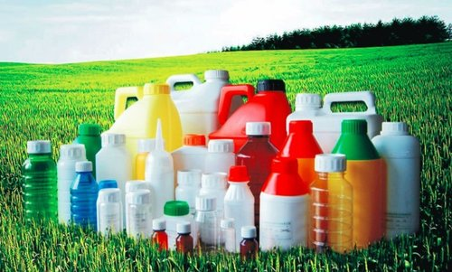 

**Agro chemicals**

* Pharmaceutical chemical: These include diagnostics, prescription drugs, vaccines, vitamin and over the counter drugs for human and veterinary application. This category also include biotechnology product.

 

**Pharmaceutical chemicals**

* Consumer chemical: These include soaps, detergents and cleaning agents as well as toiletries and cosmetics.

 

**Consumer chemicals**

1. **MARKET ANALYSIS SUMMARY**

If you are conversant with the trends in the Chemical Products Manufacturing industry, you will agree that the industry has benefited from improved industrial production activity over the last half a decade. Revenue from generic chemicals and related products has been falling due to product standardization, with increasing competition from low-cost, low-priced imports produced in China and elsewhere.

Economic recovery and increasing manufacturing activity have helped boost chemical sales. Operators have altered their current business procedures to correspond with new laws and profit margins are projected to remain tight due to volatile raw material costs.

On the other hand, the chemicals and similar products segment has been growing steadily and its sales are becoming more significant to the overall performance of the industry. Precision-turned products are high in demand in the pharmaceutical production industry, as well as agriculture, medical manufacturing and other applications.

In the coming years, the industry is expected to benefit from persistent demand for chemicals by downstream markets and from rising world chemical prices.

The chemical manufacturing landscape has seen tremendous changes in the last 20 years; it has grown from the smaller enterprise to a more organized and far reaching massive chemical manufacturing factories. This trend has benefited them in such a way that they can comfortably sell their chemical and related products nationally and also export them to other countries of the world.

**3.1 MARKET SEGMENTATION**

Our market is divided into three segments:

* **Industrial Products**: In this segment our customers include Customer B, Customer D and Distributor A.
* **Consumer Products**: Handled primarily through distributors.
* **Textile Products**: Customers are: Customer E, Customer C, Customer F and Customer G.

**3.2 TARGETED MARKET**

Perhaps it will be safe to submit that the chemical product manufacturing industry has the widest range of customers.

In view of that, we have positioned our chemical manufacturing company to service a wide range of clientele in and all around Kano, Kano state and every other location where we intend distributing our products. We have conducted our market research and feasibility studies and we have ideas of what our target market would be expecting from us.

We are in business to manufacture a wide range of chemicals and related products for the following clients;

* Paint manufacturing companies
* Pesticide manufacturing companies
* Pharmaceutical manufacturing companies
* Celluloid and film production companies
* Inorganic fertilizer manufacturing companies
* Cosmetics and beauty care manufacturing companies

**3.3 OUR COMPETITIVE ADVANTAGE**

A close study of the chemical product manufacturing industry reveals that the market has become much more intensely competitive over the last decade. As a matter of fact, you have to be highly creative, customer centric and proactive if you must survive in this industry. We are aware of the competition and we are prepared to compete favorably with other leading chemical manufacturing companies in Kano, Kano state and throughout Nigeria.

Our chemical manufacturing company is located in an ideal property highly suitable for the kind of manufacturing company that we want to run. We have enough parking space that can accommodate well over 30 cars / trucks per time.

Part of our competitive advantages are our ability to expand and curtail operations rapidly in line with market demand, concentration on core business and of course our optimum capacity utilization.

One thing is certain; we will ensure that we manufacture a wide range of chemicals to meet international standards. One of our business goals is to make PURETECH SCIENTIFIC NIGERIA LIMITED a one stop chemical manufacturing company for both cottage companies and large corporations. Our excellent customer service culture, online store, various payment options and highly secured facility will serve as a competitive advantage for us.

Lastly, our employees will be well taken care of, and their welfare package will be among the best within our category in the industry meaning that they will be more than willing to build the business with us and help deliver our set goals and achieve all our aims and objectives.

1. **STRATEGY AND IMPLEMENTATION SUMMARY**

We are quite aware that the reason why chemical production company hardly make good profits is their inability to sell off their as at when produced. In view of that, we decided to set up a standard supply chain to help us maximize profits. Over and above, we have perfected our sale and marketing strategies first by networking with distributing merchants and companies that rely on chemicals as their major raw material. In all, PURETECH SCIENTIFIC NIGERIA has developed the following strategies in marketing our chemical product:

* The segment of the markets planned to reach.
* Distribution channels planned to be used to reach market segments: television, radio, sales associates, and mail order.
* Share of the market expected to capture over a fixed period of time.

All of this has been analysed through an analysis of our Strength Weakness Opportunity and Threat.

1. **SWOT ANALYSIS**

PURETECH SCIENTIFIC NIGERIA LIMITED is in business to become one of the leading chemical manufacturing companies in the whole of Kano, Kano state and we are fully aware that it will take the right business concept, management and organizational structure to achieve our goal.

We are quite aware that there are several chemical manufacturing companies all over Nigeria and even in the same location where we intend locating ours, which is why we are following the due process of establishing a business.

We know that if a proper SWOT analysis is conducted for our business, we will be able to position our business to maximize our strength, leverage on the opportunities that will be available to us, mitigate our risks and be equipped to confront our threats.

PURETECH SCIENTIFIC NIGERIA LIMITED employed the services of an expert HR and Business Analyst with bias in manufacturing to help us conduct a thorough SWOT analysis and to help us create a business model that will help us achieve our business goals and objectives.

This is the summary of the SWOT analysis that was conducted for PURETECH SCIENTIFIC NIGERIA LIMITED;

* **Strength:**

Our core strength lies in the quality of our products, the power of our team and the state of the art chemical manufacturing plant that we intend to own. We have a team of experienced staff members that can go all the way to produce durable products. We are well positioned in the heart of Kano, Kano state and we know we will attract loads of clients from the first day we open our chemical manufacturing company for business.

* **Weakness:**

A major weakness that may count against us is the fact that we are a new chemical manufacturing company and we don’t have the financial capacity to compete with multi – million naira chemical manufacturing companies in Nigeria and most especially from China when it comes to manufacturing chemicals and related products at rock bottom prices. So also, we may not have enough cash reserve to promote our chemical manufacturing company the way we would want to do.

* **Opportunities:**

The fact that we are going to be operating our chemical manufacturing company in Kano, Kano state provides us with unlimited opportunities to sell our products to a large number of companies. We have been able to conduct thorough feasibility studies and market survey and we know what our potential clients will be looking for when they visit our chemical manufacturing plant; we are well positioned to take on the opportunities that will come our way.

* **Threat:**

Just like any other business, one of the major threats that we are likely going to face is economic downturn. Another threat that may likely confront us is the arrival of a new chemical manufacturing company in same location where ours is located. So also, unfavourable government policies may also pose a threat for businesses such as ours.

1. **MARKETING AND SALES STRATEGY**

Before choosing a location for PURETECH SCIENTIFIC NIGERIA LIMITED, we conducted a thorough market survey and feasibility studies in order for us to be able to penetrate the available market and become the preferred choice for stakeholders in and around Kano, Kano state. We have detailed information and data that we were able to utilize to structure our business to attract the number of customers we want to attract per time.

We hired experts who have good understanding of the chemical manufacturing industry to help us develop marketing strategies that will help us achieve our business goal of winning a larger percentage of the available market in Kano state and throughout Nigeria.

In summary, PURETECH SCIENTIFIC NIGERIA LIMITED will adopt the following sales and marketing approach to win customers over;

* Introduce our chemical manufacturing company by sending introductory letters alongside our brochure to key stake holders in and around Kano, Kano state.
* Ensure that we manufacture a wide range of chemicals and related products
* Make use of attractive hand bills to create awareness and also to give direction to our plant
* Position our signage / flexi banners at strategic places around Kano, Kano state
* Create a loyalty plan that will enable us reward our regular customers
* List our business and products on yellow pages ads (local directories)
* Leverage on the internet to promote our business
* Engage in direct marketing and sales
* Encourage the use of word of mouth marketing (referrals)
* Join local chambers of commerce and industries with the aim of networking and marketing our products.

#### 6.1 PUBLICITY AND ADVERTISING STRATEGY

Despite the fact that our chemical manufacturing company is well located, we will still go ahead to intensify publicity for the business. We are going to explore all available means to promote our chemical manufacturing company.

PURETECH SCIENTIFIC NIGERIA LIMITED has a long – term plan of opening retail outlets in various locations all around Kano, Kano state and key cities in Nigeria which is why we will deliberately build our brand to be well accepted in Kano state before venturing out.

As a matter of fact, our publicity and advertising strategy is not solely for winning customers over but to effectively communicate our brand. Here are the platforms we intend leveraging on to promote and advertise Puretech product;

* Place adverts on community based newspapers, radio and TV stations.
* Encourage the use of word of mouth publicity from our loyal customers
* Leverage on the internet and social media platforms like YouTube, Instagram, Facebook, Twitter, LinkedIn, Snapchat, Google+ and other platforms to promote our business.
* Ensure that we position our banners and billboards in strategic positions all around Kano, Kano state.
* Distribute our fliers and handbills in target areas in and around our neighbourhood
* Advertise our chemical manufacturing company in our official website and employ strategies that will help us pull traffic to the site
* Brand all our official cars and trucks and ensure that all our staff members and management staff wears our branded shirt or cap at regular intervals.

**6.2 OUR PRICING STRATEGY**

We are aware of the pricing trend in the chemical product manufacturing industry which is why we have decided to produce various sizes of containers used in packaging the chemicals.

Our prices will conform to what is obtainable in the industry but we will ensure that within the first 6 to 12 months our products are sold a little bit below the average industrial price. We have put in place business strategies that will help us run on low profits for a period of 6 months; it is a way of encouraging people to buy into our chemical manufacturing brand.

**6.3 PAYMENT OPTIONS**

The payment policy adopted by PURETECH SCIENTIFIC NIGERIA LIMITED is all inclusive because we are quite aware that different customers prefer different payment options as it suits them but at the same time, we will ensure that we abide by the financial rules and regulation of Nigeria.

Here are the payment options that we will make available to her clients;

* Payment via bank transfer
* Payment with cash
* Payment via credit cards / Point of Sale Machines (POS Machines)
* Payment via online bank transfer
* Payment via check
* Payment via mobile money transfer
* Payment via bank draft

In view of the above, we have chosen banking platforms that will enable our client make payment for the purchase of our products without any stress on their part. Our bank account numbers will be made available on our website and promotional materials.

1. **MANAGEMENT SUMMARY**

PURETECH SCIENTIFIC NIGERIA LIMITED do not intend to start a chemical manufacturing business like the usual cottage business; our intention of starting a chemical manufacturing company is to build a standard business whose products will be exported to other countries of the world. We will ensure that we put the right management structures in place that will support the kind of growth that we have in mind while setting up the business.

We will ensure that we hire people that are qualified, honest, customer centric and are ready to work to help us build a prosperous business that will benefit all the stake holders. As a matter of fact, profit-sharing arrangement will be made available to all our senior management staff and it will be based on their performance for a period of ten years or more.

In view of that, we have decided to hire qualified and competent hands to occupy the following positions;

* Chief Executive Officer (Owner)
* Plant Manager
* Quality Control Officer
* Human Resources and Amin Manager
* Sales and Marketing Manager
* Machine Operator
* Accountants/Cashiers
* Customer Services Executive / Front Desk Officer

Roles and Responsibilities

Chief Executive Officer – CEO:

* Increases management’s effectiveness by recruiting, selecting, orienting, training, coaching, counseling, and disciplining managers; communicating values, strategies, and objectives; assigning accountabilities; planning, monitoring, and appraising job results; developing incentives; developing a climate for offering information and opinions.
* Creates, interconnects, and implements the organization’s vision, mission, and overall direction – i.e. leading the development and implementation of the overall organization’s strategy.
* Responsible for fixing prices and signing business deals
* Responsible for providing direction for the business
* Responsible for signing checks and documents on behalf of the company
* Evaluates the success of the organization

Admin and HR Manager

* Responsible for overseeing the smooth running of HR and administrative tasks for the organization
* Maintains office supplies by checking stocks; placing and expediting orders; evaluating new products.
* Ensures operation of equipment by completing preventive maintenance requirements; calling for repairs.
* Defines job positions for recruitment and managing interviewing process
* Carries out induction for new team members
* Responsible for training, evaluation and assessment of employees
* Responsible for arranging travel, meetings and appointments
* Oversees the smooth running of the daily office activities.

Plant Manager:

* Responsible for overseeing the smooth running of the chemical manufacturing plant
* Part of the team that determines the quantity of resins, photographic films, papers and plates, evaporated salt, gelatin, water-treating compounds, automotive chemicals and other organic and non – organic chemicals et al that are to be produced
* Maps out strategy that will lead to efficiency amongst workers in the plant
* Ensures that the steady flow of raw materials (chemicals) to the plants and easy flow of finished products through wholesale distributors to the market
* Ensures operation of equipment by completing preventive maintenance requirements; calling for repairs.
* Ensures that the factory meets the expected safety and health standard at all times.
* Interfaces with third – party suppliers (vendors) of raw materials (chemicals and packaging materials)
* Supervises the workforce in the factory.

Quality Control Officer

* Ensures that all the chemical that we manufacture in our production line meets the required quality before they are released in the market
* Makes certain that production and manufacturing lines perform efficiently and facilitate communications between management and production departments.
* Ensures that manufacturing production lines run smoothly and generate a consistently suitable output for their employers
* Ensures that the organization work in line with international best practices
* Handles any other responsibility as assigned by the plant manager

Sales and Marketing Manager

* Manages external research and coordinate all the internal sources of information to retain the organizations’ best customers and attract new ones
* Models demographic information and analyze the volumes of transactional data generated by customer purchases
* Identifies, prioritizes, and reaches out to new partners, and business opportunities et al
* Identifies development opportunities; follows up on development leads and contacts; participates in the structuring and financing of projects; assures the completion of development projects.
* Responsible for supervising implementation, advocate for the customer’s needs, and communicate with clients
* Develops, executes and evaluates new plans for expanding sales
* Documents all customer contact and information
* Represents the company in strategic meetings
* Helps to increase sales and growth for the company

Machine Operators

* Responsible for operating machines used in the manufacturing and packaging of chemicals and other organic and non – organic chemicals
* Assists in loading and unloading of chemicals and raw materials
* Handles any other duty as assigned by the plant manager or supervisor.

Accountant/Cashier:

* Responsible for preparing financial reports, budgets, and financial statements for the organization
* Provides managements with financial analyses, development budgets, and accounting reports; analyzes financial feasibility for the most complex proposed projects; conducts market research to forecast trends and business conditions.
* Responsible for financial forecasting and risks analysis.
* Performs cash management, general ledger accounting, and financial reporting
* Responsible for developing and managing financial systems and policies
* Responsible for administering payrolls
* Ensures compliance with taxation legislation
* Handles all financial transactions for the organization
* Serves as internal auditor for the organization

Client Service Executive/Front Desk Officer

* Welcomes guests and clients by greeting them in person or on the telephone; answering or directing inquiries.
* Ensures that all contacts with clients (e-mail, walk-In center, SMS or phone) provides the client with a personalized customer service experience of the highest level
* Through interaction with clients on the phone, uses every opportunity to build client’s interest in the company’s products and services
* Manages administrative duties assigned by the manager in an effective and timely manner
* Consistently stays abreast of any new information on the company’s products, promotional campaigns etc. to ensure accurate and helpful information is supplied to clients
* Receives parcels / documents for the company
* Distributes mails in the organization
* Handles any other duties as assigned by the line manager

**8.0 THE NEED FOR PURETECH SCIENTIFIC NIGERIA LIMITED**

Recently, the National Institute of Standards and Technology (NIST) reviewed the field of chemical measurement and identified a multitude of needs and challenges for future development (see this report on NIST's website at <http://www.nist.gov/cstl/hndocs/ChemMeasmain.html>). The NIST report recognized the "enabling" capability of chemical analysis for several applications. NIST developed a list of seven key application areas in need of chemical measurement improvements, which included process control and product development, but found the current state of technology to be less than optimal, stating that "real-time analytical measurements are not generally available, either on-line or off-line."

According to the report, the reason most real-world chemical measurements are conducted off-line is that many sophisticated methods of chemical analysis are not finding their way from the laboratory to research and development (R&D) and manufacturing facilities. This system needs to change, based on chemical manufacturers' desires for reduced costs, increase efficiency, increase speed to market and improved product quality. NIST expects the changes to be realized as "robust techniques for real-time, highly reliable analyses in practical environments." These new solutions will be sensors that respond quickly to change in complex manufacturing environments. Current methods, such as Gas Chromatography and Mass Spectrometry, are too slow to adapt to the above dynamic manufacturing trends (see Competition).

The NIST report further defined industry needs against a likely time frame. Short-term needs (less than 3 years) include a systems approach (integrated sampling, online detection, signal transmission, data handling, and maintenance), real-time compositional information for liquid phase streams, and increase speed of analysis, sensitivity, and selectivity. Medium and long-term needs include high reliability, a PC-based generic user interface, real-time trace analysis, and miniaturization. All of these needs are addressed by **PURETECH SCIENTIC NIGERIA LIMITED**.