OLAK-JUNI0R INVESTMENT NIG. LTD
BUSINESS FEASIBILITY REPORT
2/15/2020
DIRECTOR: OLAK-JUNIOR NIG. LTD

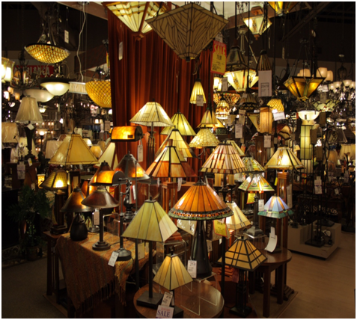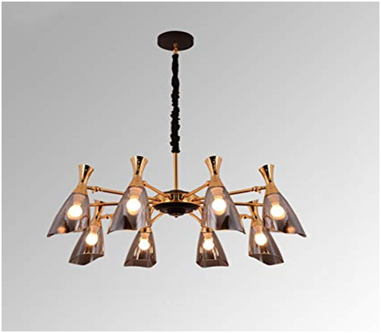
OLAK-JUNIOR INVESTMENT NIGERIA LIMITED
1.0 EXECUTIVE SUMMARY
Olak-Junior Investment Nigeria Limited is registered multi-venture Company that will be located in Oyo, Oyo State. Into importation and general supply of building materials, engineering and construction consultancy services that caters for mostly individual, corporate and commercial customers. We planned to lease a facility that is big enough (a 15 thousand square foot facility) to fit into the design of the kind of standard building materials supply warehouse and office that we intend launching and the facility will be located in a corner piece building, strategically sited to be the biggest building material store in Oyo town, Oyo state.
We will retail a wide range of building materials such as lumber and other structural building materials, hardware, tools, plumbing and electrical supplies, doors and windows etc. We are set to service a wide range of clientele within and outside Oyo, Oyo state.
We are aware that there are several building material supply stores (wholesales and retails) all around Oyo (our parent company inclusive), which is why we spent time and resources to conduct a thorough feasibility studies and market survey so as to be well positioned to favorably compete with all our competitors. We will have an online service option for our customers, and our outlet will be well secured with the various payment options.
Our company will ensure that all our customers are given first class treatment whenever they visit our building material store. We will have a Customer Relation Management software that will enable us manage a one on one relationship with our customers no matter how large they are. We will ensure that we get our customers involved in the selection of brands that will be on our store and also when making some business decisions.
At Olak-Junior Investment Nigeria Limited, we will, at all times demonstrate our commitment to sustainability, both individually and as a firm, by actively participating in our communities and integrating sustainable business practices wherever possible. We will ensure that we hold ourselves accountable to the highest standards by meeting our customers’ needs precisely and completely whenever they patronize our products.
Olak-Junior Investment Nigeria Limited is a profit oriented business (a subsidiary of Olak Investment Limited) that will be owned and managed by Mr Olawale Ridwan Ololade. Mr Olawale Ridwan Ololade has a B.Sc. in Accounting, with over 5 years’ experience in the building materials industry, working for some of the leading brands in Nigeria. Although the business will initially be launched with just one outlet in Oyo town, but there are plans to open other outlets all around major cities in Oyo state and beyond.
1.2 OUR MISSION
Our mission is to be the preferred wholesale and retail supplier of quality building materials at the leading edge of our industry and to provide superior, cost-effective services to our customers.
1.3 OUR VISION
Our vision is to become the leading brand in the building materials industry in Nigeria and to establish a one stop building materials supply store in major cities of Oyo state; Ibadan, Ogbomosho, Oke Ogun etc.
1.4 KEY TO SUCCESS
Olak-Junior Investment Nigeria Limited has identified several keys that will be instrumental in creating sustainable businesses. If these keys are followed, the likelihood of success will significantly increase. The following are the critical keys to becoming a successful supplier of building materials as stated in our mission and vision statement:
1. DELIVER EXCELLENT CUSTOMER SERVICE
Everyone appreciates quality customer service. our clients are no different, so we will do everything we can to provide our customers with a seamless experience that will potentially lead to repeat business or a positive recommendation.
Similar to what was mentioned earlier, we will maintain strong communication with clients and make our self available to answer their questions.
2. BUILD OUR BRAND
We will always build our brand to maintain a positive reputation. Fostering a strong brand for our business is important because it will reflect the quality of our company and shapes public perception. By implementing the right marketing ideas, we’ll continually grow our brand awareness based on the specific needs of our target market.
3. NETWORKING
Networking is a very beneficial part of growing our company. Access great networking opportunities by seeking our trade organization, that will provide us with opportunities to become certified, speak about our services, meet new client prospects and learn about the latest industry trends.
4. GENERATE NEW LEADS
As we all know, building materials supply opportunities don’t just appear out of nowhere. In addition to pursuing great networking opportunities, contractors should be constantly seeking out additional ways to generate leads.
One basic way involves building a website that makes it easy for our clients to contact us and request supply services. Try to include positive testimonials from existing clients and make our social media icons visible to help spread the word about our unique products and services.
In addition to traditional ways such as listing our business in local directories, billboards, and TV and radio ads, you might also want to check out online services and directories.
5. GET POSITIVE REVIEWS
These days, many clients turn to online reviews before choosing a supplier to work with. We will encourage our customers to go out and review us on Google and social media – basically anywhere we have a business presence. It’s beneficial to ask for a review immediately after helping a client resolve an issue. In the event someone leaves a negative review, we would respond. It may not change the reviewer’s mind, but our action shows the current reviewer and potential future clients that we care.
6. FOSTER A POSITIVE WORK CULTURE
Developing and retaining good employees is huge – and it all starts with a positive work culture.
- Safety: Show our crew members that we care about their safety by encouraging them to not cut corners.
- Leadership: Our employees want to be led, not managed to the extreme. Show confidence in their ability to make good decisions and focus on being a leader our workers want to follow.
- Teamwork: Without our people, supply wouldn’t get completed. We will express the value of working together and appreciating one another’s strengths.
- Training: Mentorship and training lead to increased productivity on the job site. They also show that we’re invested in our employees.
7. KEEP GOOD RECORDS
It’s important to implement proper filing systems and organization for our business. Keeping solid records is a must. Invoice our work, document inventory, keep track of employee hours, follow up on late payments and keep records of meetings as necessary.
8. PARTNER WITH MATERIAL MANAGEMENT PROFESSIONALS
In today’s business environment, successful companies like ours know that maximizing productivity and efficiency – all within tight deadlines – is key to a profitable job site. That’s why having access to quality material management professionals is important. According to the National Association Building Material Suppliers, up to 40 percent of a project’s labor cost can be consumed by material handling – and that’s just labor costs.

2.0 COMPANY SUMMARY
Olak-Junior Investment Nigeria Limited is a profit oriented company into the importation and supply (sales) of building materials and consultancy (construction) services company. The company will serve the need of both local and international customers seeking quality building materials and consultancy. Our company will be headquartered in Oyo with warehouse extensions in other cities to support our operations as we grow.

3.0 OUR PRODUCT OFFERING
Olak-Junior Investment Nigeria Limited is in building materials industry to service a wide range of clients and of course to make profits, which is why we will ensure we go all the way to make available a wide range of building materials from top manufacturing brands in Nigeria, United States and other countries of the world.
We will do all that is permitted by the law of Nigeria to achieve our aim and ambition of starting the business. Our product offerings are listed below;
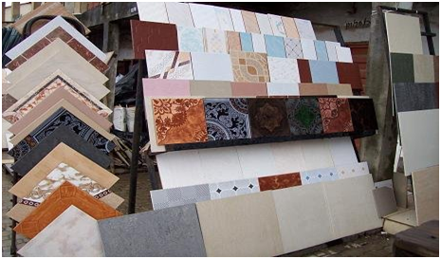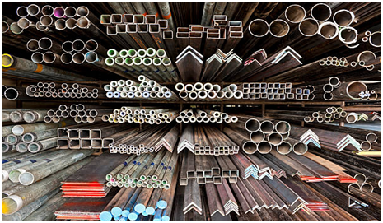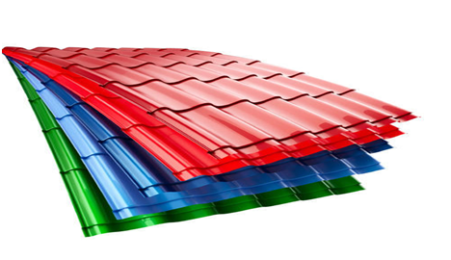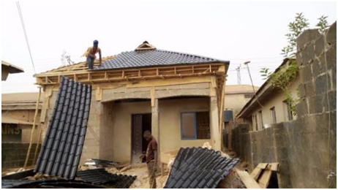Retailing building materials

Retailing doors and windows
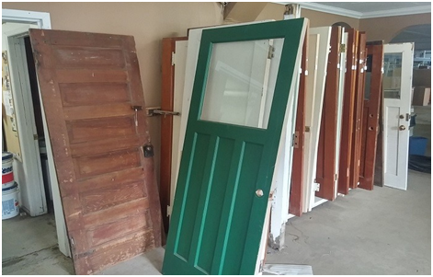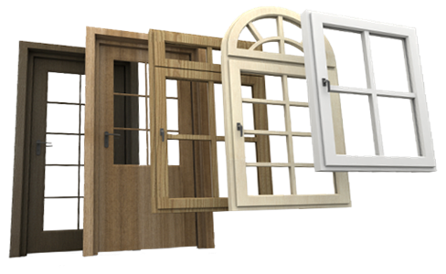

Retailing electrical supplies

Retailing fencing
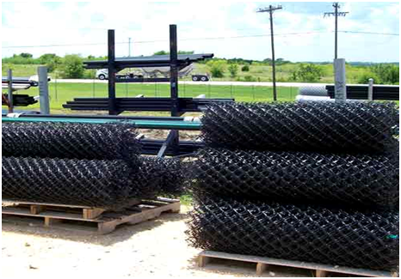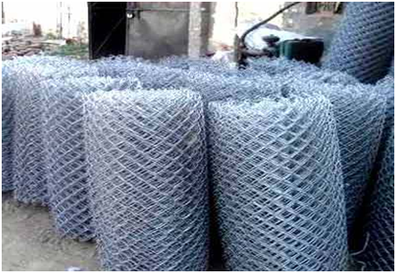

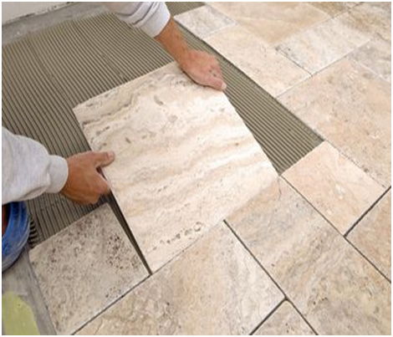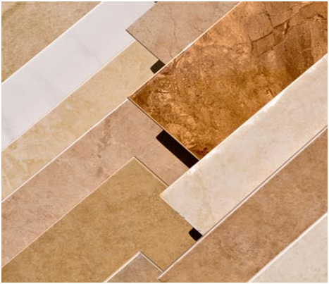Retailing floor coverings (tiles or ceramic only)

Retailing plumbing supplies
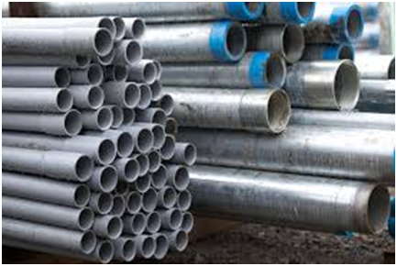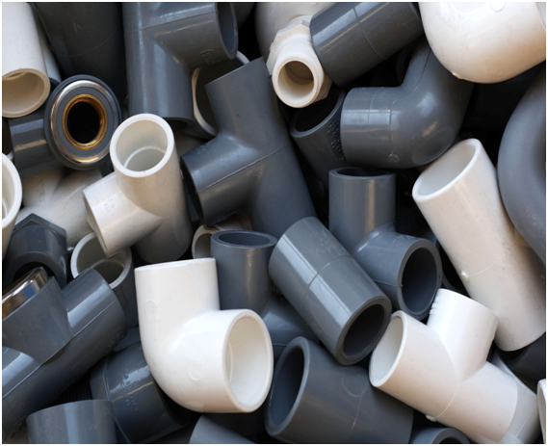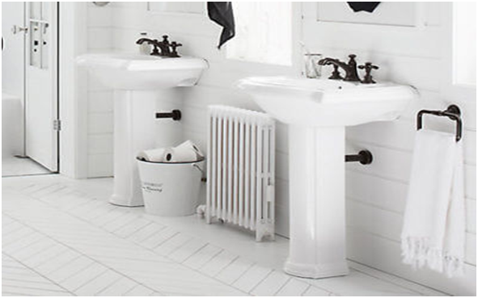

4.0 MARKET ANALYSIS SUMMARY
If you are conversant with the Building Materials Industry, you will quite agree that the changes in disposable income, consumer sentiment, ever changing trends and of course the rate of home ownership are major growth drivers for this industry.
No doubt, a massive rise in consumer confidence has also contributed in helping the industry experience remarkable growth, but uneven performance in these drivers has led to slightly constrained revenue growth.
So also, the rising demand for both building renovations, as a result of increasing disposable income and consumer sentiment will result in revenue growth, but profit margins will stagnate as building material supply stores keep prices low to attract more sales amid growing competition.
A close watch on industry activities reveals that, the retail market for building materials was hit hard by the economic downturn experienced in recent time. As part of marketing strategies, building material supply stores partner with key players in the construction and real estate industry. They are in the best position to offer you building material supply contract.
4.1 OUR TARGET MARKET
We have positioned our building material supply store to service the residents of Oyo, Oyo state and every other location where outlets of our building material supply stores will be located all over key cities in Oyo state.
We have conducted our market research and feasibility studies and we have ideas of what our target market would be expecting from us. We are in business to supply a wide range of building materials to the following;
- Construction Companies
- Plumbers
- Home Remodeling Companies
- Small Building Material Retail Stores
4.2 OUR COMPETITIVE ADVANTAGE
A close study of the building material stores industry reveals that the market has become much more intensely competitive over the last decade. As a matter of fact, we have to be highly creative, customer centric and proactive if we are to survive in this industry. We are aware of the stiff competition and we are well prepared to compete with other leading building material supply stores in Oyo state and throughout Nigeria.
We will launching a standard building material supply store that will indeed become the preferred choice for key players in the construction cum real estate industry. Our building material supply store will be located at a commercial center in Oyo town.
One thing is certain, we will ensure that we have a wide range of building materials available in our stores at all times. It will be difficult for customers to visit our store and not see the type of building materials that they are looking for.
One of our business goal is to make Olak-Junior Investment Nigeria Limited a one stop building material shop for customers at all levels. Our excellent customer service culture, online store, various payment options and highly secured facility will serve as a competitive advantage for us.
Lastly, our employees will be well taken care of, and their welfare package will be among the best within our category in the industry meaning that they will be more than willing to build the business with us and help deliver our set goals and achieve all our aims and objectives. We will also give good working conditions and commissions to freelance sales agents that we will recruit from time to time.
5.0 SWOT ANALYSIS
Our intention of opening just one outlet of our building materials store in Oyo, Oyo state is to test run the business for a period of 2 to 5 years to know if we will invest more money, expand the business and then open other outlets all over major cities in Oyo state and Nigeria.
We are quite aware that there are several building material supply stores all over state and even in the same location where we intend locating ours, which is why we are following the due process of establishing a business.
We know that if a proper SWOT analysis is conducted for our business, we will be able to position our business to maximize our strength, leverage on the opportunities that will be available to us, mitigate our risks and be welled equipped to confront our threats.
We employed the services of an expert HR and Business Analyst with bias in supply chain business to help us conduct a thorough SWOT analysis and to help us create a business model that will help us achieve our business goals and objectives. This is the summary of the SWOT analysis that was conducted for our company;
- Strength:
Our business is located in a city with heavy construction and real estate activities and also, we can boast of having good business relationship with top manufacturers in the building materials manufacturing industry.
- Weakness:
A major weakness that may count against us is the fact that we don’t have our own building material production plant, we are a new building material supply store and we don’t have the financial capacity to compete with multi – billion naira building materials supply stores when it comes to supplying building materials at a rock bottom prices.
- Opportunities:
The fact that we are going to be operating our building material supply store in one of the busiest building material markets in Oyo, Oyo state provides us with unlimited opportunities to sell our materials to a large number of individuals.
We have been able to conduct thorough feasibility studies and market survey and we know what our potential clients will be looking for when they order building materials from us; we are well positioned to take on the opportunities that will come our way.
- Threat:
Just like any other business, one of the major threats that we are likely going to face is economic downturn. It is a fact that economic downturn affects purchasing / spending power especially construction materials. Another threat that may likely confront us is the arrival of a new building material store in the same location where ours is located. So also, unfavorable government policies may also pose a threat for businesses such as ours.
6.0 SALES AND MARKETING STRATEGY
Olak-Junior Investment Nigeria Limited is in business to retail a wide range of building material to the businesses and residents of Oyo town – Oyo state. We are in the building materials stores industry to maximize profits and we are going to go all the way out to ensure that we achieve or business goals and objectives.
Olak-Junior Investment Nigeria Limited will generate income by;
- Wholesale and retailing building materials
- Wholesale and retailing doors and windows
- Wholesale and retailing electrical supplies
- Wholesale and retailing fencing
- Wholesale and retailing floor coverings (wood or ceramic only)
- Wholesale and retailing lighting fixtures
- Wholesale and retailing plumbing supplies.
6.1 MARKETING STRATEGY
Before choosing a location for Olak-Junior Investment Nigeria Limited, we conducted a thorough market survey and feasibility studies in order for us to be able to penetrate the available market and become the preferred choice for key players in the construction and real estate industry of Oyo town, Oyo state.
We have detailed information and data that will be used to structure our business to attract the number of customers we want to attract per time.
We will hire experts who have good understanding of the building material supply stores industry to help us develop marketing strategies that will help us achieve our business goal of winning a larger percentage of the available market in the town and state in general.
In summary, Olak-Junior Investment Nigeria Limited will adopt the following sales and marketing approach to win customers over;
- Open our building material supply store in a grand style with a party for all
- Introduce our building material supply store by sending introductory letters alongside our brochure to construction companies, plumbers, home remodeling companies and other key stake holders in Oyo town, Oyo state.
- Ensure that we have a wide range of building materials from different manufacturing brand at all times
- Make use of attractive hand bills to create awareness and also to give direction to our building materials supply store
- Position our signage/flexi banners at strategic places around Oyo and major cities in the state.
- Create a loyalty plan that will enable us reward our regular customers
- List our business and products on yellow pages ads (local directories)
- Leverage on the internet to promote our business
- Engage in direct marketing and sales
- Encourage the use of word of mouth marketing (referrals)

6.2 PUBLICITY AND ADVERTISING STRATEGY
Despite the fact that our building material supply store is well located, we will still go ahead to intensify publicity for the business. We are going to explore all available means to promote our building material supply store.
Olak-Junior Investment Nigeria Limited has a long – term plan of opening outlets in various locations all around Oyo town and key cities in Oyo state which is why we will deliberately build our brand to be well accepted in Oyo before venturing out.
As a matter of fact, our publicity and advertising strategy is not solely for winning customers over but to effectively communicate our brand. Here are the platforms we intend leveraging on to promote and advertise our company;
- Place adverts on community based newspapers, radio and TV stations
- Encourage the use of word of mouth publicity from our loyal customers
- Leverage on the internet and social media platforms to promote our business
- Ensure that our we position our banners and billboards in strategic positions all around Oyo state
- Distribute our fliers and handbills in target areas in and around our neighborhood
- Advertise our building material supply store business in our official website and employ strategies that will help us pull traffic to the site
- Brand all our official cars and trucks and ensure that all our staff members and management staff wear our branded shirt or cap at regular intervals
6.3 OUR PRICING STRATEGY
Aside from quality, pricing is one of the key factors that gives leverage to building materials stores, it is normal for consumers to go to places where they can get building materials at cheaper price which is why big player in the lumber and building material supply stores industry will attract loads of clients.
We know we don’t have the capacity to compete with multi – million naira building material stores but we will ensure that the prices and quality of all the building material that are available in our store are competitive with what is obtainable amongst building material supply stores within our level.
6.4 PAYMENT OPTION
The payment policy to adopted by our company is all inclusive because we are quite aware that different customers prefer different payment options but at the same time, we will ensure that we abide by the financial rules and regulation of Nigeria.
Here are the payment options that we will make available to her clients;
- Payment via bank transfer
- Payment with cash
- Payment via credit cards
- Payment via online bank transfer
- Payment via check
- Payment via mobile money transfer
- Payment via bank draft
In view of the above, we have chosen banking platforms that will enable our client make payment for supply of our building materials without any stress on their part. Our bank account numbers will be made available on our website and promotional materials.
7.0 FINANCIAL PLAN
This section provides the financial analysis of our proposed business. It provides the capital requirement, cash flow analysis, profitability analysis and net present value analysis of the proposed business.
7.1 CAPITAL REQUIREMENT
The initial capital requirement of the business is shown below:
PROJECTED INVESTMENT
 | N
WAREHOUSE/OFFICE COMPLEX | 1,600,000.00
PURCHASE OF OFFICE EQUIPMENT | 200,000.00
PURCHASE OF OFFICE FURNITURES | 110,000.00
PURCHASE OF DELIVERY VEHICLE | 2,050,000.00
PURCHASE OF OFFICE BRANDED CAR | 1,200,000.00
WORKING CAPITAL | 6,000,000.00
TOTAL INVESTMENT | 11,160,000.00

The projected capital requirement of the business of 11,160,000 naira as presented above. The capital shown above to the tune of N1,600,000 will be utilized in the procurement of warehouse and office complex. The business will also procure office equipment, office furniture, delivery vehicle and a branded company car to the tune of N3,560,000. Lastly, an amount equal to N6,000,000 will be used as working capital to finance the business.
7.2 CASHFLOW ANALYSIS
The cash flow analysis is used to show the ability of the business to generate cash from its activities to meet up with her current business expenditures. Below is the projected cash flow for our first year activities. The projected cash flow for our first year of operation is summarized below.
The projected cash flow in the first year of our operation is based on the fact that our business is expecting to obtain a loan of N5,000,000 and an owners contribution of N6,160,000. Of this amount the company intend to use the sum of N4,840,000 to acquire the necessary fixed asset, office furniture and fittings and equipment. The balance of N6,000,000 will be used as working capital for the first year of operation. Sales shall increase by 10%, with a corresponding increase in revenue.
OLAK-JUNIOR INVESTMENT NIGERIA LIMITED
PROJECTED CASHFLOW STATEMENT
 | Jan | Feb | Mar | Apr | May | Jun | Jul | Aug | Sep | Oct | Nov | Dec | Total
CASH INFLOW FROM OPERATION | N | N | N | N | N | N | N | N | N | N | N | N | N
Cashflow from sales of roofing sheet | 400,000 | 440,000 | 484,000 | 532,400 | 585,640 | 644,204 | 708,624 | 779,487 | 857,436 | 943,179 | 1,037,497 | 1,141,247 | 8,553,714
cashflow from sales of electric materials | 280,000 | 308,000 | 338,800 | 372,680 | 409,948 | 450,943 | 496,037 | 545,641 | 600,205 | 660,225 | 726,248 | 798,873 | 5,987,599
cashflow from sales of lighting materials | 200,000 | 220,000 | 242,000 | 266,200 | 292,820 | 322,102 | 354,312 | 389,743 | 428,718 | 471,590 | 518,748 | 570,623 | 4,276,857
casflow from supply of fencing materials | 250,000 | 275,000 | 302,500 | 332,750 | 366,025 | 402,628 | 442,890 | 487,179 | 535,897 | 589,487 | 648,436 | 713,279 | 5,346,071
cashflow from supply of plumbing materials | 180,000 | 198,000 | 217,800 | 239,580 | 263,538 | 289,892 | 318,881 | 350,769 | 385,846 | 424,431 | 466,874 | 513,561 | 3,849,171
TOTAL CASH INFLOW FROM OPERATION | 1,310,000 | 1,441,000 | 1,585,100 | 1,743,610 | 1,917,971 | 2,109,768 | 2,320,745 | 2,552,819 | 2,808,101 | 3,088,911 | 3,397,803 | 3,737,583 | 28,013,412
CASH OUTFLOW FROM OPERATION
Cashflow from purchase of roofing sheet materials | 350,000 | 385,000 | 423,500 | 465,850 | 512,435 | 563,679 | 620,046 | 682,051 | 750,256 | 825,282 | 907,810 | 998,591 | 7,484,499
cashflow from purchase of electric materials | 220,000 | 242,000 | 266,200 | 292,820 | 322,102 | 354,312 | 389,743 | 428,718 | 471,590 | 518,748 | 570,623 | 627,686 | 4,704,542
cashflow from purchase of lighting materials | 185,000 | 203,500 | 223,850 | 246,235 | 270,859 | 297,944 | 327,739 | 360,513 | 396,564 | 436,220 | 479,842 | 527,827 | 3,956,092
cashflow from purchase of fencing materials | 230,000 | 253,000 | 278,300 | 306,130 | 336,743 | 370,417 | 407,459 | 448,205 | 493,025 | 542,328 | 596,561 | 656,217 | 4,918,385
cashflow from purchase of plumbing materials | 145,000 | 159,500 | 175,450 | 192,995 | 212,295 | 233,524 | 256,876 | 282,564 | 310,820 | 341,902 | 376,093 | 413,702 | 3,100,721
Sales and distribution expenses | 10,000 | 10,000 | 10,000 | 10,000 | 10,000 | 10,000 | 10,000 | 10,000 | 10,000 | 10,000 | 10,000 | 10,000 | 120,000
Administrative expenses | 150,000 | 150,000 | 150,000 | 150,000 | 150,000 | 150,000 | 150,000 | 150,000 | 150,000 | 150,000 | 150,000 | 150,000 | 1,800,000
TOTAL CASH OUTFLOW FROM OPERATION | 1,290,000 | 1,403,000 | 1,527,300 | 1,664,030 | 1,814,433 | 1,979,876 | 2,161,864 | 2,362,050 | 2,582,255 | 2,824,481 | 3,090,929 | 3,384,022 | 26,084,241
NET CASHFLOW FROM OPERATION | 20,000 | 38,000 | 57,800 | 79,580 | 103,538 | 129,892 | 158,881 | 190,769 | 225,846 | 264,431 | 306,874 | 353,561 | 1,929,171
Cashflow From Investments |  |  |  |  |  |  |  |  |  |  |  |  | -
Warehouse/office complex | 1,600,000 |  |  |  |  |  |  |  |  |  |  |  | 1,600,000
office equipment | 200,000 |  |  |  |  |  |  |  |  |  |  |  | 200,000
office furnitures | 110,000 |  |  |  |  |  |  |  |  |  |  |  | 110,000
Purchase of delivery vehicles | 2,050,000 |  |  |  |  |  |  |  |  |  |  |  | 2,050,000
purchase of branded office car | 1,200,000 |  |  |  |  |  |  |  |  |  |  |  | 1,200,000
NET CASHFLOW FROM INVESTMENT | 5,160,000 |  |  |  |  |  |  |  |  |  |  |  | 5,160,000
CashFlow From Financing
Directors contribution | 5,000,000 |  |  |  |  |  |  |  |  |  |  |  | 5,000,000
Debt Finance | 5,000,000 |  |  |  |  |  |  |  |  |  |  |  | 5,000,000
NET CASHFLOW FROM FINANCING | 10,000,000 | - | - | - | - | - | - | - | - | - | - | - | 10,000,000
NET CASH AND CASH EQUIVALENT |  |  |  |  |  |  |  |  |  |  |  |  | 6,769,171

7.3 PROFITABILITY ANALYSIS
The analysis of the profitability of our company is based on the projected income statement of the business for a period of one years. The projected income statement of the business is shown below:
OLAK-JUNIOR INVESTMENT NIGERIA LIMITED
PROJECTED INCOME STATEMENT
Revenue | 28,013,412
Less: cost of Sales | 24,164,240.66
Gross Profit | 3,849,171.08
Adminstrative expenses | 1,800,000.00
Selling and Distribution Expenses | 120,000.00
Depreciation | 356,000.00
Operating Profit | 1,573,171.08
Less: Finance Cost | 375,000.00
Profit Before Tax | 1,198,171.08
Taxation | 359,451.32
Profit After Tax | 838,719.75

