HANNAN HANIF HOTEL (SUBSIDIARY OF HANNAN HANIF GLOBAL INVESTMENT) 1/9/2020

|  |
| --- |
|  |

FEASIBILITY REPORT

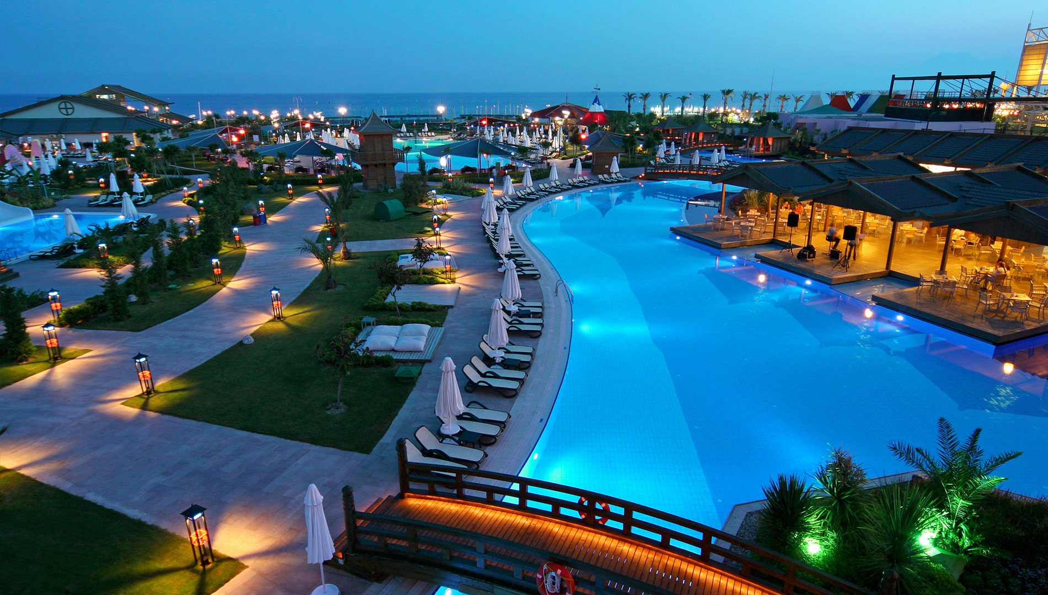

Table of Contents

**1.0 EXECUTIVE SUMMARY 3**

**1.2 OUR MISSION 4**

**1.3 OUR VISION 4**

**1.4 KEY TO SUCCESS 4**

**2.0 PRODUCT AND SERVICES 4**

**3.0 COMPANY SUMMARY 7**

**4.0 MARKET ANALYSIS SUMMARY 7**

**4.1 MARKET SEGMENTATION 7**

**4.2 TARGETED MARKET 9**

**5.0 SWOT ANALYSIS 9**

**6.0 STRATEGY FOR IMPLEMENTATION 11**

**6.1 COMPETITION AND COMPETITIVE ADVANTAGE 12**

**7.0 SALES AND MARKETING STRATEGY 12**

**7.1 MARKETING STRATEGY 14**

## 1.0 EXECUTIVE SUMMARY

Hannan Hanif Global Investment is a home away from home paradise for a temporarily lodging in the heart of Kano, Kano state. We are equipped with state of art facilities for lodging, Intercontinental Restaurants, Bars, Gym center, Event hall, Seasoned staff, Securities and spacious parking space.

We plan to create an environment of pampered luxury that surpasses any other hospitality business in our industry in Kano state. To be more than just lodging and accommodation. We plan to create an environment of luxury that surpasses the standard fare for our locations. Expanding our exposure via the Internet and introducing new products and services to customers in all our locations will allow us to maintain a higher than average occupancy rate and above average profits.

The riches of the locations where Hannan Hanif Hotel is located will potentially draw significant numbers of tourist to the region. In addition to providing information about our locations, we plan to collaborate with tour agencies and business throughout the area by offering packages and special rates. As the company becomes established through the peak season, we plan to expand our services to the residents of our locations in time of the off-season. The adjourning rooms open creating a large area, ideal for formal or informal gatherings (e.g. weddings receptions, office parties, Christmas parties, etc.).

The target market to be pursued by Hannan Hanif Hotels are people or families looking for a vacation destination, honeymooners, family reunions, tourists and drop-in customers. The settings and facilities to be put in place would be natural for people and families to visit, we also feature entertaining brands and comedians who will be a trill to our guests, especially the weekendwrs.

The short term goal is to increase sales that will allow us to compete with our competitors, make short term profits, increase our market share, improve our marketing strategy and we to continue to innovate our businesses. Hannan Hanif Hotel is a subsidiary of Hannan Hanif Global Investment. A Manager will appointed that will reside on the property, managing and maintaining the business and satisfying our locations license agreements.

## 1.2 OUR MISSION

Our mission is to create enduring relationships with our guests and members by providing highly personalized service and gracious hospitality in an informally elegant setting.

## 1.3 OUR VISION

To have our properties be known as among the topmost luxury destinations in the world; recognizable by service and product of quality standard and to be consistent in promotion of excellence, novelties and future development of "a home away from home"

## 1.4 KEY TO SUCCESS

Hannan Hanif Hotel planned to put the following measures in place to achieve it set objectives. These measures are termed the strategic keys to success. They includes;

* Presenting the highest level of quality achievable in its services line;
* Growing and maintaining relationships with customers and the community to generate repeat sales while constantly adding new ones;
* Allocating a significant and consistent budget in grass roots and international security for our customers;
* Innovation a new services design offerings that will differentiate us from competition.

## 2.0 PRODUCT AND SERVICES

Hannan Hanif Hotels will offer fully equipped ask for more services to her wide range customers; accommodation, fully-equipped kitchens, laundry facilities and stone fireplaces, common-area outdoor hot tub as well as the following services on-site:

* Hotel services; Accommodation, lodging etc.

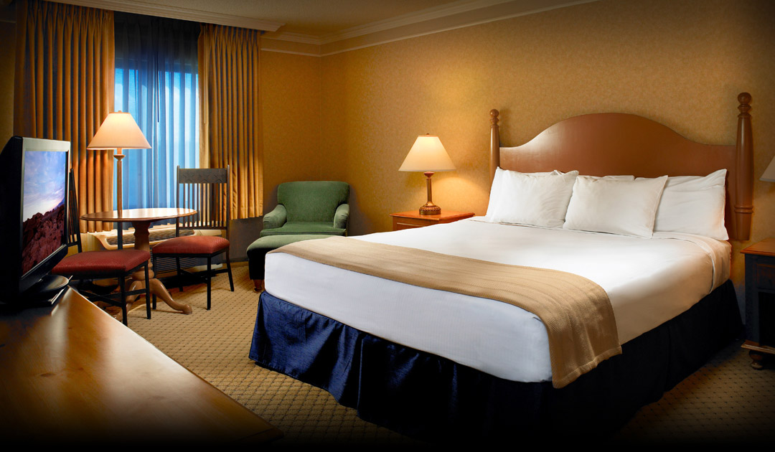

* Event Centre

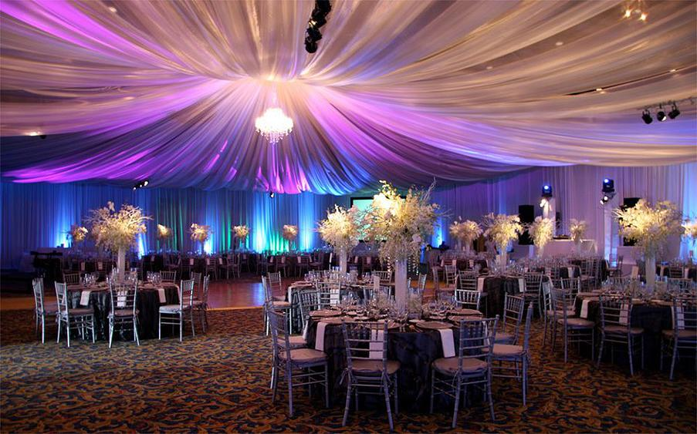

* Restaurants

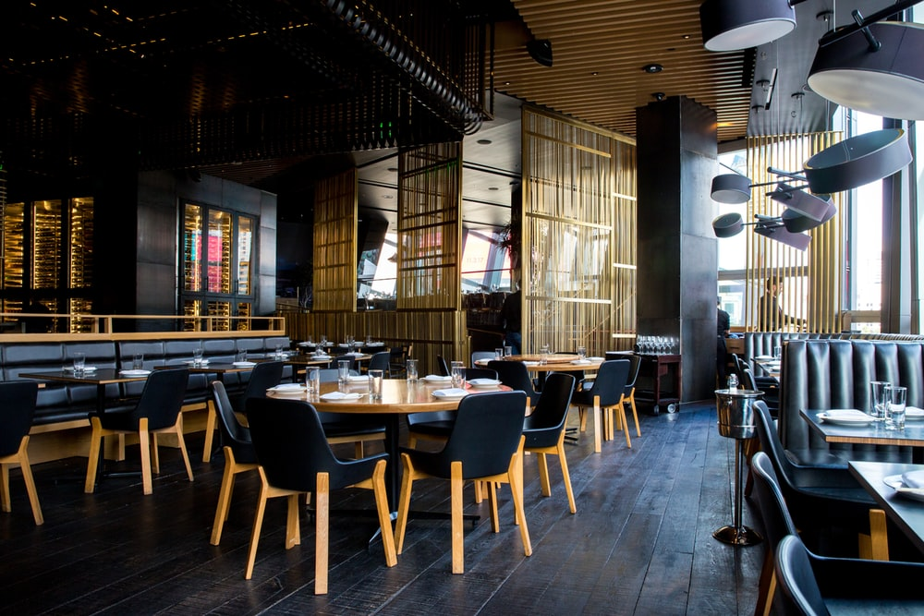

* Gym centre

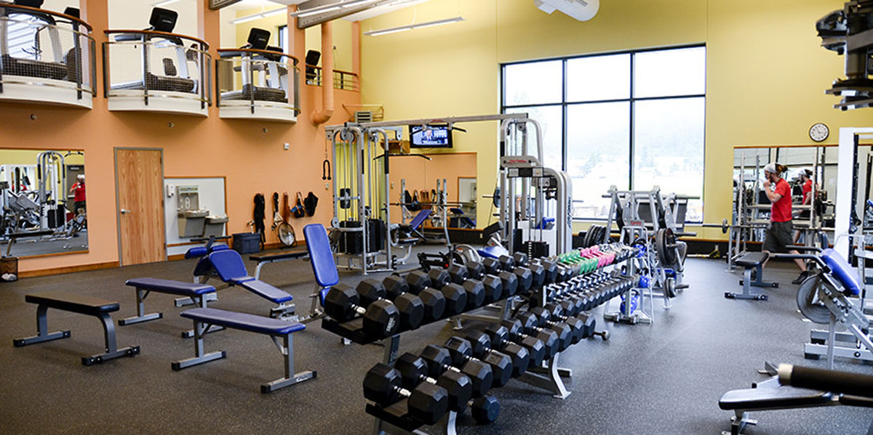

* Academic hall

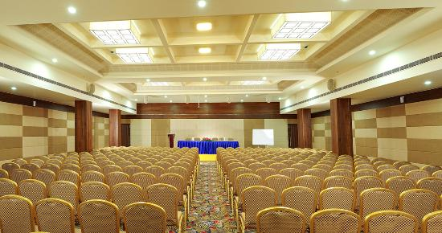

## 3.0 COMPANY SUMMARY

Hannan Hanif Hotel is a hospitability company, a subsidiary of Hannan Hanif Global Investments Limited. The company will serve the need of both local and international customers seeking a conducive atmoshere for pleasure, cremonies, conferences etc. Hannan Hanif Hotel will headquartered in Kano with facilities of international standard to support it operations as it grow.

## 4.0 MARKET ANALYSIS SUMMARY

Hotel business and operation has been very profitable and successful due to the economic upturn experienced in the early and mid 90's. Resort hotel development and investments nationwide are currently going strong. In the past two years, sales of time-shares in the Valley Resort area have increased by over 35 percent. Each year, room occupancy in hotels is close to 100% during the peak skiing season. Our hotel, conveniently located to have direct access to tourists will offer a luxury but modest relaxing environment for not only international tourist but also for the local people looking for a nice place to spend the weekends or short vacations (e.g. summer school vacations, carnival, etc.).

Also, it is expected that we will offer to our customer excellent facilities to host special events as seminars, weddings, private parties, etc. Also, it will include a SPA Package for those tourists looking for a place to relax and invest some money in their body treatment (e.g. facials, massage therapy, and others.)

## 4.1 MARKET SEGMENTATION

Individual market segments exhibit unique characteristics relating to future growth potential, seasonal aspects of demand, average length of stay, rates of double occupancy, facility requirements, price sensitivity, and other factors. Thus, knowledge of market segmentation gives consultants and developers a means of gauging the profit potential for a hotel, as well as avoiding costly mistakes by building a property aimed at capturing demand that the market does not supply. to this end our customers at Hannan Hannif can be broadly segmented into the followings

**The Commercial Segment**

The commercial segment consists of individuals who travel to a market to conduct business. Not surprisingly, commercial demand tends to be heavy from Monday through Thursday, congruent with the business hours of local firms, and fall sharply through the weekend. The typical length of stay for commercial guests ranges from one to three days, and the rate of double occupancy is a low 1.2 to 1.3 people per room. In other words, commercial travellers typically do not share rooms, a trend that can result in a higher contracted rate for commercial accounts. Commercial demand is relatively constant throughout the year, although some declines are noticeable in late December and other holiday periods. The more room nights a corporate account or individual traveler commits to, the deeper the discount.

**The Meeting and Group Segment**

Corporate groups and those described as SMERFE (social, military, ethnic, religious, fraternal, and educational) make up the bulk of meeting and group demand, which consists of seminars, conventions, trade association shows, and similar gatherings of ten or more people. Demand in this segment is highest in the spring and fall, with activity slowing in the summer months. Travelers in this segment typically prefer hotels with extensive meeting space, business technology, food and beverage outlets, and the miscellaneous components required to host meetings and banquets.

Corporate groups can boost a hotel’s profit in two ways. First, during times of national economic prosperity, corporate accounts tend to exhibit limited price sensitivity and book in large blocks, leading to higher margins. Though the current economic crisis has resulted in fewer corporate bookings and lower negotiated rates, corporate group demand continues to be higher-rated than SMERFE groups. Second, corporate groups often sponsor banquets and other events that generate revenue for the host hotel. As with individual commercial travelers, demand from corporate groups is strongest on Monday through Thursday nights. By contrast, budget-conscious SMERFE travelers show a strong preference for weekend and summer meeting times, when rates are generally lowest.

**The Leisure Segment**

Unlike the weekday prominence of commercial and meeting and group demand, the leisure market segment tends to fill rooms on Friday and Saturday nights. Leisure travelers also book weekday stays during holiday periods, when commercial demand is traditionally down. Leisure demand in markets is primarily generated by attractions such as amusement parks, shopping malls, outlet stores, and museums. Events such as college graduation ceremonies or visits among families and friends also provide incentive for leisure travel in a market.

Leisure travelers typically stay from one to four days, with the rate of double occupancy ranging from 1.8 to 2.5 people per room. This figure can be meaningful in the case of a full-service hotel, where restaurants, spas, gift shops, and other revenue-generating facilities stand to profit from the extra traffic that double occupancy brings through. Depending on the type of hotel, average rate can move up or down the spectrum. If you run an all-suite property with inclusive food and beverage, for instance, you’ll tend to attract less price-sensitive guests, while highway properties with limited amenities are often obliged to offer discounted leisure room rates.

## 4.2 TARGETED MARKET

Our key clients are contracted corporate clients originating from both international and domestic markets from within the travel trade, automotive and IT segments. The strategic location of the property is key to its success in these areas due to the proximity of the Exhibition Halls, and Kano state being a commercial centre.

Key to our business success is the level of customer loyalty and repeat business we receive on an annual basis. We offer our guests the most up-to-date technical business facilities, both inside the rooms and within the hotel's conference facilities.

Our guests feel that they can conduct their business from within a less austere atmosphere than can be experienced in our competitive properties, where there is less personal recognition. They appreciate being called by name when they arrive, and having staff remember their specific requirements, time and again. This is key in developing the relationship beyond an initial stay and evidences our added value in relation to competitive properties in the vicinity.

**5.0 SWOT ANALYSIS**

The following analysis highlights the internal strengths and weaknesses of our organization and the opportunities and threats facing the company in our external environment. We must work to improve our areas of weakness. Organizational strengths must be leveraged in order to capitalize on external opportunities as they arise, and contingency plans formulated in order to deal with threats presented by the environment.

**Strengths**

Hannan Hanif Hotel strengths can be identified as follow;

* Strategy: established differentiation strategy.
* Structure: flat, decentralized structure.
* Skills: diverse range of service skills within management and staff.
* Style: strong, participative culture.
* Staff: specialized and experienced staff well motivated and highly skilled. A well trained team who are proud of their hotel and respect and promote the brand values.
* Shared Values: clear and well communicated.
* Brand Strength: brand values well represented engendering brand loyalty amongst existing and new guests.
* Reputation: promote a strong reputation within the local market and corporate and travel trade markets for reliability, exemplary service and quality.

**Weaknesses**

Hannan Hanif Hotel identified the following weaknesses;

* Capital Investment: Requires approval of credit lines from local investors to fund the initial capital investment to build the facilities.
* Seasonal revenue: The flow of tourist circle that occurs during the spring-summer seasons versus winters differs, this needs to be properly manage.
* Staff: Season turnover requires ongoing training and orientation of new staff.
* Opportunities

**Opportunities**

Opportunities seen by Hannan Hanif Hotels includes:

* **Market:** The expanding market is a great opportunities for Hannan Hanif Hotels.
* **Competition:** There are only few direct competitors.
* **Suppliers and Staff:** The suppliers of materials and Staff (personel) require to run the facilities could b obtainable from the local market.
* **Guest dependency:** Repeat corporate business based on personnel service and quality, in small but luxurious environment.

**Threats**

The threats foresee by Hannan Hanif Hotels are as follows:

* **Market Entry**: There is high potentials for a competitors, global brands to enter the market with similar product.
* **Substitute**: Fully furnished and serviced business apartments offering at lower rate.
* **Economy**: Recovery from slight recession may take time.

**6.0 STRATEGY FOR IMPLEMENTATION**

Hannan Hanif Hotl will aggressively market to both winter and summer visitors . During the winter there is skiing but in the summer months, the resort has hot-air balloon trips, white water adventures, day hikes into Relaxation Valley, and other recreational activities that take advantage of valley's spectacular beauty.

There are only about thirty hotel and Resort of international standard presently in Kano.  These facilities represent only 580 room units of the total of 4,000 room units in the resort area. The majority of room units in the area are condos.

Our customers are looking for a different lodging experience that cannot be found in any of the area's complexes or hotels.  We will offer our customers a comfortable, congenial environment that will assure return visits to the Hannan Hanif Hotel.

The lodge and other services will cost a little more but we will offer our customers all the services they need to make their stay memorable. We will offer a food shop that will be able to take special orders daily.  There will be a ski rental shop where customers can outfit themselves and purchase ski passes.  Each evening, guests can gather in the lodge's main room where there is a large fireplace, drinks and light music.

**6.1 COMPETITION AND COMPETITIVE ADVANTAGE**

A close study of the hospitability industry reveals that the market has become much more intensely competitive over the last decade. Currently the top hotels operating in the state includes; Mozida Suites, Prince Hotel, Bristol Palace, Grand Central Hotel, Green Palace Hotel, K.Suites Hotel, La Suites, La Sultana Hotel. As a matter of fact, to compete successfully in the market you have to be highly creative, customer centric and proactive if you must survive in this industry. We are aware of the stiffer competition and we are well prepared to compete favorably with other leading Hotels in Kano state.

The competitive edge of Hannan Hanif is the service, first and foremost.  The co-owners of the of Hannan Hanif, have over twenty years experience in managing international lodging facilities. Another significant advantage for the Hannan Hanif Hotel is its location.  Being located in the recently opened friendly area, Hannan Hanif Hotel is uniquely positioned to be centrally located to both expected customers within and customers on international vacations.

**7.0 SALES AND MARKETING STRATEGY**

The Hannan Hanif Hotel is positioned as a new upscale facility that is focused on the high-income visitors. From a careful environmental examination carried out by our research team, we find a list of 9 essential marketing strategies considered to be the best in maximizing our objectives. they are;

**1. Go live with a great website**

This website is the most important distribution for our business and the crux of a good online marketing strategy. This is the place where people can learn more about our individual business and decide whether or not to book a stay with us. It’s also the only online distribution channel where we believe we can generate direct online sales, so our website has a booking engine to handle self-service reservations. As more internet users rely solely on their smart phones and tablets, a mobile friendly website is in progress to be launch.

## 2. Differentiate our self from the rest

To really contend with the competition, our hotel will offer something unique and distinctly different to entice potential guests. Our hotel marketing campaign would be equally individual. Quality customer care needs would be the core of everything in our hotel and other hospitability services we render. We believe going extra mile for our guests can yield massive returns.

## 4. Get recommendation by real authority

One surefire way identified to securing new customers is to get our hotel listed with local tourist offices. Whether it’s a printed flyer in a bricks and mortar office, or a prominent link on a local tourism website, we’re are in the process to take premier listing over many rival competitors. We are looking to appeal the business travelers, nearby convention and exhibition centers to promote our hotel and also get local marketing and event companies in the region of our hospitality packages.

## 5. Promote hotel with online travel agencies

In the modern digital age, no hotel can secure regular business without capitalizing on online travel agencies and travel brokers. A simple listing can generate thousands of bookings in the long-term, but it’s worth remembering that each time a booking is generated through such an agency, a commission will be applied.

## 6. Keep an eye on reviews and recommendations

We believed a great review can earn us a new customer. A poor review can cost us hundreds. we will try to encourage better reviews and recommendations from previous guests by engaging them after checking out. Our hotel could feature dozens, if not hundreds of times on review websites, so we will ensure that each page is loaded with positive reviews and complimentary content. Also, we would monitor reviews on the most popular sites, taking note of any bad reviews and engaging dissatisfied guests with helpful and constructive feedback. Neutralise negative feedback wherever we can.

**7.1 MARKETING STRATEGY**

Before choosing a location for Hannan Hanif Hotel, we conducted a thorough market survey and feasibility studies in order for us to be able to be able to penetrate the available market and become the preferred hospitability arena for all potential customers.

We have detailed information and data that we were able to utilize to structure our business to attract the numbers of customers we want to attract per time.

We hired experts who have good understanding of the Hospitability industry to help us develop marketing strategies that will help us achieve our business goal of winning a larger percentage of the available market. In summary, Hannan Hanif Hotel will adopt the following marketing approach to win customers over;

* Open our business in a grand style with a party for all.
* Introduce our business by sending introductory letters alongside our brochure to where we believe our potential customers will be; airports, travel agencies etc,
* Ensure that we have a wide range of services expected from customers within and outside Nigeria at all times.
* Make use of attractive hand bills to create awareness of our hotel.
* Position our signage / flexi banners at strategic places around Kano state.
* Position our greeters to welcome and direct potential customers
* Create a loyalty plan that will enable us reward our regular customers
* Engage on road shows within our neighborhood to create awareness for Hotel and other packaged services available.

**7.2 PAYMENT POLICY AND OPTION**

The payment policy adopted by Hannan Hanif Hotel is all inclusive because we are quite aware that different customers prefer different payment options as it suits them but at the same time, we will ensure that we abide by the financial rules and regulation of Nigeria.

Here are the payment options that Hannan Hanif Hotel will make available to her clients;

* Payment via bank transfer
* Payment with cash
* Payment via credit cards / Point of Sale Machines (POS Machines)
* Payment via POS machines
* Payment via online bank transfer
* Payment via check
* Payment via bank draft

In view of the above, we have chosen banking platforms that will enable our client make payment for purchase without any stress on their part. Our bank account numbers will be made available on our website and promotional materials to clients who may want to deposit cash or make online transfer for the purchase of our products.