**BUSINESS FEASIBILITY REPORT**

**CHEFBAM INTERCONTINENTAL KITCHEN**

**………………..AMAZING DELICIES**

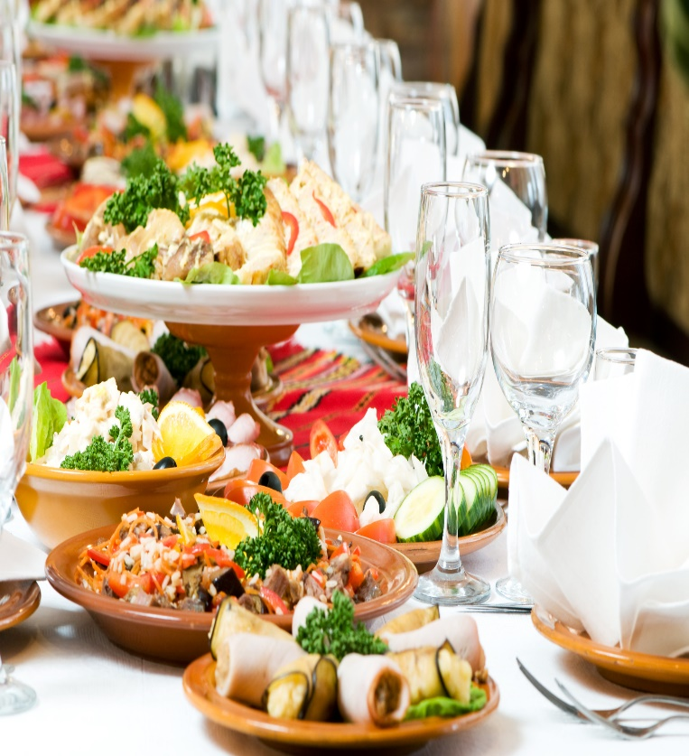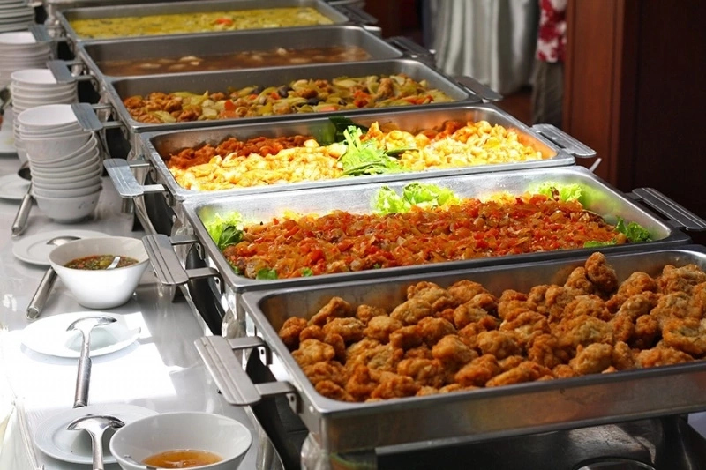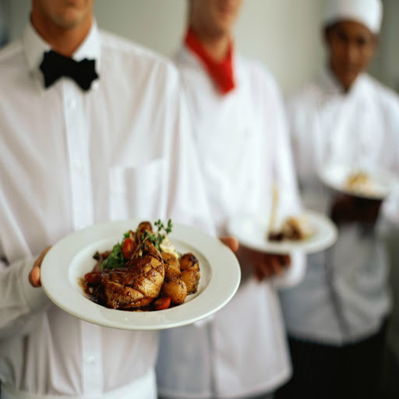

Table of Contents

***1.0*** ***EXECUTIVE SAMMARY*** 2

1.2 OUR MISSION 2

1.3 OUR VISSION 2

1.4 KEY TO SUCCESS 3

**2.0** **COMPANY SUMMARY** 3

**4.0** **MARKET ANALYSIS SUMMARY** 5

4.1 TARGET MARKET 5

4.2 COMPETITION AND COMPETITIVE ADVANTAGES 6

5.0 SWOT ANALYSIS 6

5.1 SWOT analysis for ChefBam Intercontinental Kitchen Kitchen 7

6.0 SALES AND MARKETING STRATEGY 8

6.1 STRATEGY AND IMPLEMENTATION SUMMARY 8

7.0 GOVERNANCE LEADERSHIP AND STAFFING 9

8.0 PARTNER’S PROFIL 9

9.0 PARTNERSHIP DEED 9

1. ***EXECUTIVE SAMMARY***

ChefBam Intercontinental Kitchen is a fast food outlet and catering service business enterprise that will serve both the middle and upper class residence of Lagos state and beyond.

ChefBam Intercontinental Kitchen will offer creative, colorful, and unusual food options of international tastes as well as the traditional standbys. ChefBam Intercontinental Kitchen will provide catering services for event of all categories and also a tastiest local delicacies most craved for in Nigeria and Africa at large. Our plan is to be a mobile kitchen that can travel to any part of the country. We will hire dedicated support staff to provide excellent services to our potential clients.

In addition, our services will be sensitively unique relative to the existing catering market which is quite stagnant.  Most people make the incorrect assumption that fast food means ordinary, boring food.  This assumption prevails throughout the modern community so there is not much demand for new offerings.

To this end, ChefBam Intercontinental Kitchen will inject new life into the catering market, leveraging on the founder’s catering skills to develop creative new catering options.  ChefBam Intercontinental Kitchen advanced skills, industry insight, and a great market opportunity will allow ChefBam Intercontinental Kitchen to operate at a breakeven at the first year and profitability in the subsequent years.

There is a need of a warm and friendly place with excellent food. A place where you always know you will get the best of everything. ChefBam Intercontinental Kitchen will feature a cozy dining room and an elegant lounge. Comfortable furnishings and decor with soothing warm tones. The lounge will comfy couches and antique love seats with a softly lit bar. It will be the perfect place to stop in for a bite to eat, for a drink or for a small business meeting. For extra comfort and to please a large group of people we will make up special platters for all categories of customers.

## 1.2 OUR MISSION

Our mission is to give our customers a place to celebrate life’s special moments by connecting people to real food offering. *Our services will exceed the expectations of our customers.*

## 1.3 OUR VISSION

*To be a leading provider of quality delicious foods and impeccable customer service by offering a versatile and flexible service with consistency and presentation that will leave a lasting Impression.*

## 1.4 KEY TO SUCCESS

AT ChefBam Intercontinental Kitchen, we planned to put the following measures in place to achieve our set short and long term objectives. These measures are termed the strategic keys to success. They include;

**KNOWING OUR CONCEPT**

We will choose our kitchen (restaurant and catering) concept carefully. We will target both the Upper and Middle class resident. Some of the concepts include:

* fast food restaurant
* fast casual dining such as a café and a pub and a family style dining
* Pop Up restaurant with no long time commitment
* Mobile catering services

**GETTING A MEMORABLE LOGO**

Make sure that your restaurant business is represented by a unique logo. People will see our [restaurant logo](https://www.designhill.com/logo-design/restaurant-logos/) on our street signs, advertisements, billboards, newspapers, business cards, websites, menu card and elsewhere.

**ENSURING A UNIQUE MENU CARD**

When people visit our restaurant, the first thing they will come across with is our restaurant menu card. The card has the prices and dishes displayed for the customers. They can pick a dish that suits to their budget after carefully scanning the card. We believe professionally created menu card design has the ability to speak a lot about our restaurant business.

**BUILD A DEDICATED WEBSITE**

We will put our restaurant business online. People can anywhere, book tables to dine in our restaurant. Our restaurant features and services will be available on the web. So, we will create a memorable [website design](https://www.designhill.com/website-design) and put it on the web.

**USE SOCIAL MEDIA**

One of the most effective way we intend to promote our restaurant business is to take advantage of social media. Our potential customers are on social sites such as Facebook, Instagram and Twitter. So, we will create a useful [social media page](https://www.designhill.com/social-media-page) for our business.

1. **COMPANY SUMMARY**

ChefBam Intercontinental Kitchen is a partnership business enterprise serving both the needs of the international and local customers craving for amazing delicacies.

ChefBam Intercontinental Kitchen is established as a profit partnership oriented business with expectation to have investing corporate partners to secure a going concern objective for the business.

The trade name ‘’**ChefBam Intercontinental Kitchen**’’ is in the process of being registered, and the product logo is being finalized.

1. **PRODUCT AND SEVICES**

ChefBam Intercontinental Kitchen will offer both a restaurant and catering services of different demand. This services include; special order, event services, etc.

**RESTAURANT SERVICES**

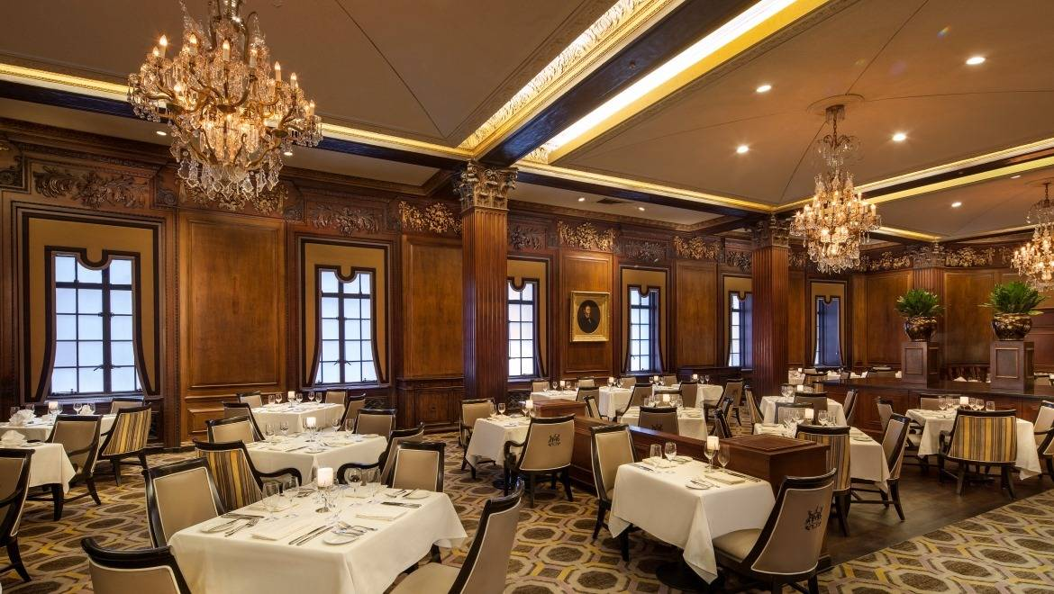

**SPECIAL ORDER**

We will cater for our customers who need a product or services that they can’t find on our menu or restaurant or want to call in an order to pick up. This are the perfect solution for these categories of customer; Family Parties, Special Events, and Celebrations, Fundraisers, Picnics, Fairs, Festivals, everything in between.

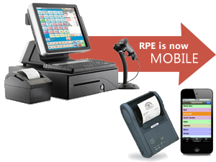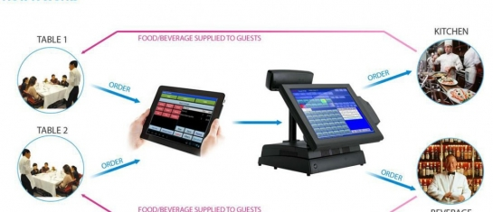

**CATERING SERVICES**

We will handle all aspect of events, such as graduation party, wedding reception, corporate business dinner etc. This services will be redered in accordance to the client’s wishes, sets up catering tables, decorations and lighting.

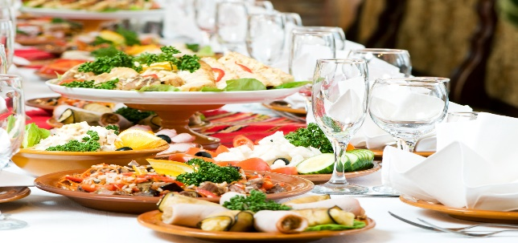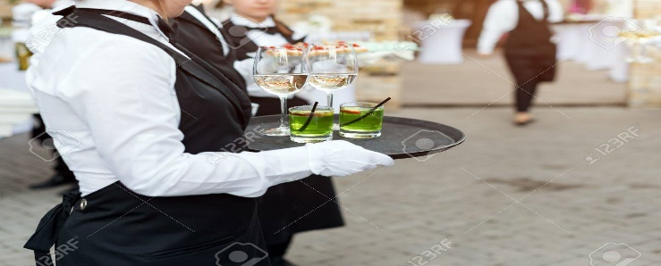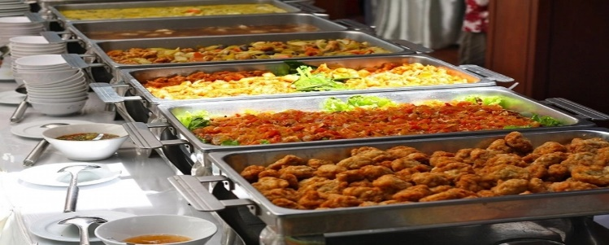

1. **MARKET ANALYSIS SUMMARY**

Our analysis of the market has shown that there has been an increase in competition among restaurant businesses in the area of services and marketing. Some restaurants businesses even have customized services for clients celebrating specific occasions.

Some have gone beyond to ensure that their products and services meet environment-friendly guidelines, hence, winning the patronage of environment-conscious consumers.

In addition, Restaurants businesses has become more profitable business than ever before in Nigeria due to the increase in population and the nature of jobs available. With such increase, comes the need for more restaurants that will cater for the stomach needs of the increasing population. This need will even more continue over time. Also, the need for qualitative food at the cheapest price called for our establishment of a standard Kitchen like we intend, in the state to meet the society delicacy needs.

## 4.1 TARGET MARKET

The food industry has a wide range of customers; a good number of people on planet earth consumed fast food and it is difficult to find people around who don’t. In view of that, we have positioned our kitchen channel to service both the Middle and the Upper class customers in Lagos state and every other location we will cover on special order all over the states of Nigeria. We have conducted our market research and we have ideas of what our target market would be expecting from us. We are in business to serve amazing delicacies of a wide range at different affordable prices

## 4.2 COMPETITION AND COMPETITIVE ADVANTAGES

A close study of the industry reveals that the market has become much more intensely competitive over the last decade. As a matter of fact, we have to be highly creative, customer centric and proactive if we must survive in this industry.

We are aware of the stiffer competition and we are well prepared to compete favorably with other leading Restaurants in our environment, Lagos state. Our Company is launching a standard Restaurant and a catering channel that will indeed become the preferred choice of all our targeted customers.

One thing is certain; we will ensure that we have a wide range of delicacies available in our kitchen at all times. One of our business goals is to make Our excellent customer service culture, timely and reliable delivery services, online presence, and various payment options will serve as a competitive advantage for us.

Lastly, our employees will be well taken care of, and their welfare package will be among the best within our category in the industry, meaning that they will be more than willing to build the business with us and help deliver our set goals and achieve all our aims and objectives. We will also give good working conditions and commissions to freelance sales agents that we will recruit from time to time.

## 5.0 SWOT ANALYSIS

We are quite aware that there are several catering companies and standard Restaurants all over all over Lagos, Nigeria and even in the same location where we intend locating ours, which is why we are following the due process of establishing our businesses.

We know that if a proper SWOT analysis is conducted for our businesses, we will be able to position our business to maximize our strength, leverage on the opportunities that will be available to us, mitigate our risks and be welled equipped to confront our threats. We employed the services of an expert HR and Business Analyst with bias in Restaurant and Catering to help us conduct a thorough SWOT analysis and to help us create a business model that will help us achieve our business goals and objectives. This is the summary of the SWOT analysis that was conducted for our Company;

## 5.1 SWOT analysis for ChefBam Intercontinental Kitchen

* **strength:**

Our location, the business model we will be operating on (robust technology), varieties of payment options, wide range delicacies, prompt delivery Services and our excellent customer service culture will definitely count as a strong strength. So, also our management team members are people who have what it takes to grow a kitchen business from start – up to profitability with a record time.

* **Weakness:**

A major weakness that could serve as a deterrent to us is that we are new in business and we don’t have the financial capacity to compete with leaders in the industry for now.

* **Opportunities:**

The fact that we are going to be operating our production and distribution business in Lagos provides us with unlimited opportunities to sell our product to a large number of customers of different class. We have been able to conduct thorough feasibility studies and market survey and we know what our potential clients will be looking for when they patronize our Restaurant; we are well positioned to take on the opportunities that will come our way.

* **Threat:**

Just like any other business, one of the major threats that we are likely going to face is economic downturn. It is a fact that economic downturn affects purchasing / spending power. Another threat that may likely confront us is the arrival of a similar business in same location where ours is located.

## 6.0 SALES AND MARKETING STRATEGY

Before choosing a location for our Company, we conducted a thorough market survey and feasibility studies in order for us to be able to penetrate the available market and become the preferred choice We have detailed information and data that we were able to utilize to structure our business to attract the numbers of customers we want to attract per time.

In summary, our company will adopt the following sales and marketing approach to win customers over;

* Open our business in a grand style with a party for all.
* Introduce our business by sending introductory letters alongside our brochure to corporate offices, hotels, households and key stake holders in Lagos state
* Make use of attractive hand bills to create awareness for business
* Position our signage / flexi banners at strategic places around the state
* Position our greeters to welcome and direct potential customers
* Create a loyalty plan that will enable us reward our regular customers
* Engage on road shows within our neighborhood to create awareness for our delicacies

## 6.1 STRATEGY AND IMPLEMENTATION SUMMARY

**LOCATION**

ChefBam Intercontinental Kitchen will strategically be located in the heart of Lagos state Corridor, easily accessible to all classes of customers (upper and middle class to be precise). Although, a number of Restaurants company are also located within, but only few are multi-ventures like we intend to do.

**COMPANY FACILITIES REQUIRED**

The primary facility is the complex where our customer will be served, a feel at home dinning room settings suitable to accommodate fifty plus customers at a time.

Also, a warehouse facility for storage and block of offices for staff. However, ChefBam Intercontinental Kitchen facility needs will grow rapidly over the next 10 years as production capacity expand. Ultimately, additional facilities will be needed for conference, dinner, mini party and special order engagements.

## 7.0 GOVERNANCE LEADERSHIP AND STAFFING

Being an equal Partnership enterprise, an administrative model that encourages timely decisions and avoids the delay decision traditionally associated with a partnership company will be developed. A flat organization that hires support staff as needed to build the foundation of the company will be put in place. The Experiences of the two partners in catering services is an added advantage to reduce the complexity in staffing.

## 8.0 PARTNER’S PROFIL

**BAMIDELE SULAIMAN KELVIN (BAM)**

Mr. Bamidele Sulaiman is ……………………………………………………………………….

## 9.0 PARTNERSHIP DEED

**ChefBam Intercontinental Kitchen** is willing to admit partner or investors. The business will be run outside family or relative interference. This deed is an agreement and shall be governed by and construed in accordance with the partnership business laws of Nigeria. Any controversy or claim arising out of or relating to this agreement or the breach thereof shall be settled by arbitration in accordance with the rules of the Nigeria Arbitration Association then in effect, and judgement upon the award rendered by the arbitrator or arbitrators shall be binding upon the parties hereto.

The deeds of this partnership shall include:

* 1. Equitable share of profit
  2. Equitable share of loss
  3. The two parties are active partners
  4. The parties are to be involve in collective management.

However, there is also a room for a joint venture agreement, admission of a new partner or equity finance from a venture capitalist which in turn can be a provider of finance, to which this agreement can be reviewed for.