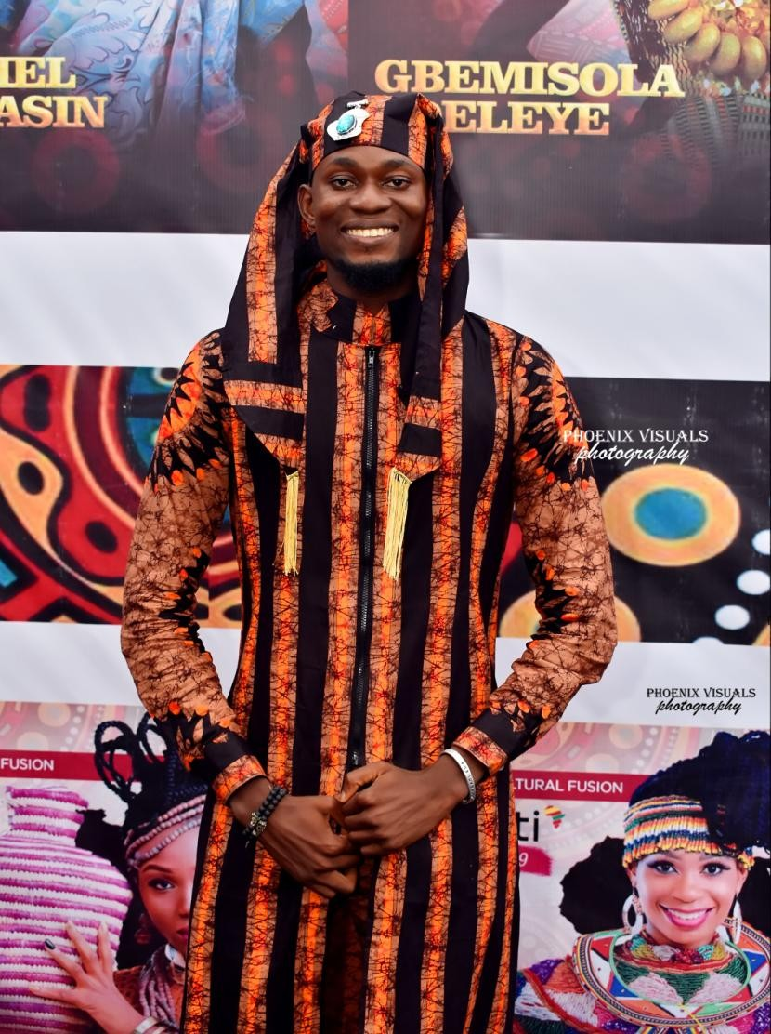

|  |
| --- |
| BAKARE OLALEKAN MUBARAK |
| *Tallest Male Model in Sub-Sahara Africa* |
| Compiled by: YusFook Consulting and Associates. |

***BAKARE OLALEKAN MUBARAK*** born in the year 1995 is a Nigeria model and actor born and raised in Ilorin, Kwara state, Nigeria. BAKARE started his modeling adventure in his home state; during his undergraduate studies he participated and was crowned Mr. Kwara International 2015/2016 edition and since then, he has travelled within and outside Nigeria modeling for big brands and signing big endorsements.

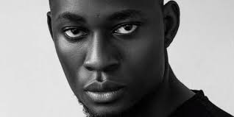

BAKARE attained a celebrity status from having great [wealth](https://en.wikipedia.org/wiki/Wealth); his height, body posture, participation in sports, entertainment industry, and his position as humanitarian, and even, from connection to other celebrities and notable personalities.

At 24 years, BAKARE is the tallest model in Sub-Saharan Africa and stands at an impressive height of 6ft9, about the same height as the current tallest professional model in the world. Mubarak is a model, an influencer, an actor and an ex pageant king (Mr. Kwara international 2015/16, and also Mr. Nigeria international Kwara 2016/17).

**ACHIEVEMENTS, AWARDS AND RECORGNITIONS**

BAKARE, a Commonwealth Culture and Charity Ambassador,   
has numerous awards to his credit. Having worked with renowned brands such as; Fashion TV, Glo Nigeria, Zenith Bank, First Bank, Afro tourism, MESS LA, Itel mobile Nigeria, Top tea, etc.

Also, he was the youngest of the 16 delegates from across the world that went on the Nigeria travel week Southwestern tour and a one-time Yandi ambassador (A renowned SME & digital solution company).

On the year 2020, he was honored at the African Achievers Awards (AAA) 10th Anniversary, under the Youth Ambassador Category. T**he African Achievers Awards** is an annual awards event. Awards are given on merit to deserved individuals in the categories of [community development](https://en.wikipedia.org/wiki/Community_development), leadership, arts & culture business & entrepreneurship, agriculture, community service, [rural development](https://en.wikipedia.org/wiki/Rural_development) and education.

He was conferred the honor of Cultural Ambassador at the prestigious Nike Art Gallery largest art gallery in West Africa which has been following his blossoming career.

Bakare Mubarak also received the Royal Endorsement for his singular drive to promote African Fashion, Culture, Art and Tourism by His Imperial Majesty Oba Saliu Akanmu Olasupo Adetunji Oba of Ibadan and Bakare aims to promote the Ibadan City as one of the unique antique tourist destinations in the world.

On November 2020, he was appointed Coordinator of 2030 BRP2MA-Afro Heritage and Cultural Heritage by 2030 BLACKS RESETTLEMENT MOTHER AFRICA. In addition, he has acted in a few movies and walked on various runways and editorials.

Bakare was appointed Ambassador of Business Liaison, Education and Culture Worldwide for the 16th Region Global Chamber of Commerce (16th RGCC) by the Global Chamber of Commerce, International Headquarters USA.

### PROJECTS/INITIATIVES

### Towards enhancing and promoting our diverse cultural heritage, Bakare came up with a new plan; geared towards resurrecting extinct culture and value added to the existing. The project is aimed to set foot in new fashion markets and simultaneously colorized and enlarge the existing traditional market share.

### *PHOTO WAKA:* Photo Waka series by Bakare Mubarak, a trademarked initiative that is a fusion of Modeling and Tourism and promotes culture and art, and on the long run intends to showcase the beauty of our nation and unite us through the means of photo tourism, ultimately creating and preserving peace/unity amongst the Nigerian community, in the Diaspora and the world as a whole. He is proud to say that the Ooni of Ife Kingdom is the Grand Patron of The Photo Waka Initiative.https://scontent.flos1-1.fna.fbcdn.net/v/t1.0-9/51956017_1329473610541789_1278169889193852928_o.jpg?_nc_cat=101&ccb=2&_nc_sid=6e5ad9&_nc_ohc=YbA3nvGeKSAAX9xWmIt&_nc_ht=scontent.flos1-1.fna&oh=57602f7878a8e2a8039a639304cb2e64&oe=60466A91*MODERN AFRICAN MAN*: Are world class commercial clips showcasing the beauty of Afro centric man ranging from wears, accessories etc. and concentrating showing the beauty of these attires and a beautiful lifestyle of the African culture from food, dress, dance and the African Paraphernalia.

**Also, BAKARE** Allied with the Oluwo of Iwo Kingdom, Oba **AbdulRasheed Adewale Akanbi,** Kabiyesi Alayeluwa, Arole Olodumare 1 of Yoruba Land. He made known his intentions and willingness to work with the King, in several capacity in a bid for a renaissance of history and projection of Iwo kingdom, a historically rich kingdom, to the world in a good light. One of which is to pull off an expedition of his unique initiative (Photo Waka) in the Kingdom.

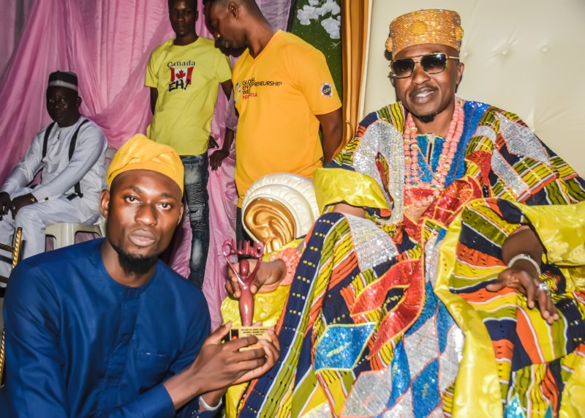

He championed a project, Aso-Oke Fashion Documentary Film. A project he concluded in collaboration with Africa Fashion Week London, Sustainable Fashion Week New York and wife of the Executive Governors of Kwara and Ekiti state.

Bakare Mubarak, called for the promotion of African traditions and youth empowerment across the continent. He made the call during a meeting with renowned Kenya scholar, Prof Patrick Lumumba. He said, “I humbly communicated the core values of the initiative, aims and objective and willingness to have the support and presence of Prof PLO Lumumba, which was expressly granted.

He also met with the deputy governor of Kajiado County in Kenya, added that, “I am pleased to have created this wonderful affiliation and to have shared ideas on strategic symbiosis as regards moving forward cultural exchange, youth engagement, civic engagement, African fashion, art and tourism.” On December 5, 2020, Mubarak was honoured at the African Achievers Awards for his selfless service towards creating value in Africa.

Earlier this year, he made an historical visit to Badagry. The trip was emotional yet revealing walk-through of slavery in Badagry, Nigeria, visited relics, museums and ancient buildings that tell the story of Nigeria' evolution as a country. He was hosted by Governing Board in Badagry.

### HUMANITARIAN SERVICES:

Right from childhood, BAKARE grew up as an individual who actively engages in promoting human welfare and social reforms, and who has no prejudice with human suffering on grounds of gender, sexual orientation, religious or national divisions. He has taken part in many humanitarian services as part of his passion and has super projects completed and many in progress. He has collaborated with many NGOs and Foundations. He was part of the EDUCATION IS A MUST by The Yinka Ayinla Foundation to promote education amongst teenagers. He also joined the Special Adviser to Lagos State Government on Civic Engagement for the pilot scheme of the #Snacks4Thought pupils feeding Initiative; as they feed thousands of pupils in Lagos Nigeria. Also WALK AGAINST RAPE AND DRUG ABUSE by Saab Foundation to preach against rape and substance abuse..

On March 2020, BAKARE took the fight to curtail coronavirus to the streets of Lagos. He took the hand-washing campaign to the streets, washing hands and using sanitizers on Lagosians, to push the World Health Organisation, WHO, message in fighting the pandemic. He and his crew also dramatised their message.

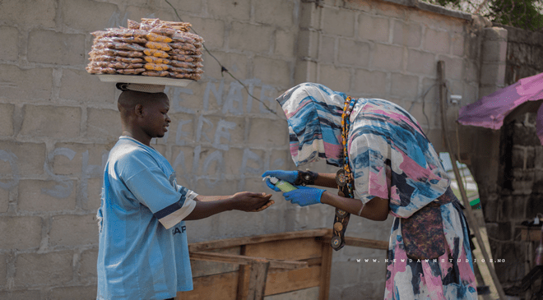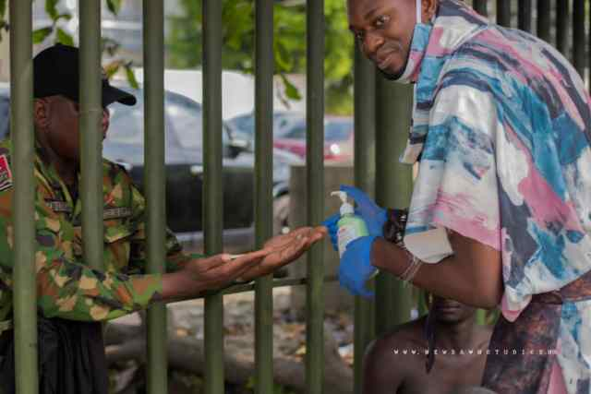

**PLANNED CALENDER FOR UPCOMING ACTIVITIES AND EVENTS**

The primary aim of Bakare’s calendar of appearances is to promote and participate in partnerships with institutions that promote African Culture, Fashion, Arts and Echo Tourism. In addition, to raising funds and support organizations that raise funds for humanitarian causes in his capacity as the tallest model in sub-Saharan Africa.

*Please note some of the events below are pending confirmation. Dates and time of each of the event will be communicated via BAKARE’s official social media handles.*

* Fashion Rebirth (Abuja Nigeria)
* Miss commonwealth International Pageant (London UK) (planed two weeks of UK Tour events tours to be confirmed)
* World Fashion Week (Abuja Nigeria)
* ArtX Lagos (Lagos Nigeria)
* Ilorin Dubar (Ilorin Nigeria)
* Fashion Finest (Lagos Nigeria)
* Dubar Kano (Kano Nigeria)
* Nigeria Travel week (Lagos Nigeria)
* Lagos fashion week (Lagos Nigeria)
* Africa fashion week London (London UK)
* Olojo Festival (Osun state Nigeria)
* African Drum Festival (Ogun State Nigeria)
* Madagascar Fashion week (Madagascar)
* Seashells Fashion week (Seashells)
* AFA, (Mercedes Benz Fashion week) South Africa.
* Fashion without borders (South Africa)
* Soweto Fashion week.
* Amref Art Ball (New York USA)

**GALLERY**

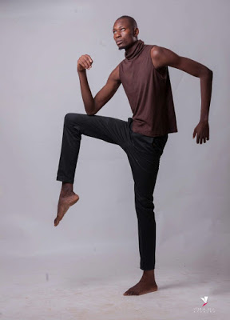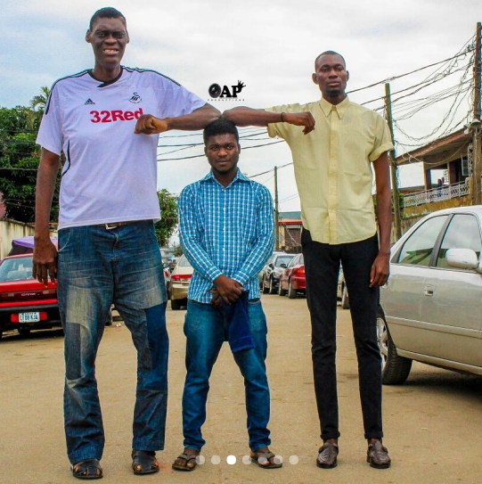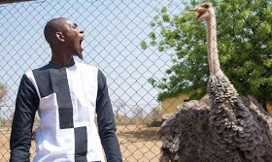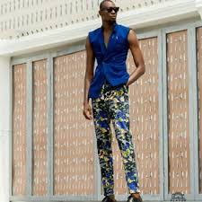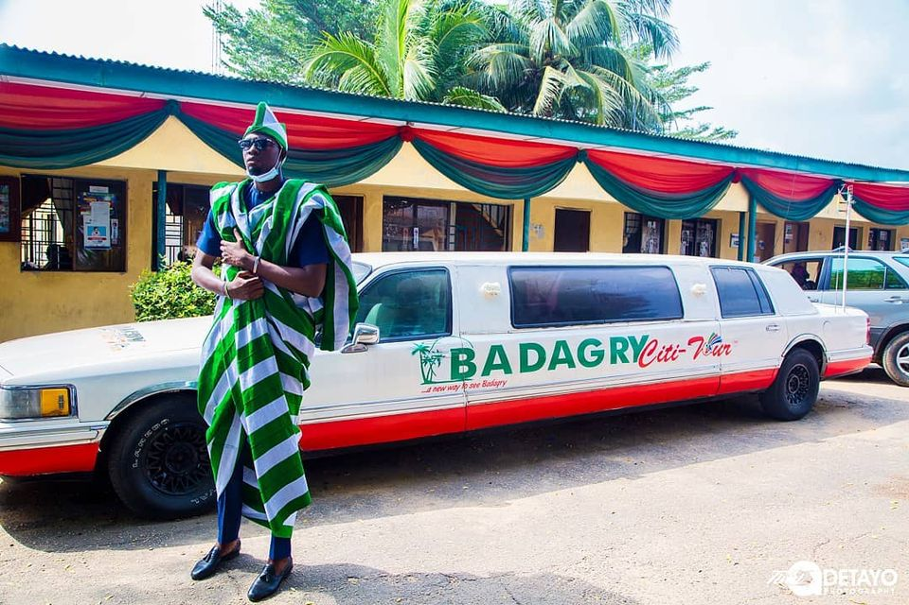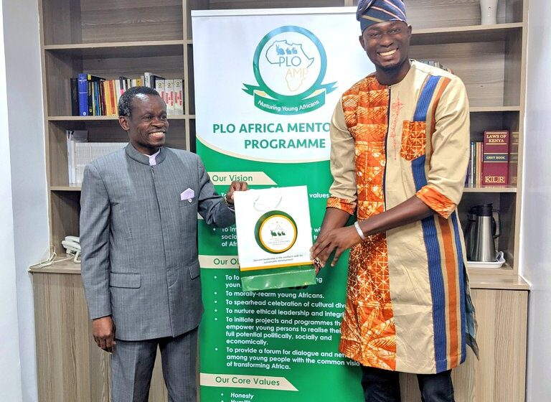

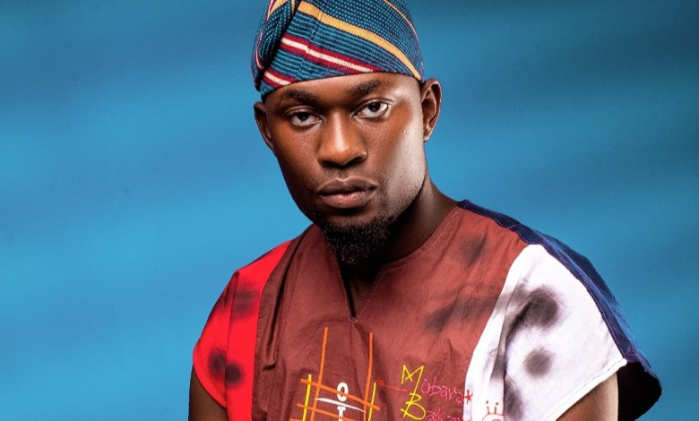

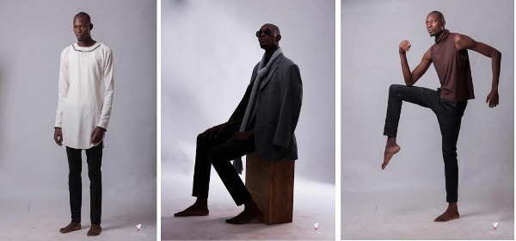



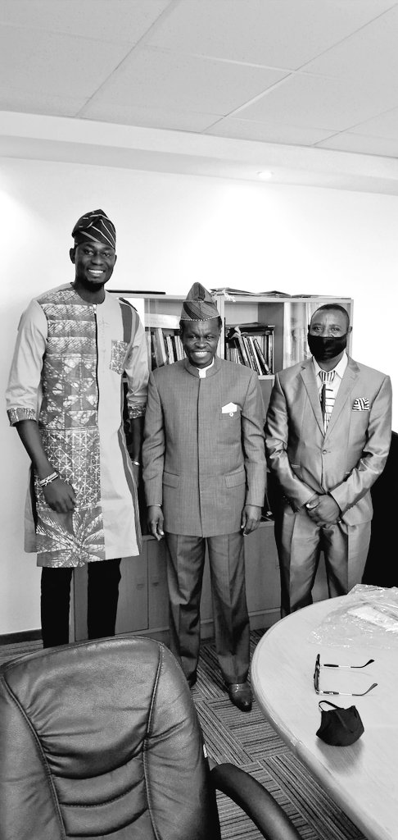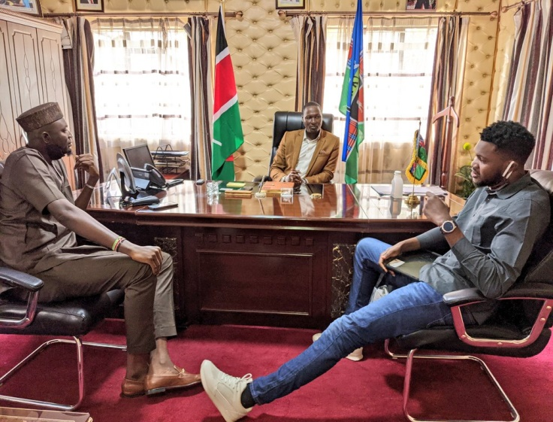

He is not just a model but a revolutionary with huge standards for himself and has graced some of the most renowned runways in the country.