Adamu and Fatima Nigeria LTD

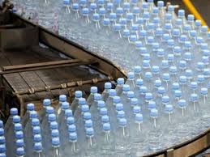

**Adamu and Fatima Nigeria LTD**

**No88888 kano kano stae**

**090\*\*\*\*\*\*\*\*\***

**1223456778**

A&F Nig Ltd (Bottled Water Production Company)

…….the highest standard of excellence refreshing

**Adamu and Fatima Nigeria LTD (Bottle water production)**

**1.0 EXECUTIVE SUMMARY**

A&F Nigeria LTD is a self-service licenced and standard manufacturer of refined clean packaged table water and has long-term presence plans in Kano market and prospective market beyond, including Kaduna, Katsina, Jigawa and Niger. Along with existing investment capital and an extensive industry expertise, the founding members of A&F REFINED WATER are passionate about making the product concept a phenomenal success in the Kano state beginning with our corporate presence in (name of a city), Kano state, Nigeria.

We are in the bottle water production business to engage in purifying and packaging bottled water. We are also in business to make profit and at the same to give our customers value for their money; we want to give people and businesses who patronize our bottled water the opportunity to be part of the success story of A&F Nigeria LTD.

We are aware that there are several large and small scale sachet and bottled water production companies whose products can be found everywhere in Nigeria, which is why we spent time and resources to conduct our feasibility studies and market survey so as to enable us locate the business in an area that will support the growth of the business. We ensured that our facility is easy to locate and we have mapped out plans to develop a wide distribution network for wholesalers all around Kano and environs.

A&F Nigeria LTD will ensure that all our customers (wholesale distributors) are given first class treatment whenever they visit our Depot/Plant. We planned to install a Customer Relation software that will enable us manage a one on one relationship with our customers (wholesale distributors) no matter how large the number of our customer base may grow to. We will ensure that we get our customers involved when making some business decisions that will directly or indirectly affect them.

A&F Nigeria LTD as stated earlier is a profit oriented business with no affiliation with any government body. The founders have over 5 years’ experience working in related industry as a senior manager prior to starting A&F Nigeria LTD. The partners will be working with a team of professionals to build the business and grow it to enviable height.

Adamu and Fatima Nigeria LTD is looking to bring innovation to bottled water where the concept of self-service and its unique product lines are currently in the beginning stage of market penetration. The company’s initial offerings will be a self-service store where the customer can choose from a large variety of bottles in sizes. Through selective marketing we intend to create a loyal customer base that will see A&S bottled water as a high-class, yet affordable packaged water with a quality product offering.

We are in the water production business to make profits and also to give our customers value for their money. These are some of the products that we will be offering;

* Bottled water
* Dispensable water
* Cooling van event services
  1. **OUR MISSION**

To meet the highest standards of excellence refreshing with superb service and product offerings in a friendly, sparkling, and soothing atmosphere.

* 1. **OUR VISION**

To be the leading standard bottled water Production Company whose products will be sold in Kano, and also throughout Nigeria.

* 1. **KEY TO SUCCESS**

Adamu and Fatima Nigeria LTD planned to put the following measures in place to achieve it set objectives. These measures are termed the strategic keys to success. They includes;

* Presenting the highest level of quality achievable in its product line;
* Growing and maintaining relationships with customers and the community to generate repeat sales while constantly adding new ones;
* Allocating a significant and consistent budget in grass roots marketing;
* Innovation a new product design offerings that will differentiate us from competition.

**2.0 COMPANY SUMMARY**

Adamu and Fatima Nigeria LTD is a manufacturer and distributor of bottled waters for use in conjunction with rented company water coolers.

***Corporate Structure***

Adamu and Fatima Nigeria LTD is established as a profit oriented corporation with expectation to have investing corporate partners to secure a going concern objective for the business.

The trade name ‘’Adamu and Fatima Nigeria LTD’’ is in the process of being registered, and the product logo is being finalized for imprinting on the bottles.

***Operations***

A&F Bottled Water will be produced, refined and bottled by Adamu and Fatima Nigeria LTD labelled with a logo. Our cooling van services operation will be done through ahead booking.

***Personal Investment***

Adamu and Fatima has already invested personal funds during the last year in order to thoroughly research the Kano state bottled water industry and verify demand within the local markets through attendance at industry conventions and trade shows (which included attendance and travel expenses). Funds have also been invested in association memberships, logo and label creation, and professional consulting fees in order to incorporate, register the trademark, and finalize the company business plan.

**2.1 COMPANY OWNERSHIP**

Adamu and Fatima is a business that is established with the aim of competing favourably with other leading water brands in Nigeria. This is why we will put the right structure in place that will support the kind of growth that we have in mind while setting up the business.

We will ensure that we only hire people that are qualified, honest, hardworking, customer centric and are ready to work to help us build a prosperous business that will benefit all our stakeholders. As a matter of fact, profit-sharing arrangement will be made available to all our senior management staff and it will be based on their performance for a period of five years or more depending how fast we meet our set target.

In view of that, we have decided to hire qualified and competent hands to occupy the following positions;

* Chief Executive Officer (Owner)
* Plant Manager
* Sales and Marketing Officers
* Accountants/Cashiers
* Distribution Truck Drivers
* Production/Machine Operators
* Cleaners

The role and responsibility of each stakeholder include;

***Chief Executive Officer – CEO (Owner)*:**

The primary role and responsibility of CEO is to, Increases management’s effectiveness by recruiting, selecting, orienting, training, coaching, counselling, and disciplining managers; communicating values, strategies, and objectives; assigning accountabilities; planning, monitoring, and appraising job results; developing incentives; developing a climate for offering information and opinions; providing educational opportunities.

Also, Creates, communicates, and implements the organization’s vision, mission, and overall direction – i.e. leading the development and implementation of the overall organization’s strategy. Other responsibilities include:

Responsible for fixing prices and signing business deals; responsible for providing direction for the business; responsible for signing checks and documents on behalf of the company and responsibility to evaluate the success of the organization.

***Plant Manager***

Responsible in oversee the smooth running of the production plant. The Plant manager forms part of the team that determines the quantity of bottled water that are to be produced per day.

Also, he/she Maps out strategy that will lead to efficiency amongst workers in the plant, responsible for training, evaluation and assessment of plant workers.

Furthermore, ensures that the steady flow of both raw materials to the plant and easy flow of finished products through wholesale distributors to the market. Ensures operation of equipment by completing preventive maintenance requirements; calling for repairs. Responsible for oversee the smooth running of HR and administrative tasks for the organization. Serves as the quality control officer by Ensuring that the plant meets the expected safety and health standard at all times

***Sales and Marketing Manager***

Manages external research and coordinate all the internal sources of information to retain the organizations’ best customers and attract new ones. Model demographic information and analyse the volumes of transactional data generated by customer purchases. Identifies, prioritizes, and reaches out to new partners, and business opportunities et al. Develops, executes and evaluates new plans for expanding increase sales. Documentation of customers’ contact and information and help to increases sales and growth for the company.

***Accountant/Cashier***

Responsible for preparing financial report, budget, and financial statements for the organization. Provides managements with financial analyses, development budgets, and accounting reports; analyses financial feasibility for the most complex proposed projects; conducts market research to forecast trends and business conditions, responsible for financial forecasting and risks analysis, performs cash management, general ledger accounting, and financial reporting, responsible for developing and managing financial systems and policies, responsible for administering payrolls, ensures compliance with taxation legislation, handles all financial transactions for the organization and also Serves as internal auditor for the organization.

***Production Workers/Machine Operators:***

Responsible for purifying and sealing of water, assists in packaging and loading into distribution trucks and any other duty as assigned by the plant manager.

***Distribution Truck Drivers***

Assists in loading and unloading bags of sachet water, maintains a logbook of their driving activities to ensure compliance with federal regulations governing the rest and work periods for operators, keeps a record of vehicle inspections and make sure the truck is equipped with safety equipment, assists the transport and logistics manager in planning their route according to a delivery schedule, local-delivery drivers may be required to sell products or services to stores and businesses on their route, obtain signatures from recipients and collect cash, transport finished goods and raw materials over land to and from manufacturing plants or retail and distribution centres, Inspect vehicles for mechanical safety issues and perform preventative maintenance.

Also, comply with truck driving rules and regulations (size, weight, route designations, parking, break periods etc.) as well as with company policies and procedures, collects and verify delivery instructions and reports defects, accidents or violations.

**3.0 THE PRODUCT AND SERVICES**

Adamu and Fatima Nigeria LTD offers home, office, general market, special order, event delivery of drinking waters, as well as water cooler rentals, under the company label.

***Drinking Water***

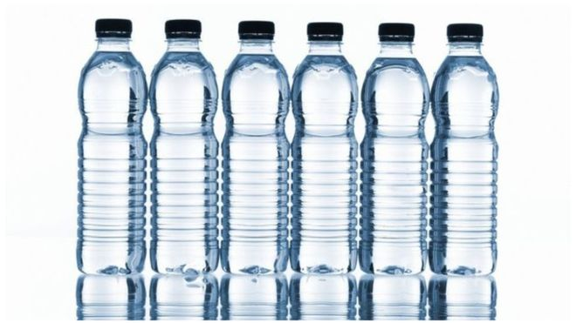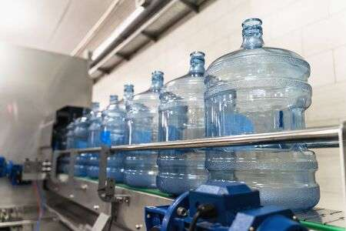

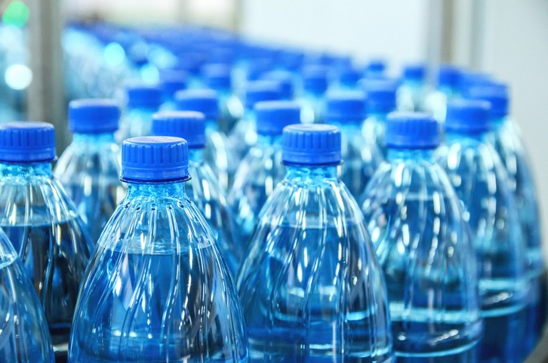

**Bottled water**

The company will offers refined and purified water by a process of reverse osmosis, where the water is forced under pressure through membranes which remove 90% of the dissolved minerals.

Bottled water is produced in different sizes and at different prices and in plastic gallons for offices. Adamu and Fatima Nigeria LTD will be the only water company in the state to offer a special new handle that makes lifting and refilling bottles much easier. Eventually, the company intends to introduce more unique features in the future.

***Cooling-van Rentals***

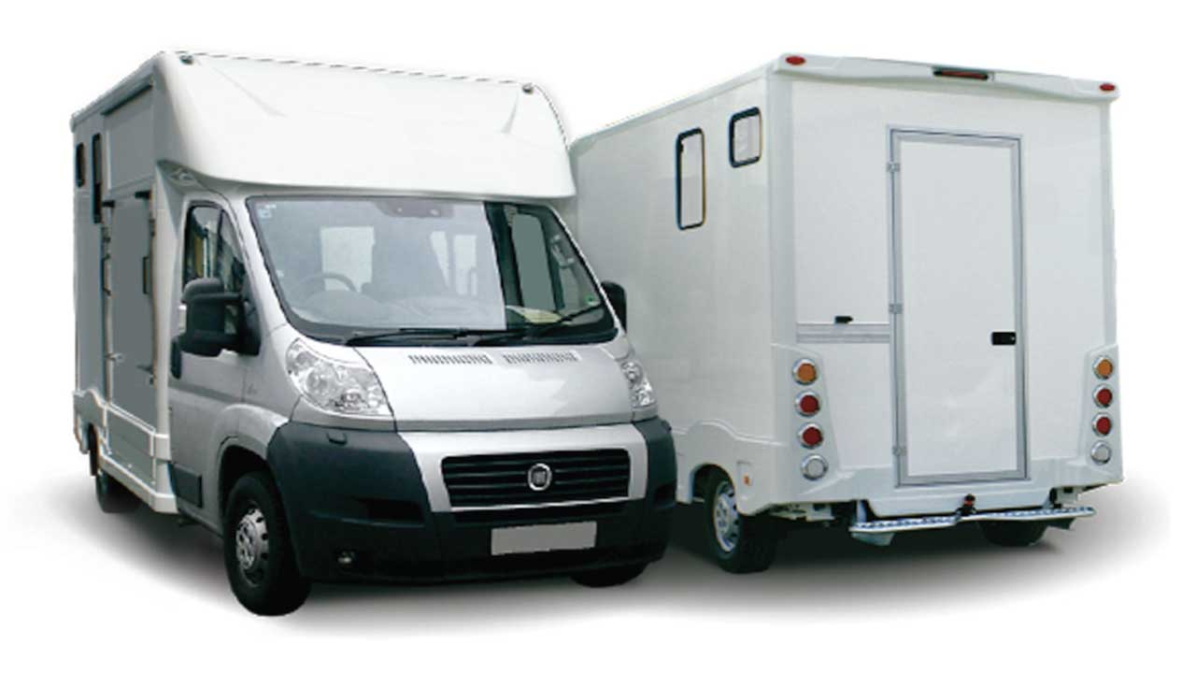***Cooling van***

Adamu and Fatimah Nigeria LTD will offer cooling-van for rent to its customer base, ceremonial events, including standard floor models or counter top models offering choices of cold water only, hot and cold, or room temperature and cold water dispensing.

***Advantages of our Water Delivery initiative***

While many consumers choose to purchase bottled water at the grocery store home and office delivery of water is increasing in popularity for several reasons:

* Convenience —instead of having to lug heavy, bulky bottles all the way from the grocery store home, delivery personnel bring longer-lasting, 5-gallon bottles right inside homes and offices.
* Customer service —if there is ever a problem with the water cooler, Sparkling Horizon arrives quickly to replace it, taking the faulty cooler back to the warehouse for repairs.

**3.1 PRODUCTION PROCESS**

Water is a very sensitive product - - on both microbiological and chemical levels. One of the main challenges of bottled water processing is to consistently produce a quality product free of pathogenic organisms and protozoa that could taint its quality, reduce its shelf life, and be a pathogenic threat to customers. Strict production control is critical to avoid any contamination of pathogenic bacteria or protozoa.

While bottled water production processes differ by type of products and applications, the basic process is the same and can be adapted to fit specific requirements.

The process aims to guarantee the highest safety standards for drinking water and ensure a taste that is in accordance with consumer preference.

* **Water Filtration**

The water must be free of any contaminants that will spoil its quality, reduce its shelf life, and be a pathogenic threat to consumers.

* **Tank venting**

The air in the storage tank must be free of microorganisms to ensure that the water stored will not be contaminated.

* **Carbonation**

Carbonation is the step of adding carbon dioxide to a drink. It is used to produce sparkling water. The CO2 that you inject into the water must be free of particles and microorganisms.

* **Bottle Blower and Bottle Washer**

To maintain the quality of the drink and its shelf life, using a safe and reliable container is essential. The air used in the bottle blower to turn the pre-forms into the final PET bottle must be free of contaminants; its filtration ensures a bottle with low bioburden is produced. Bottle blowing is done during any process using PET bottles. The water used to rinse PET bottles must be free of contaminants; its filtration ensures good quality of the bottles prior to filling.

* **Bottle Filler**

Gas filtration can also be used during the filling process of carbonated drinks. In order for the filling to be possible, the filler bowl must be pressurized, and it is essential that the gas used is microbiologically stable.

**3.2 PRODUCTION and SERVICES MACHINE**

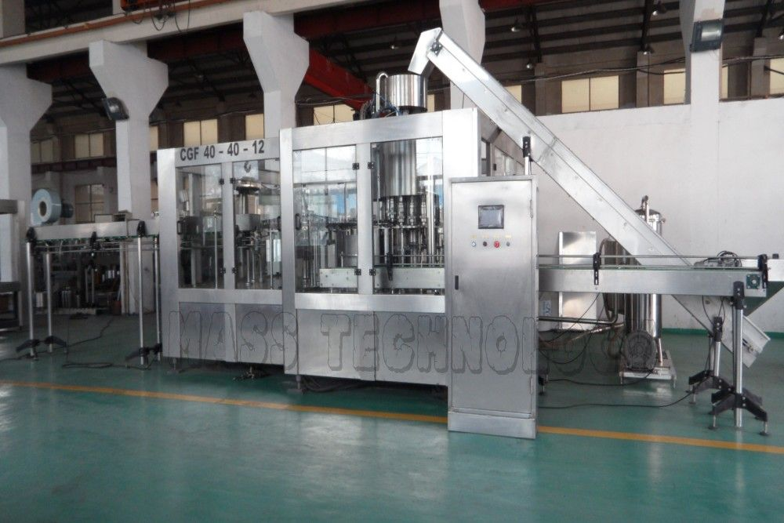

**Water filling machine**

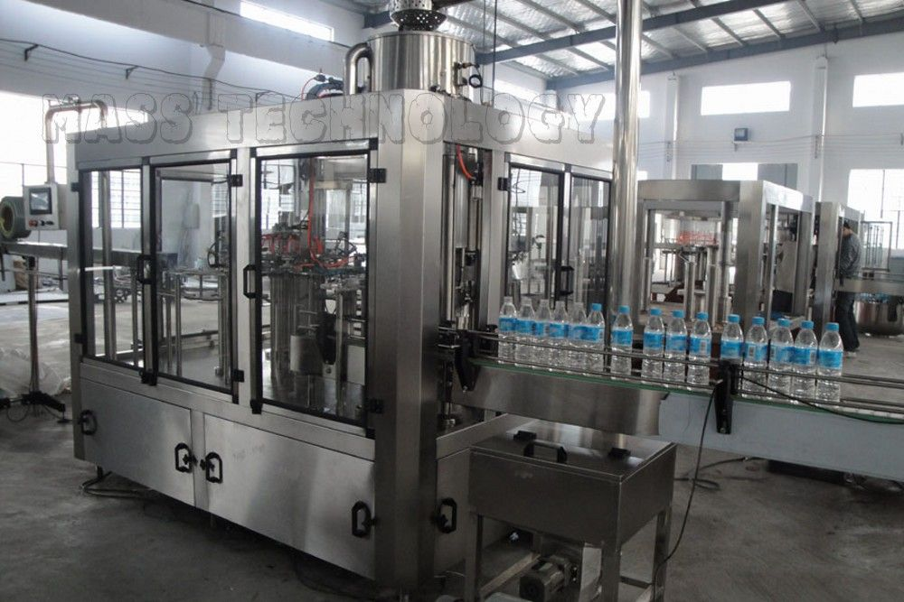**Water bottling machine**

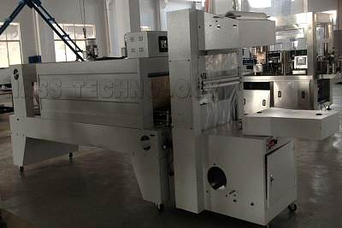**Bottle packaging machine**

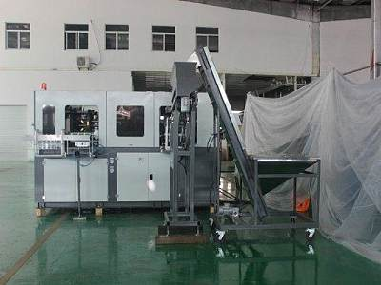**Bottle blowing machine**

**Cooling-van**

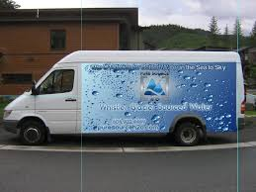

**Delivery van**

**4.0 MARKET ANALYSIS SUMMARY**

If you are conversant with the trend in the sachet/bottled water production industry, you will agree that there are competitions in different stages of the industry. That is competitions amongst bigger corporations such as Pepsi Co, Coca Cola Company and Nestle et al; and also competitions amongst smaller and medium scale bottled water production companies.

Most bottled water companies are leveraging on creativity in terms of packaging and marketing to continue to stay afloat in the industry. One creativity approach that is common is ensuring that their bottled water conforms to the appropriate level.

As a matter of fact, it is common to find sachet or bottled water production companies especially medium scale and small scale bottled water companies labelling their sachet or bottled water for specific occasions to meet the demand of their clients. For example, a client that is celebrating his or her birthday may strike an agreement with a bottled water company to specially label the bottled water that will be served in the occasion to conform with the occasion.

Lastly, another trend in the bottled water production industry is the adoption of eco – friendly approach towards the production and packaging of sachet and bottled water. As a matter of fact, the industry’s adoption of eco-friendly practices will likely persuade environmentally conscious consumers to buy its products, while increasing operators’ efficiency.

**4.1 OUR TARGET MARKET**

When it comes to bottled water, there is indeed a wide range of available customers. In essence, our target market can’t be restricted to just a group of people, but all those who reside in our target market locations. In view of that, we have conducted our market research and we have ideas of what our target market would be expecting from us.

We are in business to engage in wholesale distribution and to retail bottled water to the following groups of people;

* General markets, grocery stores and offices.
* Restaurants and Canteens.
* Event Planners, Parties and Corporate Functions.
* Students (with campus suited package).
* Everybody in our target market location

**4.2 COMPETITION**

There are currently 3 bottled water distributors with solid packaging recognitions in Kano state, however many are also in operation and are actively engaged in home and office delivery of drinking water. The other companies are equipment sales representatives.

The 3 largest competitors are:

Crystal Water

EVA Water

FARO Water

However, these firms, in total, control just 20% of the potential market for bottled water, according to the local Small Business Administration office. In fact, all have stated by phone that they constantly have more orders water delivery than they can handle, indicating strong demand for bottled water that has overrun the capacity of companies already in the market.

**4.3** **OUR COMPETITIVE ADVANTAGE**

A close study of the bottled water production industry reveals that the market has become much more competitive over the last decade. As a matter of fact, you have to be highly creative, customer centric and proactive if you must survive in this industry. We are aware of the stiff competition and we are prepared to compete favourably with other and bottled water production companies in Kano and throughout the neighbouring state – Nigeria.

Adamu and Fatima Nigeria LTD is launching a standard bottled water brand that will indeed become the preferred choice of residents of Kano and every other location where our water will be retailed. Also, the cooling van and event services plan we intend to introduce will give us an edge over our competitors, thereby making us a household name in the industry.

Part of what is going to count as competitive advantage for A&F Water Production Company is the vast experience of our management team; we have people on board who understand how to grow a business from the scratch to becoming a national phenomenon. So also, our large planned national distribution network and of course our excellent customer service culture will definitely count as a strong strength for the business.

Lastly, our employees will be well taken care of, and their welfare package will be among the best within our category in the bottled water industry, meaning that they will be more than willing to build the business with us and help deliver our set goals and achieve all our aims and objectives. We will also give good working conditions and commissions to freelance sales agents that we will recruit from time to time.

**5.0 SWOT ANALYSIS**

We are not unaware that there are several bottled water production companies both large and small all-around Kano State which is why we are following the due process of establishing a business so as to compete favourable with them.

We know that if a proper SWOT analysis is conducted for our business, we will be able to position our business to maximize our strength, leverage on the opportunities that will be available to us, mitigate our risks and be welled equipped to confront our threats.

Adamu and Fatima Nigeria Limited employed the services of an expert HR and Business Analyst with bias in start-up businesses to help us conduct a thorough SWOT analysis and to help us create a business model that will help us achieve our business goals and objectives.

This is the summary of the SWOT analysis that was conducted for Adamu and Fatima Nigeria Limited;

***Strength:***

Part of what is going to count as positives for Adamu and Fatima Nigeria Limited is the vast experience of our management team, our one of its kind technical equipment, we have people on board who are highly experienced and understand how to grow a business from the scratch to becoming a national phenomenon. So also, our large distribution network and of course our excellent customer service culture will definitely count as a strong strength for the business.

***Weakness:***

A major weakness that may count against us is the fact that we are a new bottled water production company and we don’t have the financial capacity to engage in the kind of publicity that we intend giving the business especially when big names like Nestle Foods, The Coca Cola Company and Pepsi Co et al are already determining the direction of the market both in Nigeria and in the globe.

***Opportunities:***

The opportunities for water production companies are enormous. This is due to the fact that sachet water is far cheaper than bottled water and people can easily afford it. As a result of that, we were able to conduct a thorough market survey and feasibility studies so as to position our packages in different affordable sizes to take advantage of the existing market for bottled water and also to create our own new market. We know that it is going to require hard work, but we are determined to achieve it.

***Threat:***

We are quite aware that just like any other business, one of the major threats that we are likely going to face is economic downturn and unfavourable government policies. Another threat that may likely confront us is the arrival of a new bottled water production company in same location where ours is located, but our team will be ready for any unexpected event.

**6.0 SALES AND MARKETING STRATEGY**

From the survey conducted by our research team on the market, we found out that one certainty about the bottled water production business is ‘’Packaging and Positioning’’. If your water is well packaged and branded and if your production plant is centrally positioned and easily accessible, you will always attract sales and that will sure translate to increase in revenue for the business.

To this end, we are well positioned to take on the available markets in Kano – Kano State and every city where our water will be sold and we are quite optimistic that we will meet our set target of generating enough profits from the first six months of operation and grow the business and our clientele base.

Also, we have decided to make our product to be in different affordable sizes. This will make our product an alternative within the same product, same satisfaction at different value. We shall have souvenir and fliers to be share at different occasions and location, this flier will highlight (pictorial highlight) of our range of services; Delivery, ceremonial, special other services and consultancy services. We have been able to critically examine the bottled water production industry and we have analysed our chances in the industry especially in the special order aspect and ceremonial contract and we have been able to come up with arrays of measure to make this our long-term strength.

Furthermore, before choosing a location for Adamu and Fatima Nigeria LTD, we conducted thorough market survey and feasibility studies in order for us to be able to penetrate the available market in our target locations. We have detailed information and data that we were able to utilize to structure our business to attract the number of customers we want to attract per time and also for our products to favourable compete with other leading brands.

We hired experts who have good understanding of the sachet and bottled water production industry to help us develop marketing strategies that will help us achieve our business goal of winning a larger percentage of the available markets in the central and other locations in Kano State.

In other to continue to be in business and grow, we must continue to sell our product to the available market which is why we will go all out to empower our sales and marketing team to deliver our corporate sales goals. In summary, Adamu and Fatima will adopt the following sales and marketing approach to sell our bottled water;

Introduce our bottled water brand by sending introductory letters to residents, corporate entities, offices, restaurants and other stakeholders all around Kano State.

Open our bottled water production company with a party so as to capture the attention of residents who are our first targets

Engage in road shows in targeted communities from time to time to sell our bottled water

Advertise our products in community based newspapers, local TV and radio stations

Leverage on the internet to promote our bottled water brands

Engage in direct marketing and sales

Encourage the use of word of mouth marketing (referrals)

**6.1 PUBLICITY AND ADVERTISING STRATEGY**

Despite the fact that our water production plant is a standard one that can favourably compete with other leading brands, we will still go ahead to intensify publicity for our product. We are going to explore all available means to promote our company’s’ products

Adamu and Fatima Nigeria LTD has a long – term plan of being the largest bottled water production and distributing company, which is why we will deliberately build our brand to be well accepted in Kano – Kano State before venturing out.

As a matter of fact, our publicity and advertising strategy is not solely for selling our products but to also effectively communicate our brand. Here are the platforms we intend leveraging on to promote and advertise Adamu and Fatima Nigeria LTD Water Production Company;

* Sponsor relevant community programs.
* Leverage on the internet and social media platforms like Instagram, Facebook, twitter, et al to promote our different bottled water sizes brand.
* Engage in road shows from time to time in targeted communities.
* Distribute our fliers and handbills in target areas.
* Ensure that our sachet water is well branded and that all our staff members wear our customized clothes, and all our official cars and distribution vans are customized.

**6.2 OUR PRICING STRATEGY**

When it comes to pricing for water, there are two sides to the coin. We are aware of the pricing trend in the sachet and bottled water production industry which is why we have decided to produce various sizes of bottled water.

In view of that, our prices will conform to what is obtainable in the industry but we will ensure that within the first 6 to 12 months our products are sold a little bit below the average price. We have put in place business strategies that will help us run on low profits for a period of 6 months; it is a way of encouraging people to buy into our water brand.

**6.3 PAYMENT OPTIONS**

The payment policy to be adopted by our Company is all inclusive because we are quite aware that different customers prefer different payment options as it suits them but at the same time, we will ensure that we abide by the financial rules and regulation in Nigeria.

Here are the payment options that Adamu and Fatima Nigeria LTD will make available to her clients;

* Payment with cash.
* Payment via online bank transfer.
* Payment via mobile money

In view of the above, we have chosen banking platforms that will enable our clients pay us without any difficulty. Our bank account numbers will be made available on our website and promotional materials so that it will be easier for members to pay for products purchased.

**6.4 COMPETITIVE ADVANTAGE**

Adamu and Fatima Nigeria LTD sales and marketing operations will be centred at every popular market as a top quality provider of bottled water. The company will do this by emphasizing superior customer service in all aspects of the company operations.

One major component of ensuring that customers are delighted with A&F Nigeria Limited products and services is the appointment of a talented and outgoing route delivery person who is responsible for monitoring customer satisfaction and for pursuing new business. Part sales person and part delivery person; an experienced will be hired for this important role.

**7.0 START-UP FACILITIES**

Starting a standard sachet water production company is capital intensive. The bulk of the start-up capital will be spent on acquiring facilities and also in purchasing water purifying and packaging equipment. Asides from that, you are expected to purchase distribution trucks, pay of your employees and also pay utility bills.

**8.0 SUSTAINABILITY AND EXPANSION STRATEGY**

The future of a business lies in the number of loyal customers they have, the capacity and competence of the employees, their investment strategy and their business structure. If all of these factors are missing from a business, then it won’t be too long before the business closes shop.

One of our major goals of starting Adamu & Fatima is to build a business that will survive off its own cash flow without injecting finance from external sources once the business is officially running. We know that one of the ways of gaining approval and winning customers over is to retail our water and other products a little bit cheaper than what is obtainable in the market and we are well prepared to survive on lower profit margin for a while.

Adamu and Fatima Nigeria LTD will make sure that the right foundation, structures and processes are put in place to ensure that our staff welfare is well taken of. Our company’s corporate culture is designed to drive our business to greater heights and training and re – training of our workforce is at the top burner.

As a matter of fact, profit-sharing arrangement will be made available to all our management staff and it will be based on their performance for a period of three years or more. We know that if that is put in place, we will be able to successfully hire and retain the best hands we can get in the industry; they will be more committed to help us build the business of our dreams.