AL-MUBARAQ OIL NIG. LTD

AL-MUBARAQ OIL NIG. LTD BUSINESS PLAN

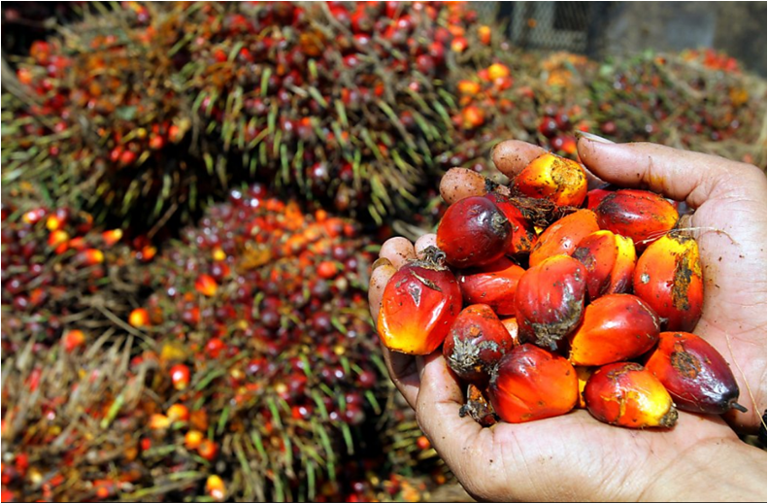

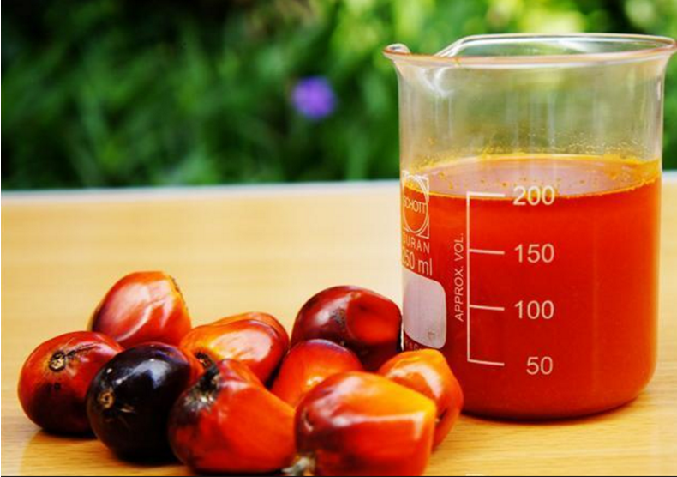

**AL-MUBARAQ OIL NIG LTD**

**NO22, Industries road, Ogbomosho, Oyo state.**

**0801234567**

**1234567890**

**12/1/2019**

CEO: AL-IMAM, AL-MUBARAQ OLUJIDE.

…………..the most tasteful and refined palm oil in Nigeria.

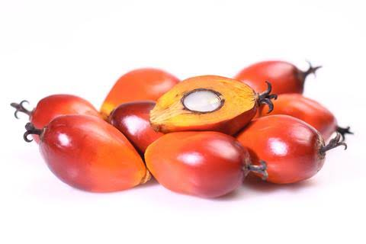

**AL-MUBARAQ NIGERIA LIMITED**

## 1.0 EXECUTIVE SUMMARY

AL-MUBARAQ Nigeria limited is an integrated palm oil production and processing farm involved in the production and processing of unadulterated hygienically prepared palm oil produce targeting the south-west, south-south, north-west, the entire nation and finally the export market. Our firm is highly focused and promised to follow a path of prosperity in oil milling for its owner, staff and outsider consumers. AL-MUBARAQ engages in the crushing and processing of palm kernel in order to extract palm oil. Our intention of starting our own oil producing company is so as to be able to sell highly refined and quality palm oil that is rich in vitamin A, cholesterol and dirt free to our various customers not only here in Nigeria but also beyond as well. Our intention is not only to establish our business for profit making but to also compete favourably with our competitors both nationally and internationally.

Palm kernel is the major raw material in the production of palm-kernel oil. We hope to grow the business from purchasing palm kernel from farmers to owning our palm tree plantation and exporting palm oil to other countries in Africa and the world at large where people consume palm oil or make use of palm oil for the production of soap or body cream et al.

Our business goal as a palm oil processing company is to become the number one choice of households and petty traders in Nigeria and other countries of the world where we intend retailing our palm oil. As a business, we are willing to go the extra mile to invest in owning our own palm tree plantation and also to hire efficient and dedicated employees. We are in the process to secure permits from all relevant departments both at local government level and state level in Oyo state.

AL-MUBARAQ is set to redefine how standard palm oil processing company should be run, not just in Ogbomosho – Oyo State, but also in the whole of the Nigeria. This is why we have put plans in place for continuous training of all our staff at regular interval. No doubt the demand for palm oil is not going to plummet any time soon because there will always be people who can’t cook without palm oil and cottage companies who need palm oil as their raw material et al, which is why we have put plans in place to continue to explore all available market around the communities where we intend retailing our palm oil. We will continue to seek for the best means at ensuring that our products get to our consumers at the right time.

In the nearest future, we will ensure that we create a wide range of distribution channels all across Lagos and Kano Nigeria, the West African Coats and the World at large. With that, we know we will be able to maximize profits in our business.

We intend to incorporate good work ethics as our corporate goal and also be renowned for our transparency standards. In order to ensure that we adhere to our corporate culture, we will recruit the best professionals possible that not only understand the industry we are in but also understand our company’s policies and are dedicated to ensuring that we are able to achieve our goals and objectives.

We will ensure that we get our employees to undergo continuous training that will not only enhance their skills but make them increase productivity for our organization. We will also ensure that our employees are well paid and undergo performance appraisals that will make them put in their best.

**1.1 OBJECTIVE**

Our plan is to position our palm oil processing company to become the leading brand in the palm oil processing line of business in the whole of Nigeria, and also to own our palm tree plantation and become a major wholesale distributor of palm oil throughout Nigeria, the West African Coast and the world at large.

**1.2 OUR MISSION**

Our mission is to produce the most tasteful and refined palm oil using the latest technology in production rather than manual.

**1.3 OUR VISION**

Our vision is to be the largest producer of vitamin rich and dirt free palm oil in the whole of Nigeria before 2020.

**1.4 KEY TO SUCCESS**

* To produces and palm oil of high quality matching industry standards and chemistry expectations.
* To deliver to buyers with punctuality and at competitive and guaranteed prices.
* To give incentives and good purchasing prices to suppliers who deliver to us good quality palm kernel nuts with low moisture content, low shell content and low imparities content and regular basis.

**2.0 PRODUCT AND SERVICES**

Palm kernel is the most common oil nuts grown as an annual crop on about 19 million hectares of land in tropical, sub-tropical and warm temperature regions of the world. They are grown principally for its edible oil and protein rich seeds. The oil content of the seeds is between 45% and 55% depending on the variety. To remove the oil content from the seeds, the process known as oil milling or extraction, expelling or expressing is carried out. Traditionally, these seeds oil extraction involves shelling pods, roasting the shelled seeds, de-skinning/winnowing the seeds, milling the cleaned seeds and kneading the paste produced. Among the different method of oil extraction (traditional, mechanical, chemical and mechano chemical methods, Study revealed that 75% of the rural women engaged in palm kernel processing used the traditional technologies which are labour intensive and time consuming. Also, it was found that amongst 436 processors of palm oil in Nigeria, 74% claimed that they were processing for income generation. Thus, palm kernel processing represents an important economic activity for the women. In recognition of the importance of the activity, as outlined above, many studies were carried out with a view to improving the process. Our research team conducted a study to evaluate the traditional palm oil extraction process. Results revealed that apart from the drudgery involved, a lot of time is wasted in the activity.

AL-MUBARAQ intends to produce and supply highly refined palm kernel oil to its various customers in the region it operate and beyond as well as all over the world.

Our aim as a business entity is to ensure that we not only generate revenue but maximize profit as well and to this end, we intend to create multiple sources of income so as to be able to have a solid bottom line. The ways we will source for extra means of revenue will be according to our ambition and in compliance with the laws.

Therefore the products and services we intend to offer at AL-MUBARAQ OIL NIGERIA LIMITED is the sale of processed Palm kernel oil for domestic and commercial purpose. And also a consultancy services for potential investors in the sector.

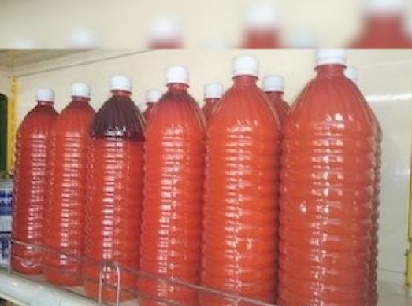

**2.1 PRODUCTION PROCESS**

Palm oil milling process is quite different from other oil seeds processing. Palm oil milling process includes 6 parts: Palm fruits receiving, sterilizing, threshing, digesting and pressing, crude oil clarifying and palm kernel recovery. Our palm oil mill process is low cost and energy-saving.

1. **Raw material reception:**as for the first step of palm oil mill process, collecting the fresh fruit bunches (FFB) and conveys by trucks, then pours the fluster into the discharge door after weighed.

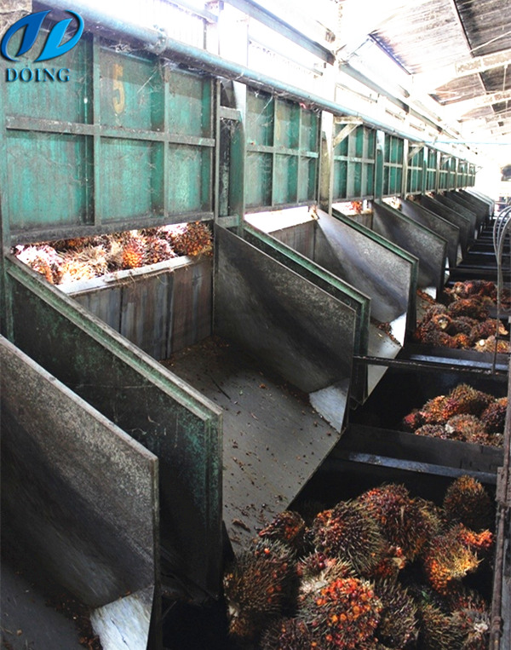

1. [**Sterilization**](https://www.palmoilextractionmachine.com/product/palm_oil_press_machine/palm_fruit_sterilization_station_502.html)**:**FFB are airtight sterilized in sterilizer of palm oil mill process, the purpose is to prevent enzymes broken down, avoiding FFA content in oil further increase.

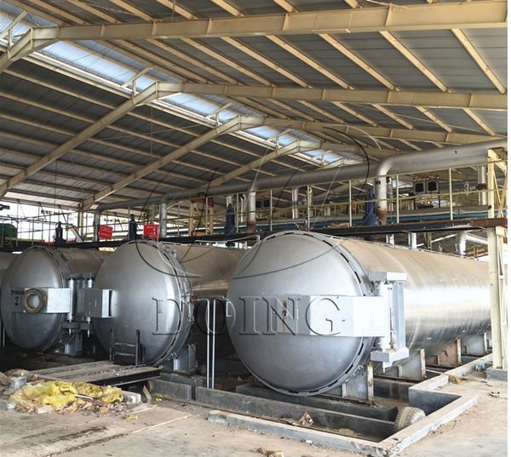

1. [**Threshing**](https://www.palmoilextractionmachine.com/product/palm_oil_press_machine/palm_fruit_threshing_machine_291.html)**:**the purpose of threshing in the palm oil mill process is to separate the palm fruit from the FFB. The drum type thresher is the usual machine to separate the fruit.

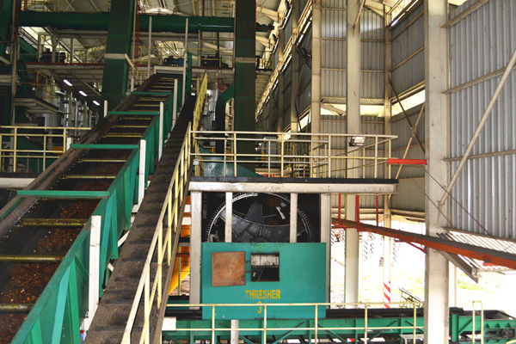

1. [**Digesting and pressing**](https://www.palmoilextractionmachine.com/product/palm_oil_press_machine/palm_oil_pressing_station_501.html)**:** the purpose of digesting in the palm oil mill process is to separate the pulp and nut and crush the palm pulp.  Then it is sent to continuous screw press. After pressing of palm oil mill process, oil palm fruit is divided into two parts: the mixture of oil, water and solid impurities, and the press cake (fiber and nut)

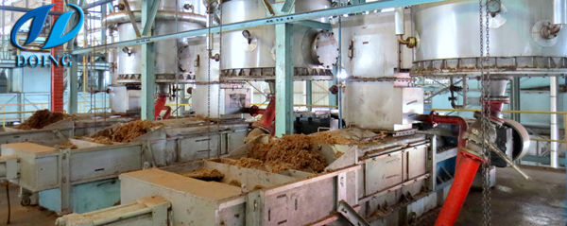

1. **Oil clarification:**as for the oil clarification of palm oil mill process, oil is clarified by the vibrate screen.

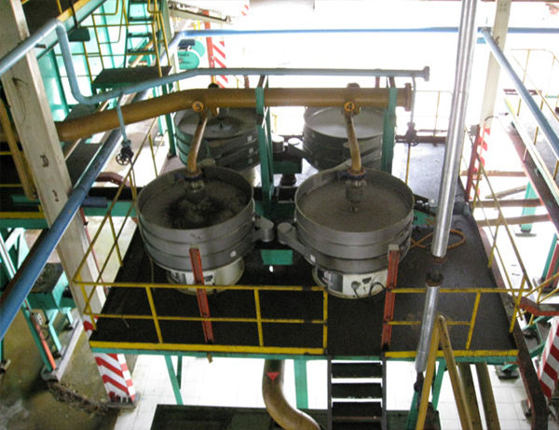

1. **Oil clarification:**as for the oil clarification of palm oil mill process,oil is clarified by the vibrate screen.

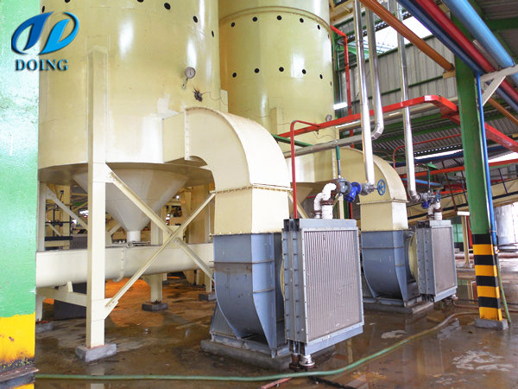

**2.2 PRODUCTION FLOW-CHAT**

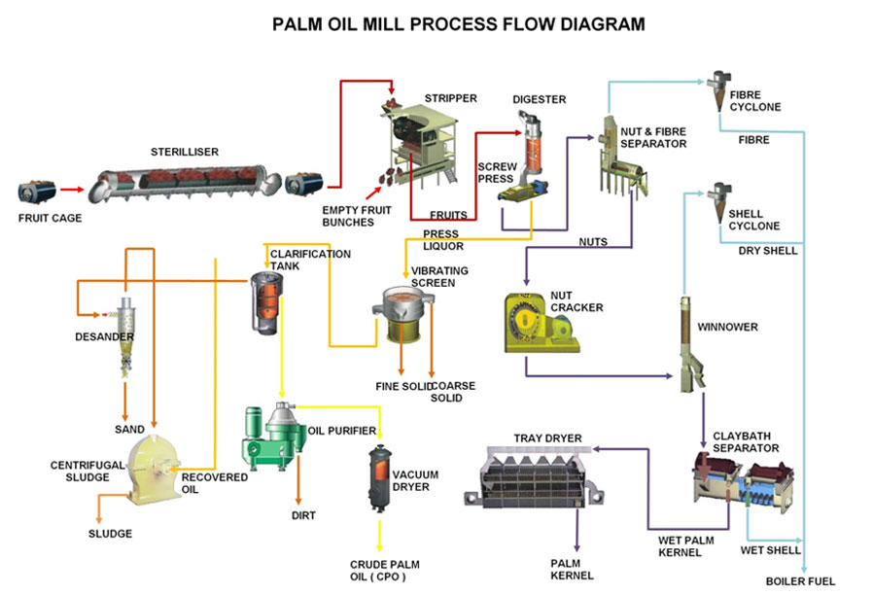

**3.0 MARKET ANALYSIS SUMMARY**

Nigeria with an estimated population of over 180 million people with national population growth rate of 5.7% per annum and an average economic growth rate 3.5% per annum. In the past five years it has a very large market for palm oil. This is because about 80% of all the edible palm oil consumed in Nigeria is made from refined Palm kernel seeds.

So with these, the demand for oil in the local market is very huge, as a result that, the refineries that uses it as their raw materials do book for the products and pay in advance in order to secure the products.

Going by a recently concluded detailed research, presents a detailed analysis which shows that demand and supply gap is currently estimated to be between 500,000 metric tons to 600,000 metric tons per annual. An estimate also shows that Nigeria requires about 1,950,000 tons of palm oil to meet up to the national requirements for food and non-food uses.

One major trend in this line of business is that most registered and well organized palm oil processing companies look beyond the market within their locations or even Nigeria; they are involved in packaging and exporting palm oil to communities abroad with robust Nigerian cum African communities. United States of America, Canada and most countries in Europe are their major targets.

Lastly, in the bid to stay afloat and continue to make profits from this line of our business, we tend to work hard to ensure that we own our own palm tree plantation. With that, it will be easier for us to maximize profits and grow the business.

**3.1 OUR TARGET MARKET**

When it comes to retailing processed palm oil, there is indeed a wide range of available customers. In essence, our target market can’t be restricted to just a group of people, but all those who make use of palm oil for cooking and also all those who make use of palm oil as raw material in the cottage industry.

One thing is certain; there are no restrictions to the demographic and psychographics composition of the target market for oil in Nigeria. This goes to show that the target market for palm oil is wide and far reaching, you can create your own make niche yourself to serve a specific purpose.

In view of that, we have conducted our market research and we have ideas of what our target market would be expecting from us. We are in business to engage in retailing and wholesale distribution cum exporting of palm oil to the following groups of people:

* Households who make use of palm oil for cooking
* Restaurants and canteens that make use of palm oil for cooking
* Nigerian cum African communities in the United States of America, Canada, and Europe
* Small scale businesses that make use of palm oil as part of their raw material.

**3.2 OUR COMPETITIVE STRATEGY**

**Our Competitive Advantage**

First and foremost, the fact that anybody with a business cum retailing skills can decide to start palm oil processing business means that the business is open to all and sundry hence it is expected that there will be high – level competition in the industry. There is hardly any busy community where palm trees can easily be cultivated that you won’t find several oil processing businesses especially on a small scale level.

As a standard palm oil processing business, we know that gaining a competitive edge requires a detailed analysis of the demographics of the surrounding area and the nature of existing competitors. And even if you are successful at first, new competitors could enter your market at any time to steal your regular customers. Hence we will not hesitate to adopt successful and workable strategies from our competitors.

We are going to be one of the very few palm oil processing companies in Ogbomosho – Oyo State that will also engage in wholesale distribution of palm oil all across Nigeria and also export palm oil to other countries of the world.

Another competitive advantage that we have is the vast experience of our management team, we have people on board who are highly experienced and understands how to grow business from the scratch to becoming a national phenomenon. Our large and robust distribution network and of course our excellent customer service culture will definitely count as a strong strength for the business.

One thing is certain, we will ensure that in future, we own our palm tree plantations all across states in the southern part of Nigeria where palm trees can easily be cultivated. With that our brand will be well communicated and accepted nationally.

Lastly, our employees will be well taken care of, and their welfare package will be among the best within our category (start-ups palm oil processing companies) in the industry, meaning that they will be more than willing to build the business with us and help deliver our set goals and achieve all our aims and objectives. We will also give good working conditions and commissions to freelance sales agents that we will recruit from time to time.

**4.0 SALES AND MARKETING STRATEGY**

AL-MUBARAQ OIL NIGERIA LIMITED is established with the aim of maximizing profits in the palm oil processing line of business both in Oyo state and throughout key cities in Nigeria and of course in some countries of the world. We are going to go all the way to ensure that we do all it takes to sell our palm oil both in retail and wholesale to a wide range of customers who make use of palm oil. AL-MUBARAQ OIL NIGERIA LIMITED will generate income by simply selling palm oil.

**4.1 OUR SALES FORCAST**

One thing is certain when it comes to palm oil processing business, if your business is centrally positioned and easily accessible, you will always attract customers cum sales and that will sure translate to increase in revenue generation for the business.

We are well positioned to take on the available market in Nigeria and every other countries of the world where we intend exporting our palm oil to and we are quite optimistic that we will meet our set target of generating enough income / profits from the first six month of operations and grow the business and our clientele base.

We have been able to critically examine the palm oil processing line of business and we have analysed our chances in the industry and we have been able to come up with the following sales forecast. The sales projection is based on information gathered on the field and some assumptions that are peculiar to start-ups in Oyo State – Nigeria.

Below are the sales projection for AL-MUBARAQ OIL, it is based on the location of our business and other factors as it relates to small scale and medium scale coconut oil production company start – ups in the United States;

* **First Fiscal Year-:** N2,690,000
* **Second Fiscal Year-:** N5,700,000
* **Third Fiscal Year-:** N10,000,000

**N.B**: This projection is done based on what is obtainable in the industry and with the assumption that there won’t be any major economic meltdown and there won’t be any major competitor offering same product and customer care services as we do within same location. Please note that the above projection might be lower and at the same time it might be higher.

**4.2 MARKET AND SALES STRATEGY**

Before choosing a location to launch AL-MUBARAQ OIL NIGERIA LIMITED, we conduct a thorough market survey and feasibility studies in order for us to be able to be able to penetrate the available market in Nigeria and the international market. We have detailed information and data that we were able to utilize to structure our business to attract the numbers of customers we want to attract per time and also for us to compete with other palm oil processing companies.

We hired experts who have good understanding of the palm oil processing line of business to help us develop marketing strategies that will help us achieve our business goal of winning a larger percentage of the available market for our products.

In other to continue to be in business and grow, we must continue to sell our palm oil to the available market which is why we will go all out to empower or sales and marketing team to deliver our corporate sales goals. In summary, AL-MUBARAQ OIL will adopt the following sales and marketing approach to sell our wide range of packaged palm oil;

* Introduce our palm oil product cum business by sending introductory letters to residence, merchants and other stakeholders both in Nigeria and abroad.
* Open our palm oil processing business with a party so as to capture the attention of residence who are our first targets
* Engage in road show in targeted communities  from time to time to sell our products
* Advertise our products in community based newspapers, local TV and radio stations
* List our business and products on yellow pages ads  (local directories)
* Leverage on the internet to promote our product cum business
* Engage in direct marketing and sales
* Encourage the use of Word of mouth marketing (referrals)

**4.3 PUBLICITY AND ADVERTISING STRATEGY**

Regardless of the fact that our palm oil processing business is a standard one that can favourably compete with other leading palm oil processing business in Nigeria and in any part of the world, we will still go ahead to intensify publicity for all our products and brand. We are going to explore all available means to promote AL-MUBARAQ OIL.

AL-MUBARAQ OIL NIGERIA LIMITED has a long term plan of owning our own palm tree plantations all across the southern part of Nigeria and export our product all across the world. This is why we will deliberately build our brand to be well accepted in South-west states before venturing out to other cities in Nigeria and the world. As a matter of fact, our publicity and advertising strategy is not solely for selling our products but to also effectively communicate our brand.

Here are the platforms we intend leveraging on to promote and advertise Delta Palm Oil Ventures;

* Place adverts on both print (community based newspapers and magazines) and electronic media platforms
* Sponsor relevant community programs
* Leverage on the internet and social media platforms like; Instagram, Facebook , twitter, et al to promote our brand
* Install our Bill Boards on strategic locations all around major communities in Nigeria
* Engage in road show from time to time in targeted communities
* Distribute our fliers and handbills in target areas
* Position our Flexi Banners at strategic positions in the location where we intend getting customers to start patronizing our palm oil.
* Ensure that all our staff members wear our customized clothes, and all our official cars and distribution trucks are customized and well branded.

**4.4 OUR PRICING STATEGY**

When it comes to pricing for products such as palm oil, there are no hard and fast rules, the prices depends are based on per liter or the container in which the palm oil are placed in.

In view of that, our prices will conform to what is obtainable in the industry but will ensure that within the first 3 to 6 months our palm oil are sold a little bit below the average prices when compared to other palm oil retailing businesses in Nigeria. We have put in place business strategies that will help us run on low profits for a period of 6 months; it is a way of encouraging people to buy into our brands.

**4.5 PAYMENT METHOD**

The payment policy adopted by AL-MUBARAQ OIL is all inclusive because we are quite aware that different customers prefer different payment options as it suits them but at the same time, we will ensure that we abide by the financial rules and regulation in the country.

Here are the payment options that AL-MUBARAQ OIL NIGERIA LIMITED will make available to her clients;

* Payment via bank transfer
* Payment with cash
* Payment via online bank transfer
* Payment via check
* Payment via bank draft

In view of the above, we have chosen banking platforms that will enable our client make payment for farm produces purchase without any stress on their part. Our bank account numbers will be made available on our website and promotional materials to clients who may want to deposit cash or make online transfer for the purchase of palm oil in wholesale.

**5.0 SWOT ANALYSIS**

SWOT analysis is a strategic planning tool that is used to do a situational analysis of a company operation. It is an important technique present to you to understand the Strengths (S), Weakness (W), Opportunities (O) & Threats (T) AL-MUBARAQ OIL NIGERIA LIMITED will be facing in its current business environment. The SWOT Analysis framework helps an organization to identify the **internal strategic factors** such as -strengths and weaknesses, & **external strategic factors** such as - opportunities and threats. It leads to a 2X2 matrix – also known as **SWOT Matrix**

### STRENGTHS

Our strength lies in the fact that we offer our customers’ high quality processed palm oil which is cholesterol free. This means that customers who use other substitutes because they feel those are better for their diet will stick to our own brand of oil instead. We are in a location that is not only strategic but also convenient for our customers and employees to access. Other includes;

* STRONG DEALER COMMUNITY: AL-MUBARAQ OIL has built a culture among distributor & dealers where the dealers not only promote company’s products but also invest in training the sales team to explain to the customer the maximum nutritional benefits out of the products.
* SUPERB PERFORMANCE: AL-MUBARAQ OIL has built expertise at entering new markets and making success of them. The expansion has helped our organization to build new revenue stream and diversify the economic cycle risk in the markets we operates in.
* RELIABLE SUPPLIERS: AL-MUBARAQ OIL has a strong base of reliable supplier of raw material thus enabling the company to overcome any supply chain bottlenecks.
* GOOD RETURNS ON CAPITAL EXPENDITURE: AL-MUBARAQ OIL is relatively successful at execution of new projects and generated good returns on capital expenditure by building new revenue streams. As seen in the production of groundnut cake.

**WEAKNESSES**

The palm oil processing industry is a saturated one and so would require us to adapt strategies that would allow us to stand out against our competitors. Also, because we are just starting up, we do not yet have the necessary finances and staff strengths as our already established competitors.

These weaknesses are the areas where AL-MUBARAQ OIL can improve upon. Strategy is about making choices and weaknesses are the areas where an organization can improve using SWOT analysis and build on its competitive advantage and strategic positioning.

* Need more investment in new technologies. Given the scale of expansion and different geographies the company is planning to expand into, AL-MUBARAQ OIL needs to put more money in technology to integrate the processes across the board. Right now the investment in technologies is not at par with the vision of the company.
* The marketing of the products left a lot to be desired. Even though the product is a success in terms of sale but its positioning and unique selling proposition is not clearly defined which can lead to the attacks in this segment from the competitors.
* The company has not being able to tackle the challenges present by the new entrants in the segment and has lost small market share in the niche categories. AL-MUBARAQ OIL has to build internal feedback mechanism directly from sales team on ground to counter these challenges.
* Days inventory is high compare to the competitors – making the company raise more capital to invest in the channel. This can impact the long term growth of AL-MUBARAQ OIL OPPORTUNITIES

There are several opportunities that abound for us in this industry as cooking oil is widely consumed by a whole lot of people. We are however seeking innovative ways to attract the health conscious customers who have shifted to alternative sources because they feel that palm isn’t hygienic enough in helping to achieve their fitness goals. Our advisory and consultancy services will serve to open up more opportunities for us in this industry.

* Economic uptick and increase in customer spending, after years of recession and slow growth rate in the industry, is an opportunity for AL-MUBARAQ OIL to capture new customers and increase its market share.

### Government green drive also opens an opportunity for procurement of AL-MUBARAQ OIL products by the state as well as federal government contractors.

* Stable free cash flow provides opportunities to invest in adjacent product segments. With more cash in bank the company can invest in new technologies as well as in new products segments. This should open a window of opportunity for AL-MUBARAQ OIL in other product categories.
* The planned market development will lead to dilution of competitor’s advantage and enable AL-MUBARAQ OIL to increase its competitiveness compare to the other competitors.

### THREATS

Threats in a business environment are normal expectations if the business is a serious one. The threats that we are likely to face as an processing company will arise from unfavourable government policies, stiff competition from competitors, as well as customers’ shift to close substitutes on personal preference grounds. We have laid down strategies in place that will enable us handle whatever threats we are likely to face. Other may include;

* Imitation of the counterfeit and low quality product is also a threat to AL-MUBARAQ OIL product especially in the emerging markets and low income markets.
* Rising pay level especially the introduction of the new minimum wage for workers can lead to serious pressure on profitability of AL-MUBARAQ OIL.
* Liability laws in different countries are different and AL-MUBARAQ OIL may be exposed to various liability claims given change in policies in those markets.
* The company can face lawsuits in various markets given - different laws and continuous fluctuations regarding product standards in those markets.
* Rising raw material can pose a threat to the AL-MUBARAQ OIL profitability.
* As the company is operating in numerous countries it is exposed to currency fluctuations especially given the volatile political climate in number of markets across the world.

**6.0 START-UP BUDGET**

In setting up any business, the amount or cost will depend on the approach and scale you want to undertake. If you intend to go big by renting a place, then you would need a good amount of capital as you would need to ensure that your employees are well taken care of, and that your facility is conducive enough for workers to be creative and productive.

This means that the start-up can either be low or high depending on your goals, vision and aspirations for your business.

The tools and equipment that will be used are nearly the same cost everywhere, and any difference in prices would be minimal and can be overlooked. As for the detailed cost analysis for starting a palm oil processing business; it might differ in other countries due to the value of their money.

We know that no matter where we intend starting our palm oil processing business, we would be required to fulfil most of the items listed below;

* The Fee for registering the business (venture) in Nigeria – **N15,000**
* Legal expenses for obtaining licenses and permits as well as the accounting services (software, P.O.S machines and other software) – **N70,000**
* Marketing promotion expenses for the grand opening of AL-MUBARAQ OIL NIGERIA LIMITED **N150,000**
* Cost for hiring Business Consultant – **N50,000**
* Insurance (general liability, workers’ compensation and property casualty) coverage at a total premium – **N60,000**
* Cost of acquiring land erecting factory building and offices inclusive –**N7,800,000**
* Other start-up expenses including stationery and phone and utility deposits – **N25,000**
* Operational cost for the first 3 months (salaries of employees, payments of bills et al) – **N450,000**
* The cost for Start-up inventory (palm kernel supply, storage tanks, drums, bottles and packaging materials et al) – **N1,050,000**
* Cost for store equipment (cash register, security, ventilation, signage) – **N150,000**
* Cost of purchase of distribution van – **N 850,000**
* The cost for the purchase of furniture and palm oil processing equipment – **N30,000,000**
* The cost of Launching a Website – **N25,000**
* The cost for our opening party – **N100,000**
* Miscellaneous – **N200,000**

We would need an estimate of **N40, 945, 000** to successfully set up a standard and world class Palm oil processing business. Please note that this amount includes the salaries of all the staff for the first 3 month of operation.

However, to start on a small scale (using advanced traditional means), the budgeted expenditure required are;

* The Fee for registering the business (venture) in Nigeria – **N15,000**
* Legal expenses for obtaining licenses and permits as well as the accounting services (software, P.O.S machines and other software) – **N30,000**
* Marketing promotion expenses for the grand opening of Delta Palm Oil Ventures – **N15,000**
* Cost for hiring Business Consultant – **N20,000**
* Insurance (general liability, workers’ compensation and property casualty) coverage at a total premium – **N20,000**
* Cost for payment of rent for 12 month and renovation inclusive –**N24,000**
* Other start-up expenses including stationery and phone and utility deposits – **N5,000**
* Operational cost for the first 3 months (salaries of employees, payments of bills et al) – **N200,000**
* The cost for Start-up inventory (palm kernel supply, storage tanks, drums, bottles and packaging materials et al) – **N320,000**
* Cost for store equipment (cash register, security, ventilation, signage) – **N10,000**
* Cost of purchase of distribution trucks – **N450,000**
* The cost for the purchase of furniture and palm oil processing equipment (Computers, Printers, Telephone, Fax Machines, tables and chairs et al) – **N15,000**
* The cost of Launching a Website – **N25,000**
* The cost for our opening party – **N10,000**
* Miscellaneous – **N10,000**

We would need an estimate of **N750, 000** to successfully set up a minimum standard and world class Palm oil processing business. Please note that this amount also includes the salaries of all the staff for the first 3 month of operation.

## 7.0 MANAGEMENT SUMMARY

Building a Management Structure that will right for oil business is very important to us, which is why we are making sure that we put in all efforts to recruit and the right hands that will help us achieve our goals and objectives.

It is important that our management team understand and identify with our core vision and objectives and as such is able to effectively communicate these policies and goals to the lower end staff and ensure that it is effectively implemented.

Due to the fact that we intend to offer additional services to our core service, our management structure include more employees than the conventional oil producing company. This is so that the different tasks will be effectively handled without pushing too many responsibilities in the hands of a few employees.

* Chief Executive Officer
* Plant Manager
* Purchasing Manager
* Human Resources and Admin Manager
* Accountants
* Marketing Executives
* Truck Drivers
* Customer Care Executives
* Maintenance Team
* Security Guard

## 6.1 Roles and Responsibilities of individual management

**Chief Executive Officer**

* Creates strategies and policies for the overall direction of the organization
* Responsible for negotiating with high level clients on behalf of the organization
* Ensures that policies created are effectively implemented

**Plant Manager**

* Monitors production processes and ensures that it aligns with both company and industry standard
* Develops and implements budgets for production
* Seeks ways to reduce costs without reducing quality

**Purchasing Manager**

* Sources for reliable vendors and suppliers of raw materials
* Drafts purchasing contracts and ensures that it is to the benefit of the organization
* Drafts and implements purchasing strategies on behalf of the organization

**Human Resources and Admin Manager**

* Responsible for recruiting, giving orientation as well as ensuring that customers get attuned to the company’s policies
* Responsible for employee welfare and incentive packages as well as carrying out performance appraisals on behalf of the company
* Ensures that the administrative functions of the organization are carried on smoothly

**Accountants**

* Responsible for creating ensuring the implementation of financial statements, records and budget on behalf of the organization
* Prepares tax records and ensures that they are submitted to the right authorities
* Responsible for cash inflow and outflow and petty cash

**Marketing Executives**

* Drafts effective marketing strategies and modifies them continuously in order to generate revenue for the organization
* Engages in direct marketing with customers on behalf of the organization
* Manages existing customer relationship in order to help increase customer loyalty and retention on behalf of the organization

**Truck Drivers**

* Responsible for delivering products to customers at accurate destinations
* Carry out maintenance on the vehicle when necessary and report major faults to the management
* Keep traffic laws and regulations and also a logbook

**Customer Care Executives**

* Responsible for taking orders, answering enquiries and providing accurate information to clients.
* Ensures that customers’ complaints are readily resolved on behalf of the company
* Keeps an updated customer database on behalf of the company

**Maintenance Team**

* In charge of maintaining all the equipment and machineries used by the organization
* Arranges for new parts and replacements for the machineries
* Reports major machinery and equipment faults to the management

**Security Guard**

* Patrols the facility and its perimeter during work and after work hours to ensure that there is no trespasser
* Monitors incoming and outgoing people and visitor and responsible for surveillance equipment
* Remains updated on security tips and ensures that company staff is aware of security tips as well