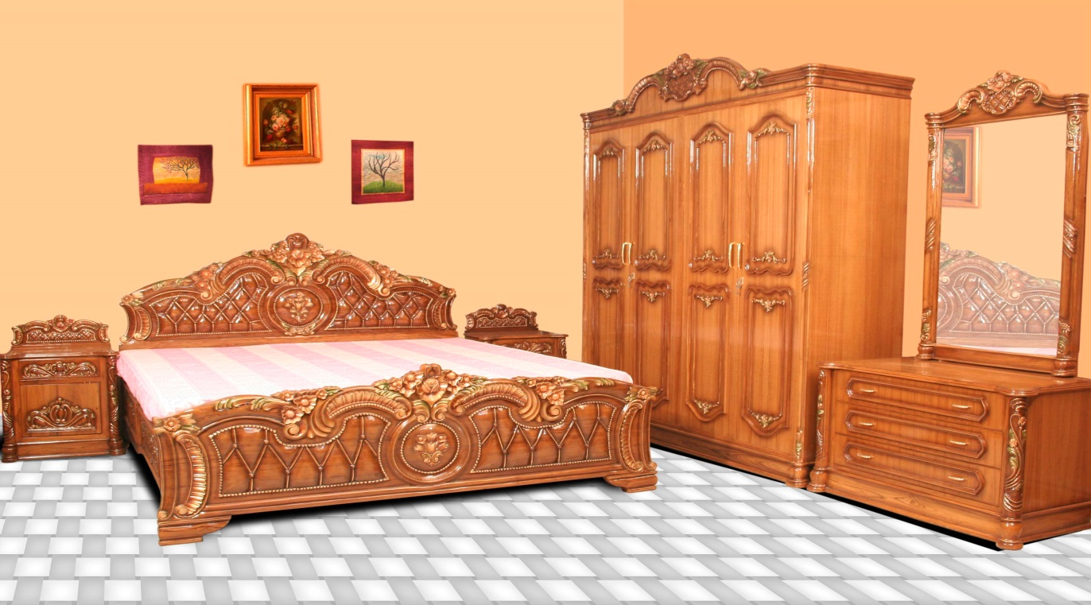

AA DAURAWA NIGERIA LIMITED BUSINESS PLAN

**[Type the company name]**

**[Type the company address]**

**[Type the phone number]**

**[Type the fax number]**

**1/1/2019**

AA DAURAWA 2019

The number one furniture suppliers in Kano state and the leading brand in the furniture manufacturing industry in Nigeria

**AA DAURAWA NIG LIMITED**

1. **EXECUTIVE SUMMARY**

AA DAURAWA NIGERIA LIMITED, we are a sole proprietorship business that is into Furniture Works. Our company operates in Kano, Kano state, Nigeria. And we currently planning to put in place a workshop/warehouse and will start production as soon as the grant fund and required machinery is put in place.  The construction of the building will be completed using environmentally friendly materials and installing energy efficient equipment.

At AA DAURAWA NIGERIA LIMITED, will manufacture a wide range of household furniture (living room, dining room and bedroom furniture, upholstered, coffee tables, sofa tables, end tables, sofas, love seats, chairs, bookshelves, ottomans, display cabinets, consoles and TV stands and otherwise), outdoor and office furniture (Desks and home office goods, lamps, recliners, rugs and outdoor furniture). We are set to serve a wide range of clientele in and around Kano state and beyond.

Our company operations will also include upholstery and welding services in compliance with the desires and concepts of our residential and commercial customers. And, following the Nigerian and global market trend, our work will be dedicated to providing our clients with the highest quality workmanship, meeting up with agreed deadlines, and executing the each project with the preferences of the client in mind. The major focus of this business plan is to identify the future target clients for our company, introduce our marketing strategy, and to improve our procedures so it can substantially increase profitability. Our company will be a standard and registered furniture manufacturing that will be located in Kano – Kano state; in an ideal location highly suitable for the kind of business we want to establish. We will need a facility that is big enough (a 20 thousand square foot facility) to fit into the design of the kind of standard furniture manufacturing company that we intend launching.

Although, we are very much aware that there are several large and small furniture manufacturing companies all around Kano, which is why we spent time and resources to conduct a thorough feasibility studies and market survey so as to be well positioned to favourably compete with all our competitors.

We have prepared this document to provide investors with information about our company. This includes our company goals, visions/mission, business structure, projected profit growth, business capital requirements, investment analysis and the furniture industry trends.

1.2 **MISSION STATEMENT**

To exceed the customers’ expectations, in every sense, by providing them with quality, durable and exceptional furniture products and services.

1.3 **VISION STATEMENT**

To be number one furniture suppliers in Kano state and to become the leading brand in the furniture manufacturing industry in Nigeria.

1.4 **KEY TO SUCCESS**

At AA DAURAWA NIGERIA LIMITED we planned to put the following measures in place to achieve our set objectives. These measures are termed “the strategic keys to success”. They include;

* Offer our customers affordable quality furniture that will last.
* Customize any piece as requested by a customer.
* And if customizing a piece won't quite work, create a whole new piece from scratch, exactly to the customer's specifications.
* Presenting the highest level of quality achievable in its product line
* Growing and maintaining relationships with customers and the community to generate repeat sales while constantly adding new ones.
* Innovation on new product design offerings that will differentiate us from competition.

1. **COMPANY SUMMARY**

AA DAURAWA NIGERIA LIMITED is a manufacturer and distributor furniture for use in home, offices, schools, etc. The company offer customized, ready-to-finish pine furniture that's hand and machine made and surprisingly affordable. The company’s target customers are young families and young adults with modest incomes who are looking for the same selection and quality that the high-end customer receives. Each piece is handcrafted from the finest pine and built to last for generations.

***Company Ownership***

The company is owned by AA DAURAWA. DAURAWA, a professional furniture with over 10 years of experience in furniture manufacturing.

***Company Locations and Facilities***

The company will be centrally located in the industrial section of the Kano state, centre of commerce.

2.1 **COMPANY STRUCTURE**

At AA DAURAWA NIGERIA LIMITED there is a strong, capable and experienced Board of Directors and Senior Management; a team to provide leadership, strength and depth of knowledge to manage and grow the business, to build and maintain a status as a leader in furniture product and furniture works consultancy services within Nigeria.

AA DAURAWA NIGERIA LIMITED, do not intend to start a furniture manufacturing business like the usual carpenter shops around the street corner; their intention of starting a furniture manufacturing company is to build a standard and one stop furniture manufacturing company in Kano, Kano state.

Although the furniture manufacturing company might not be as big as the top three furniture company in the state; Kafas Furniture Company, Afnan Furniture, Setrad Nigeria Limited et al, but they will ensure that right structure is put in place to support the kind of growth that they have in mind while setting up the business.

They will ensure that they hire people that are qualified, honest, customer centric and are ready to work to help us build a prosperous business that will benefit all the stake holders (the owners, workforce, and customers). As a matter of fact, profit-sharing arrangement will be made available to all our senior management staff and it will be based on their performance for a period of ten years or more.

In view of that, decision is on ground to hire qualified and competent hands to occupy the following positions;

* Chief Executive Officer (Owner)
* Workshop Manager
* Human Resources and Admin Manager
* Merchandize Manager
* Sales and Marketing Manager
* Carpenters and Furniture Markers
* Accountants / Cashiers
* Customer Services Executive
* Cleaners

2.2 **ROLES AND RESPONSIBILITIES**

The responsibilities of each of the personnel include the followings

*Chief Executive Officer – CEO*

Increases management’s effectiveness by recruiting, selecting, orienting, training, coaching, counselling, and disciplining managers; communicating values, strategies, and objectives; assigning accountabilities; planning, monitoring, and appraising job results; developing incentives; developing a climate for offering information and opinions; providing educational opportunities.

Creates, communicates, and implements the organization’s vision, mission, and overall direction – i.e. leading the development and implementation of the overall organization’s strategy.

Responsible for fixing prices and signing business deals

Responsible for providing direction for the business

Creates, communicates, and implements the organization’s vision, mission, and overall direction – i.e. leading the development and implementation of the overall organization’s strategy.

Responsible for signing checks and documents on behalf of the company

Evaluates the success of the organization

Reports to the board

*Admin and HR Manager*

Responsible for overseeing the smooth running of HR and administrative tasks for the organization, maintains office supplies by checking stocks; placing and expediting orders; evaluating new products. Ensures operation of equipment by completing preventive maintenance requirements; calling for repairs.

Also updates job knowledge by participating in educational opportunities; reading professional publications; maintaining personal networks; participating in professional organizations.

In addition enhances department and organization reputation by accepting ownership for accomplishing new and different requests; exploring opportunities to add value to job accomplishments. Defines job positions for recruitment and managing interviewing process

Furthermore, carries out staff induction for new team members, responsible for training, evaluation and assessment of employees, responsible for arranging travel, meetings and appointments and oversees the smooth running of the daily office activities.

*Workshop Manager*

Responsible for managing the daily activities in the workshop, ensures that proper records of furniture are kept and warehouse does not run out of finished furniture, ensures that the workshop is in tip top shape and easy to locate, interfaces with third – party suppliers (vendors) of raw materials (woods, forms, clothes, steels, nails and accessories et al).

Also, controls furniture distribution and supply inventory, supervises the workforce in the furniture manufacturing workshop.

*Merchandize Manager*

Manages vendor relations, market visits, and the on-going education and development of the organizations’ buying teams, helps to ensure consistent quality of furniture making raw materials are purchased and used for the manufacturing of furniture, responsible for the purchase of furniture raw material for the organizations.

Also, responsible for planning sales, monitoring inventory, selecting the merchandise, and writing and pricing orders to vendors, ensures that the organization operates within stipulated budget.

*Sales and Marketing Manager*

Manages external research and coordinate all the internal sources of information to retain the organizations’ best customers and attract new ones, models demographic information and analyse the volumes of transactional data generated by customer purchases, identifies, prioritizes, and reaches out to new partners, and business opportunities et al.

Also, identifies development opportunities; follows up on development leads and contacts; participates in the structuring and financing of projects; assures the completion of development projects. Responsible for supervising implementation, advocate for the customer’s needs, and communicate with clients

Furthermore, develop, execute and evaluate new plans for expanding increase sales, document all customer contact and information, represent the company in strategic meetings.

Also, help increase sales and growth for the company

*Carpenters and Furniture Making Experts*

Responsible for manufacturing of household furniture (living room, dining room and bedroom furniture, upholstered, coffee tables, sofa tables, end tables, sofas, love seats, chairs, bookshelves, ottomans, display cabinets, consoles and TV stands and otherwise), responsible for manufacturing stationary sofas/sofa-sleepers

Also, manufactures household and office metal furniture, manufactures custom architectural woodwork and other fixtures, manufactures showcases, partitions, shelving and lockers.

*Accountant / Cashier*

Responsible for preparing financial reports, budgets, and financial statements for the organization, provides managements with financial analyses, development budgets, and accounting reports; analyses financial feasibility for the most complex proposed projects; conducts market research to forecast trends and business conditions.

Also, responsible for financial forecasting and risks analysis, Performs cash management, general ledger accounting, and financial reporting, responsible for developing and managing financial systems and policies, Responsible for administering payrolls

Furthermore, ensures compliance with taxation legislation, handles all financial transactions for the organization and serves as internal auditor for the organization

*Client Service Executive*

Ensure that all contacts with clients (e-mail, walk-In centre, SMS or phone) provide the client with a personalized customer service experience of the highest level.

Through interaction with customers on the phone, uses every opportunity to build client’s interest in the company’s products and services, manages administrative duties assigned by the human resources and admin manager in an effective and timely manner.

Also, consistently stays abreast of any new information on the organizations’ products, promotional campaigns etc. to ensure accurate and helpful information is supplied to customers when they make enquiries

*Cleaners*

Responsible for cleaning finished furniture and the workshop facility at all times, ensures that toiletries and supplies don’t run out of stock, cleans both the interior and exterior of the workshop facility and handles any other duty as assigned by the workshop manager.

3.0 **PRODUCT AND SERVICES**

Manufacturing process and material selection are integral to the quality of the finished product. What our company offers is superior quality furniture. We have set a very high standard of quality control from every detail in the process of product design, material, sewing, processing, design finalization, and packing to keep increasing customer experience because we believe this is the best way for us to run a furniture business. We will put in place a professional R&D team with international designers in Germany working with design and aiming at updating our exclusive selections. Following the trend, we will continue to learn the latest trends in Europe and the United States concerning the essence of style, designing the best out of the latest products to better serve our client.

3.1 **PRODUCTION PROCESSES**

A basic preliminary in all [furniture](https://www.britannica.com/technology/furniture) production is the provision of working drawings. In a firm of any size there is invariably a special department where full-size drawings are prepared from small-scale drawings provided by the designer. In some cases the designer may make his own full-size, detailed drawings; but in a large firm it is more usual for a draftsman to work out the practical details, though usually in consultation with the designer, who advises on proportions and decorative details. The hand craftsman, in contrast, usually does the whole thing himself. In the small-scale drawing the general form and essential requirements are worked out; the full-size drawing shows proportions and constructional details.

A sample piece is then made to check the design and cutting problems. Cutting lists are prepared; the cost of materials, fittings, finish, etc. figured; and an estimate of machining and assembly time worked out. When the work is to be produced in quantity, costs are lowered considerably because only one setting of the machine and only one set of cutters are needed for the whole run of any particular part.

Selection of timber already passed through the seasoning kiln and converted to standard thicknesses, follows. The wood passes to the machine shop, where it is sawed to size, planed, moulded, grooved, or rebated as required. When a number of parts must be cut exactly alike, they are clamped in forms having the proper [contour](https://www.merriam-webster.com/dictionary/contour) and are then brought in contact with high-speed rotating knives that shape the part to proper size as the form rides against a guide on hand or automatic shapers and routers. Intricately carved pieces such as legs are roughly carved on multiple-spindle carving machines. These duplicate a master leg by means of a follower point that is guided along the surface of the model and imparts the same motions to as many as 32 high-speed rotating knives as they whittle the leg blanks. After the rough [carving](https://www.britannica.com/art/woodcarving), the pieces are machine sanded and finished by a hand carver.

If [veneering](https://www.britannica.com/topic/veneer) is required, this is now done.

Jointing follows — tanning, dowelling, [dovetailing](https://www.britannica.com/technology/dovetail-joint) etc. Automatic machines often combine several operations. Exposed parts are sanded on edge belt sanders, three-drum travelling-bed sanders, or belt sanders. Rounded parts are sanded on soft pneumatic drums, and carved parts are sanded on a buffer, a machine in which shredded sandpaper is supported by brushes on a revolving wheel.

3.2 **THE FACTORY MACHINE**

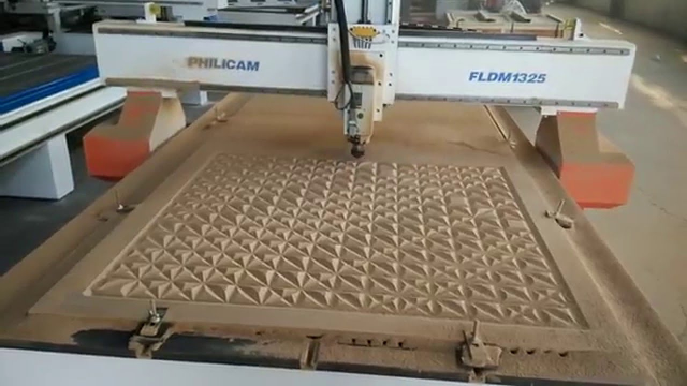

Engraving Machine

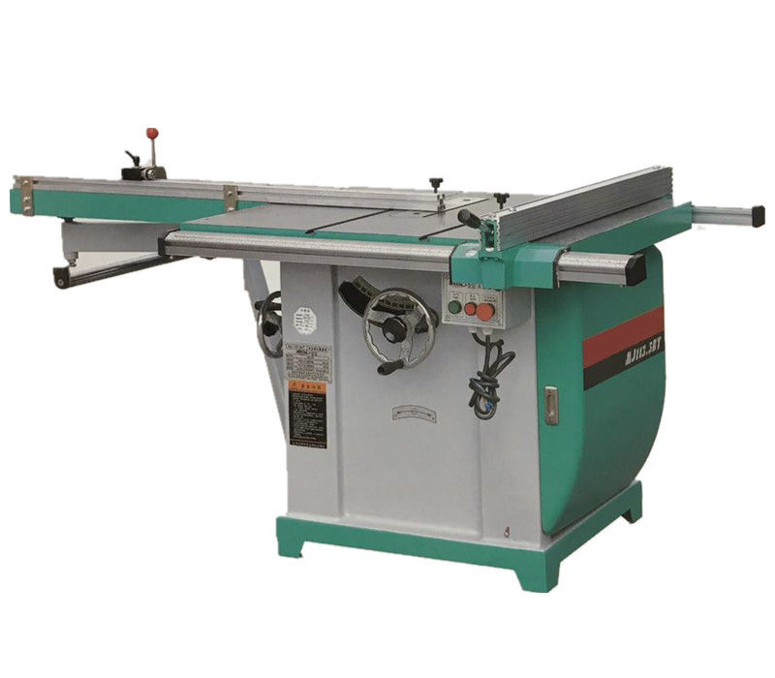

Wood Cutting Machine

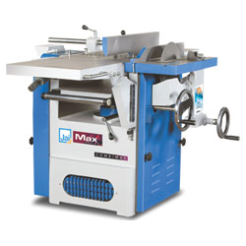

Solid Wood Working Machine

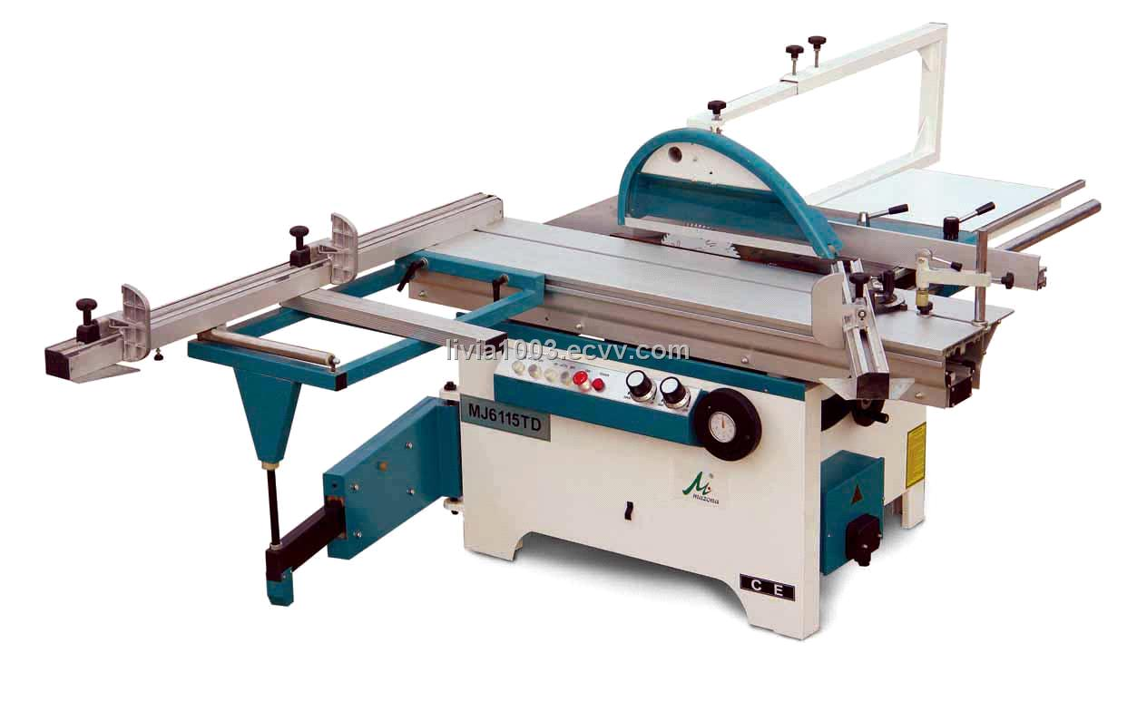

Waxing Machine

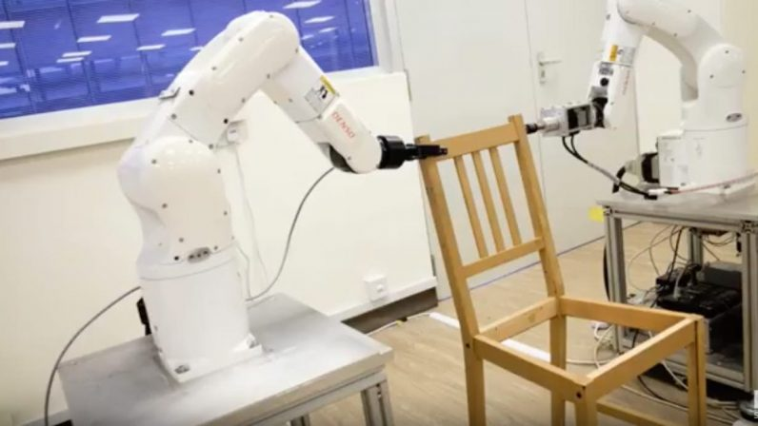

Furniture Assembling Machine

3.3 **PRODUCT AND SERVICES**

AA DAURAWA will offer wood products for the bedroom, living and dining room, and the storage room:

* Beds;

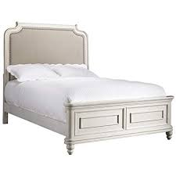

* Dressers;

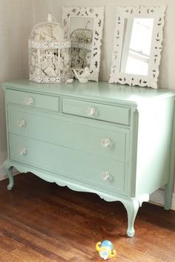

* Chest;

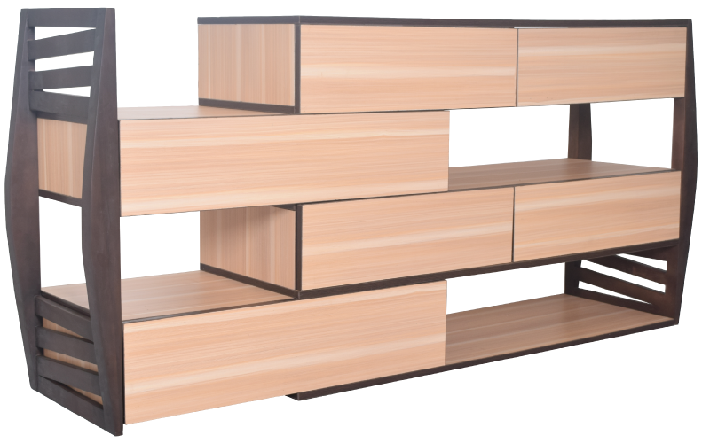

* Armoires;

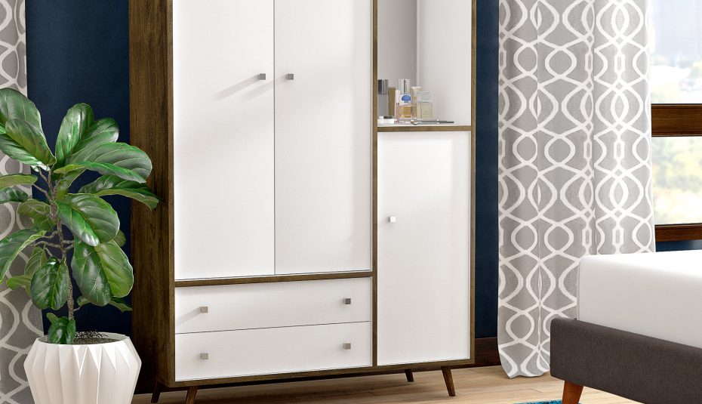

* Entertainment centers;

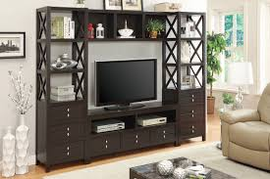

* Bookcases;

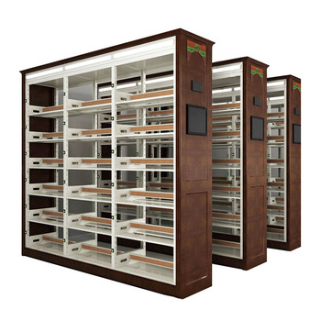

* Tables;

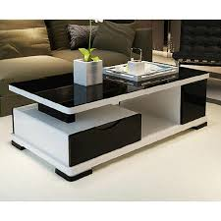

* Chairs;

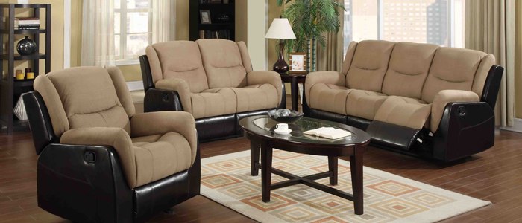

* Benches.

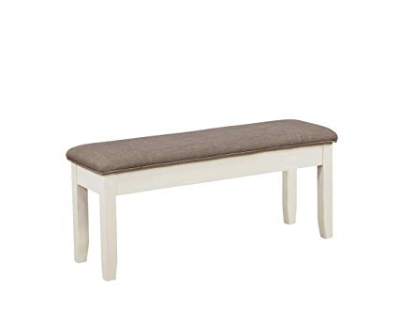

4.0 **MARKET ANALYSIS SUMMARY**

In the Kano central, there are more than 500,000 residents with modest incomes.  They are expected to make up half of the metro population by 2020 making them the fastest-growing segment of the city's housing market. It is estimated that the city will need 40,000 units of affordable housing in the next seven years.  Currently, there are three renovation projects that represent 7,500 new housing units.  Next year, two new construction projects will be completed offering another 3,000 units of affordable housing.  Another 2,500 unit project, to be located along the North-west University section downtown, is currently in the planning stages. There are changes occurring around the Bayero University, located at Gwale Local Government that will also impact the revival of the area.  Two off-campus housing projects will be completed mid-year that will add an additional 2,000 family housing units to the university area.

Also, if you are conversant with the Furniture Manufacturing Industry, you will quite agree that the changes in disposable income, consumer sentiment, ever changing trends and of course the rate of home ownership is major growth drivers for this industry.

No doubt, a massive rise in consumer confidence has also contributed in helping the industry experience remarkable growth, but uneven performance in these drivers has led to slightly constrained revenue growth for the Furniture Manufacturing industry.

So also, the rising demand for both home and office furniture, as a result of increasing disposable income and consumer sentiment, will result in revenue growth, but profit margins will stagnate as furniture stores keep prices low to attract more sales amid growing competition.

A close watch on the industry activities reveals that, the Retail Market for Home Furniture and Bedding was hit hard by the recent economic downturn and experienced a decline in revenue in recent time.

As part of marketing strategies, furniture manufacturing companies now ensure that they have showrooms at different locations where they display their home and office furniture. As a matter of fact, it is even cheaper to purchase directly from this showrooms established by furniture manufacturing companies as against purchasing from furniture retail stores. It is a strategy that will help us increases sales and income for their business.

Lastly, in recent time, the furniture manufacturing landscape has seen tremendous changes in the last 20 years; it has grown from the smaller carpenter workshop to a more organized and far reaching massive furniture making factory. This trend has benefited them in such a way that they can comfortably sell their furniture nationally and also export them to other countries of the world.

### 4.1 MARKET SEGMENTATION

The growth of affordable housing in the city area is critical to the success of AA DAURAWA NIGERIA LIMITED and we will aggressively market our target customers who live in the Metro area:

* Young working families;
* Students;
* Young adults.

4.2 **OUR COMPETITIVE ADVANTAGE**

Most Kano state furniture stores are dispersed throughout the city adjacent to affluent or suburban communities. The stores downtown are high end and offer no affordable products to the Metro residents.

The primary reason for the price of the furniture is the type of wood that is used. A bedroom set made of pine can cost less than the same set made in oak or maple. The profits are higher by focusing on the more expensive wood.  When using pine, many manufacturers improve their profits by using cheaper construction techniques.  The resulting poor qualities of these products have added to a popular misconception that pine is an inferior wood.

AA DAURAWA NIGERIA LIMITED will offer a very limited selection of styles in pine.  Most products are selected to maximize the store's profit, not the customer's satisfaction, since it is believed the customer has few options.

Our company will build its furniture to last generations and will offer the customer all the popular styles.

5.0 **MARKETING STRATEGY AND SALES STRATEGY**

Before choosing a location was chosen for the company, a thorough market survey and feasibility studies was conducted in order to penetrate the available market and become the preferred choice for residence of Kano, Kano state. The detailed information and data that was available to structure the business to attract the numbers of customers we want to attract per time.

Experts who have good understanding of the furniture manufacturing industry were hired to develop marketing strategies that will help in achieving the business goal of winning a larger percentage of the available market in the state.

In order to continue to be in business and grow, we must continue to manufacture and sell the furniture that is available in our showrooms which is why we will go all out to empower our sales and marketing team to deliver. In summary, to this end we will adopt the following sales and marketing approach to win customers over;

* Advertisement in the university daily student newspaper as well as the Metro area advertising flyer.  In the advertisements for the store opening, we will have a 20% off coupon.
* The metro area also has six community organizations that send out weekly flyers to all community residents. We will advertise in these flyers.
* Introduce our furniture manufacturing company by sending introductory letters alongside our brochure to organizations, households and key stake holders in Kano state and environs.
* Make use of attractive hand bills to create awareness and also to give direction to our furniture showrooms.
* Leverage on the internet to promote our business.
* Engage in direct marketing and sales.
* Encourage the use of Word of mouth marketing (referrals)

5.1 PUBLICITY AND ADVERTISING STRATEGY

With the fact that AA DAURAWA NIGERIA LIMITED will be well located, will still go ahead to intensify an active publicity for the business. Measures are on ground to explore all available means to promote the furniture manufacturing company.

There is long term plan, of opening showrooms in various locations all around Kano state and key cities in the Nigeria which is why, deliberately, they plan to build a brand to be well accepted in Kano, Kano state before venturing out. As a matter of fact, the publicity and advertising strategy is not solely for winning customers over but to effectively communicate brand.

Here are the platforms intend leveraging on to promote and advertise what they do and what they offer;

* Place adverts on campus and community based newspapers, radio stations and TV stations.
* Encourage the use of word of mouth publicity from our loyal customers
* Leverage on the internet and social media platforms like; YouTube, Instagram, Facebook ,Twitter, LinkedIn, Snapchat, Badoo, Google+  and other platforms to promote their business.
* Ensure that they position banners and billboards in strategic positions all around.
* Distribution of fliers and handbills in target areas in and around neighbourhood
* Contact corporate organizations, households, landlord associations and schools by calling them up and informing them of MMD Furniture and the furniture products we manufacture and sell
* Advertise furniture manufacturing company and showroom in our official website and employ strategies that will help us pull traffic to the site
* Brand all our official cars and trucks and ensure that all our staff members and management staff wears our branded shirt or cap at regular intervals.

5.2 OUR PRICING STRATEGY

Aside from quality, pricing is one of the key factors that gives leverage to furniture manufacturing companies, it is normal for consumers to go to places (furniture manufacturing companies and showrooms) where they can get home and office furniture at cheaper price which is why big player in the furniture stores industry will always attract loads of corporate and individual clients.

Currently there is no capacity to compete with Kafas Furniture Company, Afnan Furniture, Setrad Nigeria Limited et al, but will ensure that the prices and quality of all the furniture products that will be manufactured and are available in showroom are competitive with what is obtainable amongst furniture stores within thier level.

5.3 PAYMENT OPTIONS

The payment policy to be put in place will be all inclusive because of the awareness that different people prefer different payment options as it suits them. Here are the payment options that will be available in every of our outlets;

Payment by cash

Payment via Point of Sale (POS) Machine

Payment via online bank transfer (online payment portal)

Payment via Mobile money

Payment with check from loyal customers

In view of the above, banking platforms that will help towards achieving an effective payment plans without any itches is progress. Our bank account numbers will be made available on the company website and promotional materials to clients who may want to deposit cash or make online transfer for furniture purchased.

6.0 SWOT ANALYSIS

The plan is to become one of the leading office and household furniture manufacturing companies in the whole of Kano, Kano state and fully aware that it will take the right business concept, management and organization – structure to achieve our goal.

Although, there is several furniture manufacturing companies all over Nigeria and even in the same location where we intend locating ours, which is why due process are being followed toward establishing a business.

Obviously, if a proper SWOT analysis is conducted for business, it will be able to position the business to maximize our strength, leverage on the opportunities that will be available to us, mitigate our risks and be welled equipped to confront our threats.

AA DAURAWA employed the services of an expert HR and Business Analyst with bias in manufacturing to help conduct a thorough SWOT analysis and to help create a business model that will help us achieve our business goals and objectives.

This is the summary of the SWOT analysis that was conduct;

*Strength*:

The primary plan is to be one of the leading firms in the furniture industry. Our company has numerous strengths that will help us to thrive in the market place. These strengths will not only help to protect the market share in existing markets but also help in penetrating new markets. Based on [the extensive research](http://fernfortuniversity.com/) we conducted – some of the strengths are –

* Reliable suppliers – we are setting up a strong base of reliable supplier of raw material thus enabling us to overcome any supply chain bottlenecks.
* High level of customer satisfaction – with a dedicated customer relationship management department we should be able to achieve a high level of customer satisfaction among present customers and good brand equity among the potential customers.
* Successful track record of developing new products – product innovation.
* Highly successful at “Go to Market strategies’’ for its products.
* Superb Performance in New Markets – our company has built expertise at entering new markets and making success of them. The expansion will helped our organization to build new revenue stream and diversify the economic cycle risk in the markets we operates in.

*Weakness:*

Weaknesses are the areas where we can improve upon. Strategy is about making choices and weaknesses are the areas where a company can improve using SWOT analysis and build on its competitive advantage and strategic positioning.

* High attrition rate in work force – compare to other organizations in the industry our being a start-up has a higher attrition rate and have to spend a lot more compare to its competitors on training and development of its employees.
* The projected profitability ratio and Net Contribution % are below the industry average.
* There are gaps in the product range sold by the company. This lack of choice can give a new competitor a foothold in the market.
* The marketing of the products left a lot to be desired. Even though the product will be a success in terms of sale but it’s positioning and unique selling proposition is not clearly defined which can lead to the attacks in this segment from the competitors.
* Need more investment in new technologies. Given the scale of expansion and different geographies the company is planning to expand into, AA DAURAWA needs to put more money in technology to integrate the processes across the board. Right now the investment in technologies is not at par with the vision of the company.

*Opportunities:*

The fact that we are going to operate our furniture manufacturing company in one of Kano state provinces provides us with unlimited opportunities to sell our furniture to a large number of individuals and corporate organizations. We have been able to conduct thorough feasibility studies and market survey and we know what our potential clients will be looking for when they visit our furniture manufacturing workshop; we are well positioned to take on the opportunities that will come our way. Other opportunities foresee are:

* Decreasing cost of transportation because of lower shipping prices can also bring down the cost of company products thus providing an opportunity to the company - either to boost its profitability or pass on the benefits to the customers to gain market share.
* The new technology provides an opportunity to company to practices differentiated pricing strategy in the new market. It will enable the firm to maintain its loyal customers with great service and lure new customers through other value oriented propositions.
* New environmental policies – The new opportunities will create a level playing field for all the players in the industry. It represent a great opportunity for AA DAURAWA NIGERIA LIMITED to drive home its advantage in new technology and gain market share in the new product category.
* Stable free cash flow provides opportunities to invest in adjacent product segments. With more cash in bank the company can invest in new technologies as well as in new products segments. This should open a window of opportunity for Stanley Furniture Company, Inc. in other product categories.

*Threat:*

Just like any other business, one of the major threats that we are likely going to be faced with is economic downturn. It is a fact that economic downturn affects purchasing/spending power. Another threat that may likely confront us is the arrival of a new furniture manufacturing company in same location where ours is located. So also, unfavourable government policies may also pose a threat for businesses such as ours. Other threats foreseen include;

* The demand of the highly profitable products is seasonal in nature and any unlikely event during the peak season may impact the profitability of the company in short to medium term.
* Shortage of skilled workforce in certain global market represents a threat to steady growth of profits for our company in those markets.
* Changing consumer buying behaviour from online channel could be a threat to the existing physical infrastructure driven supply chain model.
* As it is our plan to operate in numerous countries we expected to be exposed to currency fluctuations especially given the volatile political climate in number of markets across the world.

7.0 CHECK LIST / MILESTONE

Business Name Availability Check: Completed

Business Registration: In progress

Opening of Corporate Bank Accounts: In progress

Securing Point of Sales (POS) Machines: Completed

Opening Mobile Money Accounts: In progress

Opening Online Payment Platforms: In progress

Application and Obtaining Tax Payer’s ID: In Progress

Application for business license and permit: In progress

Purchase of Insurance for the Business: In progress

Leasing of facility and re modeling the facility (warehouse and showroom): In Progress

Conducting Feasibility Studies: Completed

Applications for Loan from the bank: In Progress

Writing of Business Plan: Completed

Drafting of Employee’s Handbook: Completed

Drafting of Contract Documents and other relevant Legal Documents: In Progress

Design of The Company’s Logo: Completed

Graphic Designs and Printing of Packaging Marketing / Promotional Materials: In Progress

Recruitment of employees: In Progress

Purchase of the needed furniture, racks, shelves, computers, electronic appliances, office appliances and CCTV: In progress

Creating Official Website for the Company: In Progress

Creating Awareness for the business both online and around the community: In Progress

Health and Safety and Fire Safety Arrangement (License): In progress

Opening party / launching party planning: In Progress

Compilation of our list of products that will be available in our store: Completed

Establishing business relationship with vendors – manufacturers and suppliers of home and office furniture: In Progress

8.0 MANAGEMENT SUMMARY

The store's owner, AA DAURAWA, has worked in the furniture manufacturing industry for over ten years.  This experience began when he started learning furniture works, and serve as part time furniture workman for different furniture manufacturing, five years. Within three years, he reached the position of shift manager. Most recently, AA DAURAWA was the operations manager at one of the leading Furniture Manufacturing.

DAURAWA is an excellent staff supervisor and will do very well in managing the staff of his own.

9.0 FURNITURE INDUSTRY

All the companies and activities involved in the design, manufacture, distribution, and sale of functional and decorative objects of household equipment.

The modern manufacture of furniture, as distinct from its design, is a major mass-production [industry](https://www.britannica.com/technology/industry) in Europe, the U.S., and other advanced regions. It is very largely a 20th-century industry, its development having awaited the growth of a mass consumer market as well as the development of the mass-production technique. Earlier [furniture](https://www.britannica.com/technology/furniture) making was a handicraft, going back to the most ancient civilizations.

10.0 HISTORY OF FURNITURE MAKING AND USAGE

Examples of ancient furniture are extremely rare, but there is considerable knowledge of the pieces made by craftsmen in China, India, Egypt, Mesopotamia, Greece, and Rome from pictorial representations. Beds, tables, chairs, boxes, stools, chests, and other pieces were nearly always made of natural [wood](https://www.britannica.com/science/wood-plant-tissue), though [veneering](https://www.britannica.com/topic/veneer) was known in Egypt, where it was used to produce coffin cases of great durability. The Romans too used veneers, though chiefly for decorative purposes. Bronze was also used in Roman tables, stools, and couch frames. Pompeian wall paintings show that plain, undecorated wooden tables and benches were standard in kitchens and workshops and that panelled cupboards were common. Chests for valuables were covered with plates or bound with iron.

The early Middle Ages were much poorer in household furnishings of every kind than the Roman world, but in the 14th and 15th century a growing affluence brought a major revival of furniture making, with many new types of cupboards, boxes with compartments, and various sorts of desks appearing. The religious houses in particular were well supplied with furniture. Framed panelling, reintroduced in the Burgundian Netherlands, quickly spread. The mortise and tendon and mitre provided greatly improved joints.

The growing sophistication in technique brought a revolutionary change in the men who made furniture. Where previously carpenters and joiners had made furniture along with every kind of [building construction](https://www.britannica.com/technology/construction) in wood, several circumstances combined to create a new profession: that of cabinetmaker. The most important technical factor was the introduction, or reintroduction, of veneering, first in western Europe, then in Britain, [North America](https://www.britannica.com/place/North-America), and elsewhere.

In the earlier system of framework and panel, the framing gave the required strength in both length and width, the panel being a mere filling held in grooves. Its attractive appearance was the result of highlights and shadows produced by the framing, mouldings, and carving, which formed the chief means of decoration. The grain of the wood was incidental.

The introduction of veneering coincided with the use of [walnut](https://www.britannica.com/plant/walnut-tree-and-nut) as a furniture wood. It was soon realized that the grain of such a wood could be of decorative value, especially as veneering made it possible to use such visually attractive parts of the wood as burrs, butts, and curls, unreliable if used as solid wood. It became the custom to have the grain of the veneer generally run crosswise because of its decorative appearance. [Marquetry](https://www.britannica.com/art/marquetry) (a form of inlay in veneer) was another example of the decorative use of the grain and colour of wood in surfaces unbroken by panelling.

In addition to veneering and the new system of construction it involved, an [impetus](https://www.merriam-webster.com/dictionary/impetus) to the establishment of the trade of furniture making came from the increasing market demand provided by the growing affluence of the 17th and 18th centuries. In the new system of construction, plain, flat parts are [dovetailed](https://www.britannica.com/technology/dovetail-joint) together and then veneered. It can be contrasted with the traditional framed method of rails and stiles put together with [mortise and tendon](https://www.britannica.com/technology/mortise-and-tenon) [joints](https://www.britannica.com/technology/joint-carpentry), the panels fitting in grooves.

Coinciding with this change, or preceding it by a few years, was another breakaway: that of the [chair maker](https://www.britannica.com/topic/chair), who had become another specialized craftsman. At first chair making was closely associated with wood turning but by the 18th century turned legs were largely replaced by shaped legs of the [cabriole](https://www.britannica.com/topic/cabriole-leg) type. Chair making has remained a separate branch of furniture making ever since.

This growth of cabinetmaking as a trade of its own eventually resulted in a considerable degree of standardization of methods of construction, particularly in the types of joints used and in the thicknesses of wood for the various parts. It also resulted in an increased [division of labour](https://www.britannica.com/topic/division-of-labour). [Turnery](https://www.britannica.com/technology/turnery) became a separate trade, while the cabinetmaker assembled the turned parts; veneer and marquetry cutting was not done by the cabinetmaker although he laid both; [carving](https://www.britannica.com/art/woodcarving) too called for the skill and experience and tools of a craftsman who did nothing else. Another specialist, the upholsterer, did his work after the chair maker had made the frame; and it seems likely that finishing was seldom done by the cabinetmaker. This was certainly the case later in the 19th century when French polishing became the standard method of finishing furniture.

An important 19th-century change was the separation within the industry of those who made furniture from those who sold it. Previously the customer commissioned a cabinetmaker, perhaps after consulting a [design](https://www.britannica.com/topic/design-arts-and-technology) book by Chippendale, Hepple white, or Sheraton. Or he might work out his requirements in consultation with the cabinetmaker or, if he were sufficiently wealthy, employ an architect or designer. After the midyears of the 19th century the showroom gained popularity. A large store often retained its own workshops where special items were made to customers’ requirements, but for the greater part it became the practice to buy wholesale from furniture making firms.