*………………………. amazing delicacies for all.*

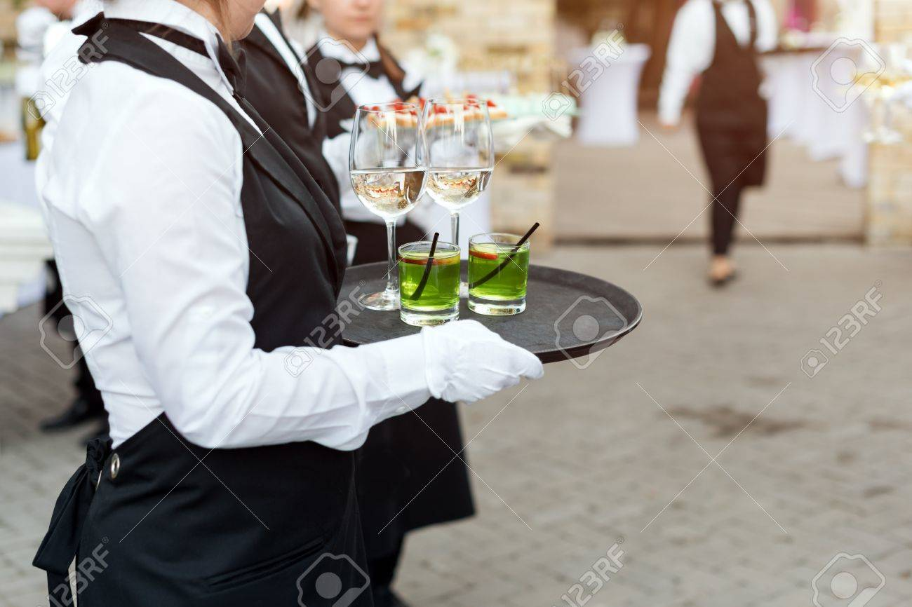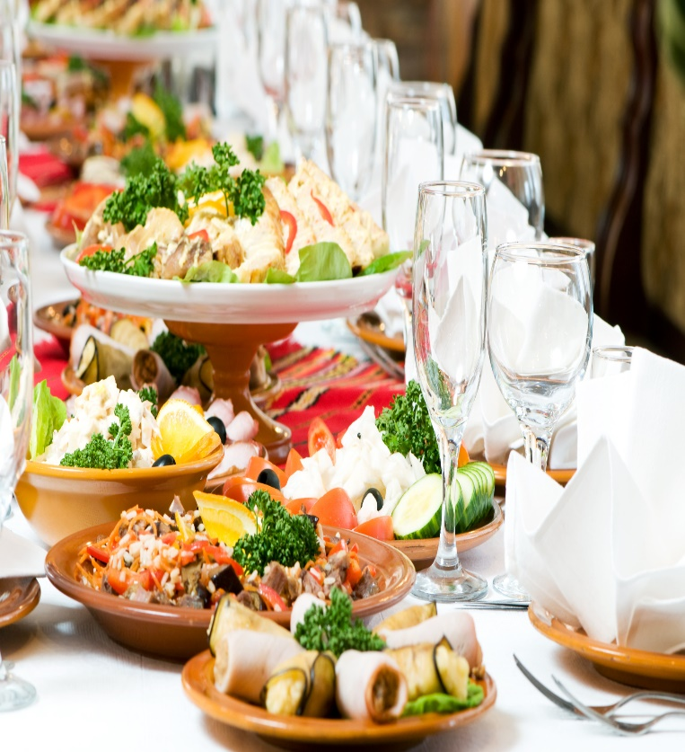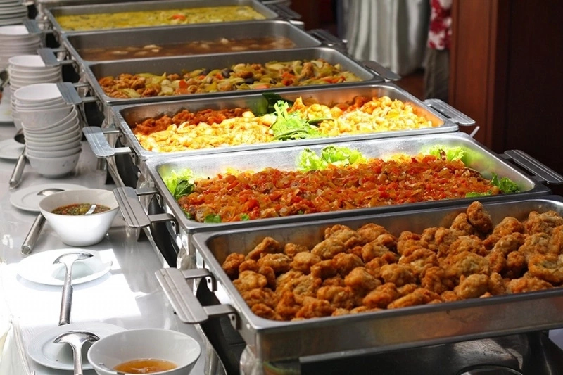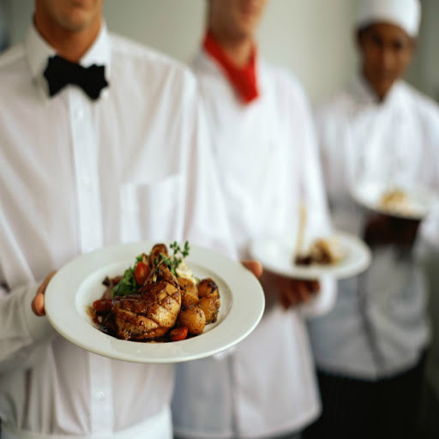

BUSINESS FEASIBILTY REPORT

a.j intercontinental kitchen

Prepared By: Yusuf Qoseem Oyewumi

yusufqoseem@gmail.com, 09032472657

1. ***EXECUTIVE SAMMARY***

**A.J** Intercontinental Kitchen is a fast food outlet and business enterprise that will serve both the middle and upper class residence of Ogbomosho and visitors alike.

**A.J** Intercontinental Kitchen will offer creative, colorful, and unusual food options of international tastes as well as the traditional standbys. **A.J** Intercontinental Kitchen will provide catering services for event of all categories and also a tastiest local delicacies most craved for in Nigeria and Africa at large. Our plan also includes a mobile service where we can deliver a special order to our customer’s door step. We will hire dedicated support staff to provide excellent services to our potential customers.

In addition, our services will be sensitively unique relative to the existing restaurant market which is quite stagnant.  Most people make the incorrect assumption that fast food means ordinary, boring food.  This assumption prevails throughout the modern community so there is not much demand for new offerings.

To this end, **A.J** Intercontinental Kitchen will inject new life into the restaurant market, leveraging on the existing modern facilities and our caterers skills to develop creative new catering options.  The facilities, advanced skills, industry insight, and a great market opportunity will allow **A.J** Intercontinental Kitchen to operate at a breakeven at the first three months and profitability in the subsequent months.

There is a need of a warm and friendly place with excellent food. A place where you always know you will get the best of everything. **A.J** Intercontinental Kitchen will feature a cozy dining room, an elegant lounge, game center and a soccer show room. Comfortable furnishings and decor with soothing warm tones. The lounge will comfy couches and antique love seats with a softly lit bar. It will be the perfect place to stop in for a bite to eat, for a drink or for a small business meeting. For extra comfort and to please a large group of people we will make up special platters for all categories of customers.

## 1.2 OUR MISSION

Our mission is to give our customers a place to celebrate life’s special moments by connecting people to real food offering. *Our services will exceed the expectations of our customers.*

## 1.3 OUR VISSION

*To be a leading provider of quality delicious foods and impeccable customer service by offering a versatile and flexible service with consistency and presentation that will leave a lasting Impression.*

## 1.4 KEY TO SUCCESS

AT **A.J** Intercontinental Kitchen, we planned to put the following measures in place to achieve our set short and long term objectives. These measures are termed the strategic keys to success. They include;

**KNOWING OUR CONCEPT**

We will choose our kitchen (restaurant, soccer show-room and game center) concept carefully. We will target both the Upper and Middle class resident. Some of the concepts include:

* fast food restaurant
* Pop Up restaurant with no long time commitment
* Soccer Show-room and game center
* Mobile catering services

**GETTING A LOGO**

Make sure that our restaurant is represented by a unique logo. People will see our [restaurant logo](https://www.designhill.com/logo-design/restaurant-logos/) on our street signs, advertisements, billboards, business cards, websites, menu card and elsewhere.

**ENSURING A UNIQUE MENU CARD**

When people visit our restaurant, the first thing they will come across with is our restaurant menu card. The card has the prices and dishes displayed for the customers. They can pick a dish that suits to their budget after carefully scanning the card. We believe professionally created menu card design has the ability to speak a lot about our restaurant business.

**BUILD A DEDICATED WEBSITE**

We will put our restaurant business online. People can anywhere (within Ogbomosho), book tables to dine in our restaurant. Our restaurant features and services will be available on the web. So, we will create a memorable [website design](https://www.designhill.com/website-design) and put it on the web.

**USE SOCIAL MEDIA**

One of the most effective way we intend to promote our restaurant business is to take advantage of social media. Our potential customers are on social sites such as Facebook, Instagram and Twitter. So, we will create a useful [social media page](https://www.designhill.com/social-media-page) for our business.

1. **COMPANY SUMMARY**

**A.J** Intercontinental Kitchen is a sole proprietorship business enterprise serving both the needs of indigenous and students customers craving for amazing delicacies.

**A.J** Intercontinental Kitchen is established as a profit oriented business with expectation to have investing corporate partners (if needs be at the longrun) to secure a going concern objective for the business.

The trade name ‘’**A.J Intercontinental Kitchen**’’ is in the process of being registered, and the product logo is being finalized.

1. **PRODUCT AND SEVICES**

**A.J** Intercontinental Kitchen will offer both a restaurant service of different demand. This services include; special order, visiting, hosting etc.

**RESTAURANT SERVICES**

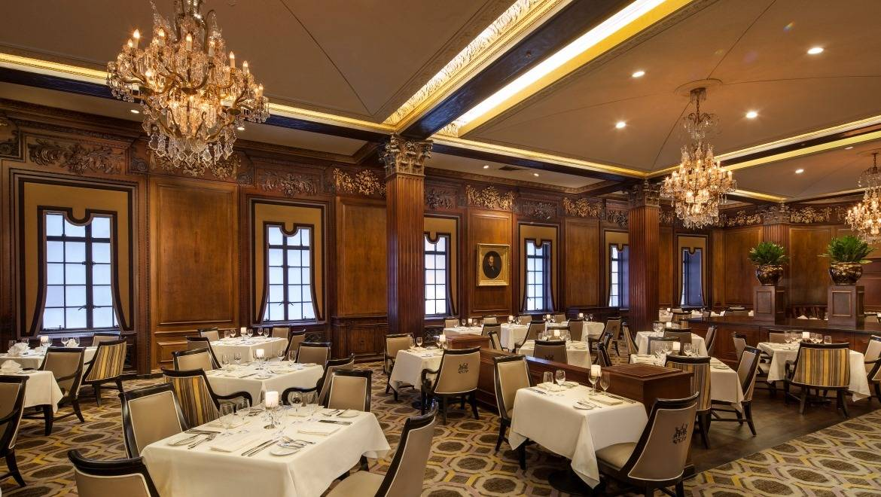

**SPECIAL ORDER**

We will cater for our customers who need a delicacy or services that they can’t find on our menu or restaurant or want to call in an order to pick up. This are the perfect solution for these categories of customer; Family Parties, Special mini Events, and Celebrations, Picnics, Fairs, Festivals, everything in between.

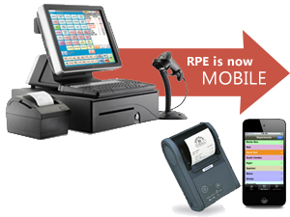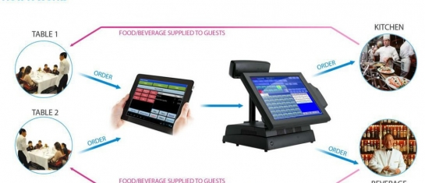

**CATERING SERVICES (in the long run)**

In the nearest future, we will handle all aspect of events, such as graduation party, wedding reception, corporate business dinner etc. This services will be redered in accordance to the client’s wishes, sets up catering tables, decorations and lighting.

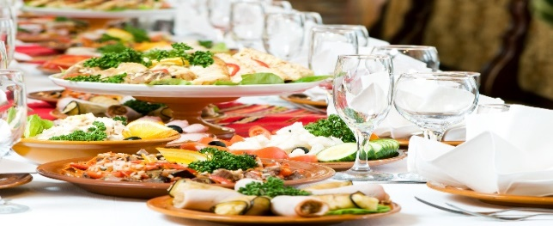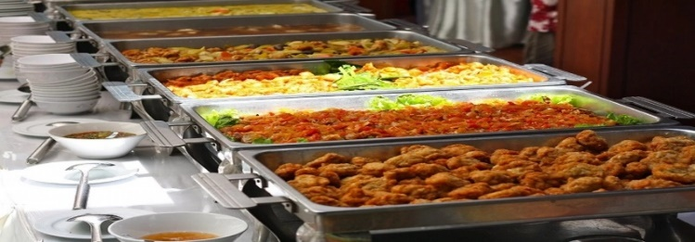

**SOCCER SHOW-ROOM/GAME CENTER**

1. **MARKET ANALYSIS SUMMARY**

Our analysis of the market has shown that there has been an increase in competition among restaurant businesses in the area of services and marketing particularly in the area where we intend to operate. Some of the restaurants businesses even have customized services for clients celebrating specific occasions. Some have gone beyond to ensure that their products and services meet environment-friendly guidelines, hence, winning the patronage of environment-conscious consumers (the university students in the area).

In addition, Restaurants businesses has become more profitable business than ever before in Ogbomosho, Particularly in the student areas, due to the increase in population and the nature of jobs available. With such increase, comes the need for more restaurants that will cater for the stomach needs of the increasing population. This need will even more continue over time. Also, the need for qualitative food at the cheapest price called for our establishment of a standard Kitchen like we intend, in the Ogbomosho to meet the society delicacy needs.

## 4.1 TARGET MARKET

The food industry has a wide range of customers; a good number of people on planet earth consumed fast food and it is difficult to find people around who don’t. In view of that, we have positioned our kitchen channel to service both the Middle and the Upper class customers in Ogbomosho, particularly the student community and every other location we will cover on special order. We have conducted our market research and we have ideas of what our target market would be expecting from us. We are in business to serve amazing delicacies of a wide range at different affordable prices.

## 4.2 COMPETITION AND COMPETITIVE ADVANTAGES

A close study of the industry reveals that the market has become much more intensely competitive over the last decade. As a matter of fact, we have to be highly creative, customer centric and proactive if we must survive in this industry.

We are aware of the stiffer competition and we are well prepared to compete favorably with other leading Restaurants in our environment, Adenike, Ogbomosho. Our restaurant is launching a standard Restaurant and a game center channel that will indeed become the preferred choice of all our targeted customers.

One thing is certain; we will ensure that we have a wide range of delicacies available in our kitchen and a colorful show-room at all times. One of our business goals is to make our excellent customer service culture, timely and reliable delivery services, online presence, and various payment options will serve as a competitive advantage for us.

Lastly, our employees will be well taken care of, and their welfare package will be among the best within our category, meaning that, they will be more than willing to build the business with us and help deliver our set goals and achieve all our aims and objectives. We will also give good working conditions and commissions to freelance sales agents that we will recruit from time to time.

## 5.0 SWOT ANALYSIS

We are quite aware that there are several catering companies and standard Restaurants all over all Ogbomosho, Oyo state and even in the same location where we intend locating ours, which is why we are following the due process of establishing our businesses.

We know that if a proper SWOT analysis is conducted for our businesses, we will be able to position our business to maximize our strength, leverage on the opportunities that will be available to us, mitigate our risks and be welled equipped to confront our threats. We employed the services of an expert HR and Business Analyst with bias in Restaurant and Catering to help us conduct a thorough SWOT analysis and to help us create a business model that will help us achieve our business goals and objectives. This is the summary of the SWOT analysis that was conducted for our Company;

## 5.1 SWOT analysis for A.J Intercontinental Kitchen

* **strength:**

Our location, the business model we will be operating on robust modern services delivery, varieties of delicacies with a complimentary and affordable prices, wide range delicacies, prompt mobile (special order) delivery Services, our business environment beautified to our customers’ delights and our excellent customer service culture will definitely count as a strong strength. So, also our management team members are people who have what it takes to grow a kitchen business from start – up to profitability with a record time.

* **Weakness:**

A major weakness that could serve as a deterrent to us is that we are starting afresh, as new business and we currently don’t have the financial capacity to compete with existing kitchens operating the same location as ours for now.

* **Opportunities:**

The fact that we are going to be operating our business in a student settlement provides us with unlimited opportunities to sell our product to a large number of customers of different class. We have been able to conduct thorough feasibility studies and market survey and we know what our potential customers will be looking for when they patronize our Restaurant; we are well positioned to take on the other opportunities that will come our way.

* **Threat:**

Just like any other business, one of the major threats that we are likely going to face is economic downturn. It is a fact that economic downturn affects purchasing / spending power.

Also the incessant strike that characterized the academic activities of the university we leverage our customer based on.

Another threat that may likely confront us is the arrival of a similar business in same location where ours is located.

## 6.0 SALES AND MARKETING STRATEGY

Before choosing a location for our Company, we conducted a thorough market survey and feasibility studies in order for us to be able to penetrate the available market and become the preferred choice. We have detailed information and data that we were able to utilize to structure our business to attract the numbers of customers we want to attract per time.

In summary, our company will adopt the following sales and marketing approach to win customers over;

* Open our business in a grand style with a party for all.
* Introduce our business by sending introductory letters alongside our brochure to corporate offices, hostels and the university faculties and departments.
* Make use of attractive hand bills to create awareness for business
* Position our signage / flexi banners at strategic places.
* Position our greeters to welcome and direct potential customers
* Create a loyalty plan that will enable us reward our regular customers

## 6.1 STRATEGY AND IMPLEMENTATION SUMMARY

**LOCATION**

**A.J** Intercontinental Kitchen is already strategically located in the heart of Adenike, a student community in Ogbomosho, easily accessible to all classes of customers (upper and middle class to be precise). Although, a number of Restaurants are also located within, but only few are multi-ventures like we intend to do.

**COMPANY FACILITIES REQUIRED**

The primary facilities (which we already have) is the complex where our customer will be served, a feel at home dining room settings suitable to accommodate fifty plus customers at a time.

Also, a warehouse facility for storage and block of offices for staff. However, **A.J** Intercontinental Kitchen facility needs will grow rapidly over the next 10 years as production capacity expand. Ultimately, additional facilities will be needed for soccer show-room, a gaming center and a mini hall for special order engagements.

## 7.0 GOVERNANCE LEADERSHIP AND STAFFING

Being a sole proprietorship enterprise, an administrative model that encourages timely decisions and avoids the delay decision traditionally associated with a one-man business will be developed. A flat organization that hires support staff as needed to build the foundation of the company will be put in place.

**8.0 FINANCIAL PLAN**

This section provides the financial analysis of the business. it provides the capital requirement, cash flow analysis and profitability analysis of the proposed business in her first year of operation.

**8.1 CAPITAL REQUIREMENT**

The initial capital requirement of the business is shown below:



The projected capital requirement of the business of N800,000 presented above. The capital shown above to the tune of N480,000 will be utilized in the renovation (interior and exterior renovation of the building, procurement of attractive furniture and fittings, interior decorations, kitchen utensils and other office equipment, in order to ensure effective and efficient business operation. The balance, an amount equal to N320,000 will be used as working capital to finance the business.

**8.2 CASH FLOW ANALYSIS**

The cash flow analysis is employed to show the ability of the business to generate cash from its activities. The cash flow is projected for the first year of her operation.



The cashflow for the first year is built based on the assumption of the receipt of N800,000 loan/grant facility. More so, the business will incur capital assets to the tune of N 420,000. The business hopes to generate revenue majorly from restaurants and the soccer show room. The projected sales/revenue will be based on the customer we serve and how well we serve them, thereby we expected our sales to steadily increased on a monthly basis. More so, the business hopes to leverage more on variety of delicacies and assorted drinks as was expected to yield more income. The expenses to be incurred by the business are divided into pre-operation, operating and developmental expenses (as we wish to expand beyond). Expenses relating to marketing, storage and general administrative will also be incurred. Lastly, the business will also invest heavily on corporate social responsibly in terms of scholarships to orphans and less privileged at the long run. The cashflow is shown above.

**8.3 STATEMENT OF PROFIT AND LOSS**

The analysis of the profitability of the business is based on the projected income statement of the business for the first year of her operation. The projected income statement of the business is shown below:

